User Navigation Guide – Margins Notice Reports Within the Gas Data Portal
Margins Notice Reports – Navigation Guide #1
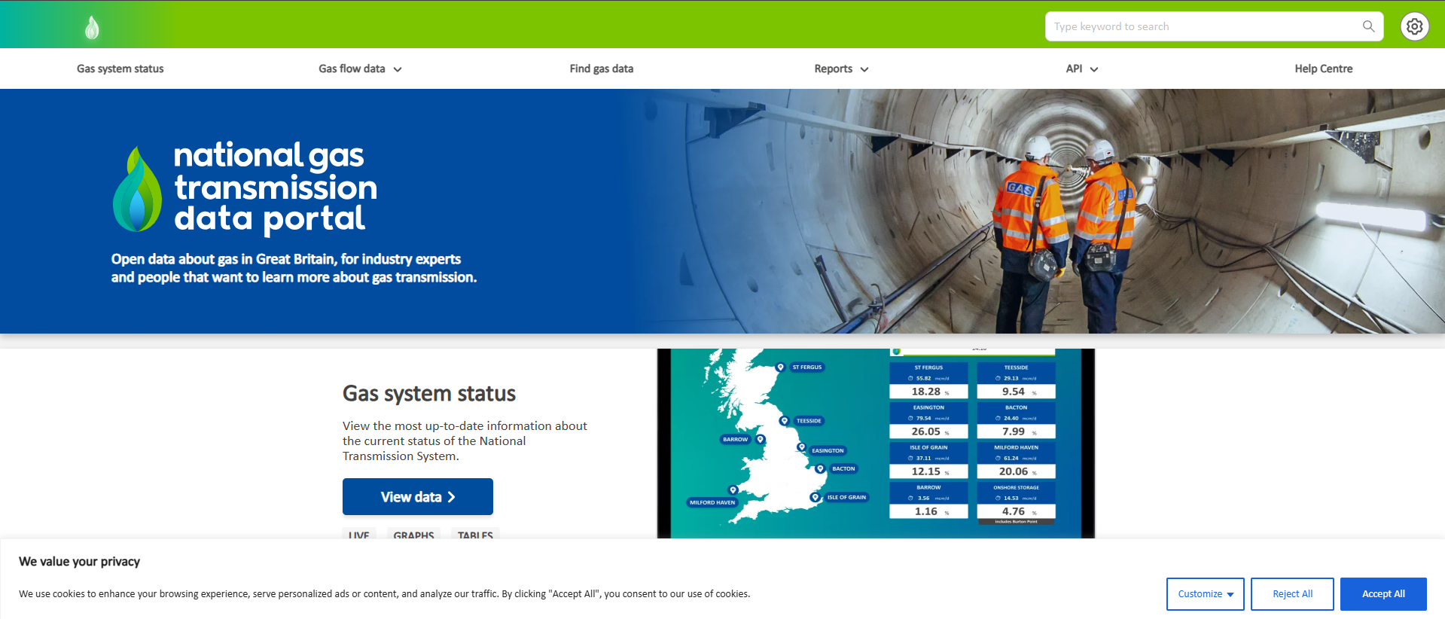
On the main page of the gas data portal, please select the “Reports” drop-down menu.
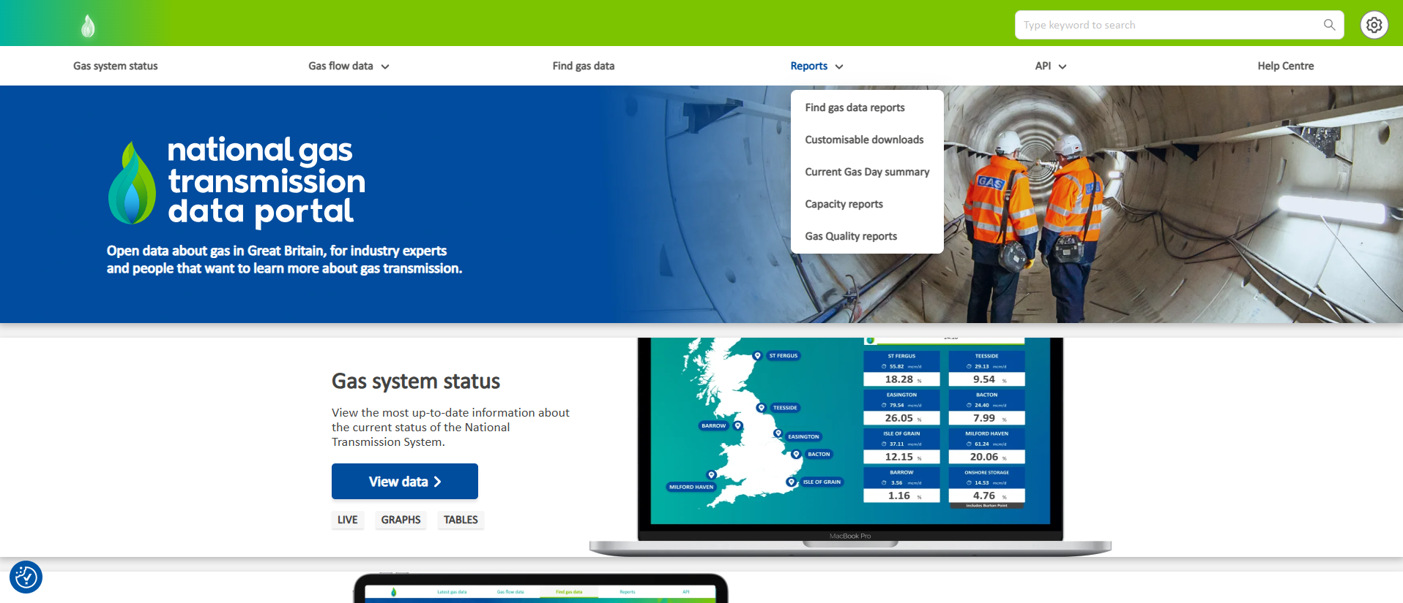
In the drop-down menu, please select “Find Gas Data Reports” tab.
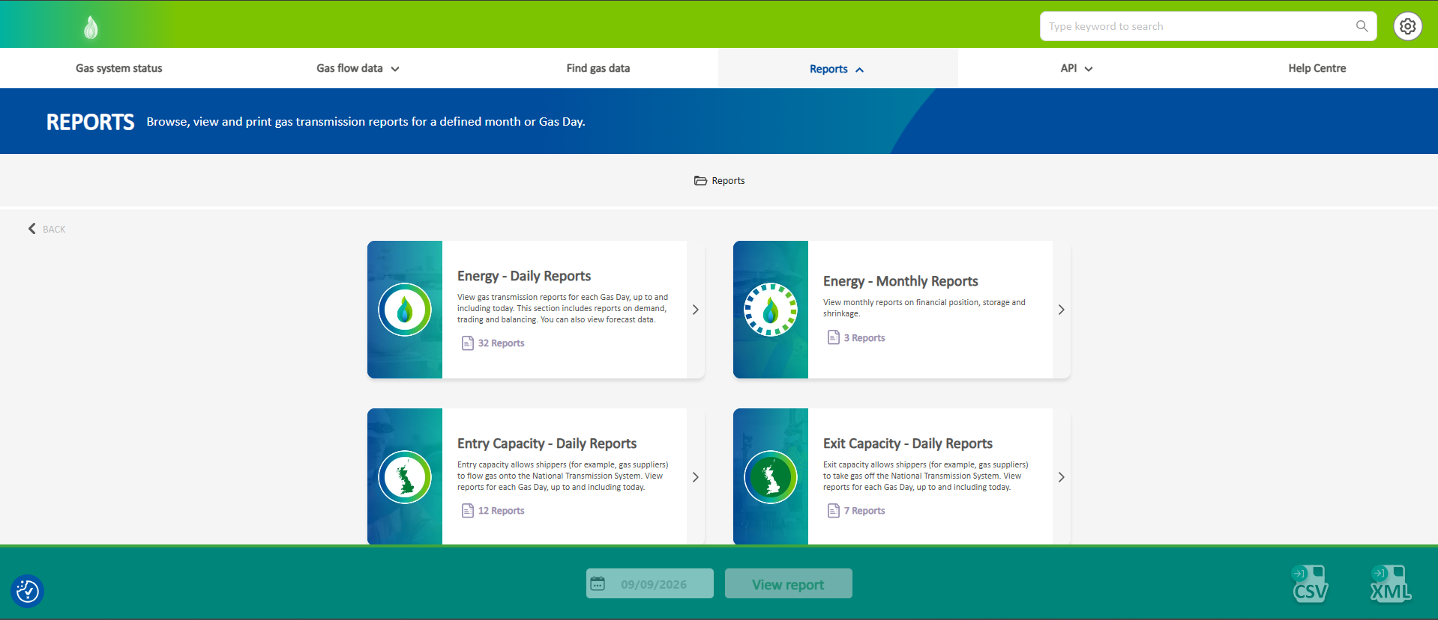
After selecting “Find Gas Data Reports” tab, please select “Energy – Daily Reports” from the options displayed on the landing page shown above.
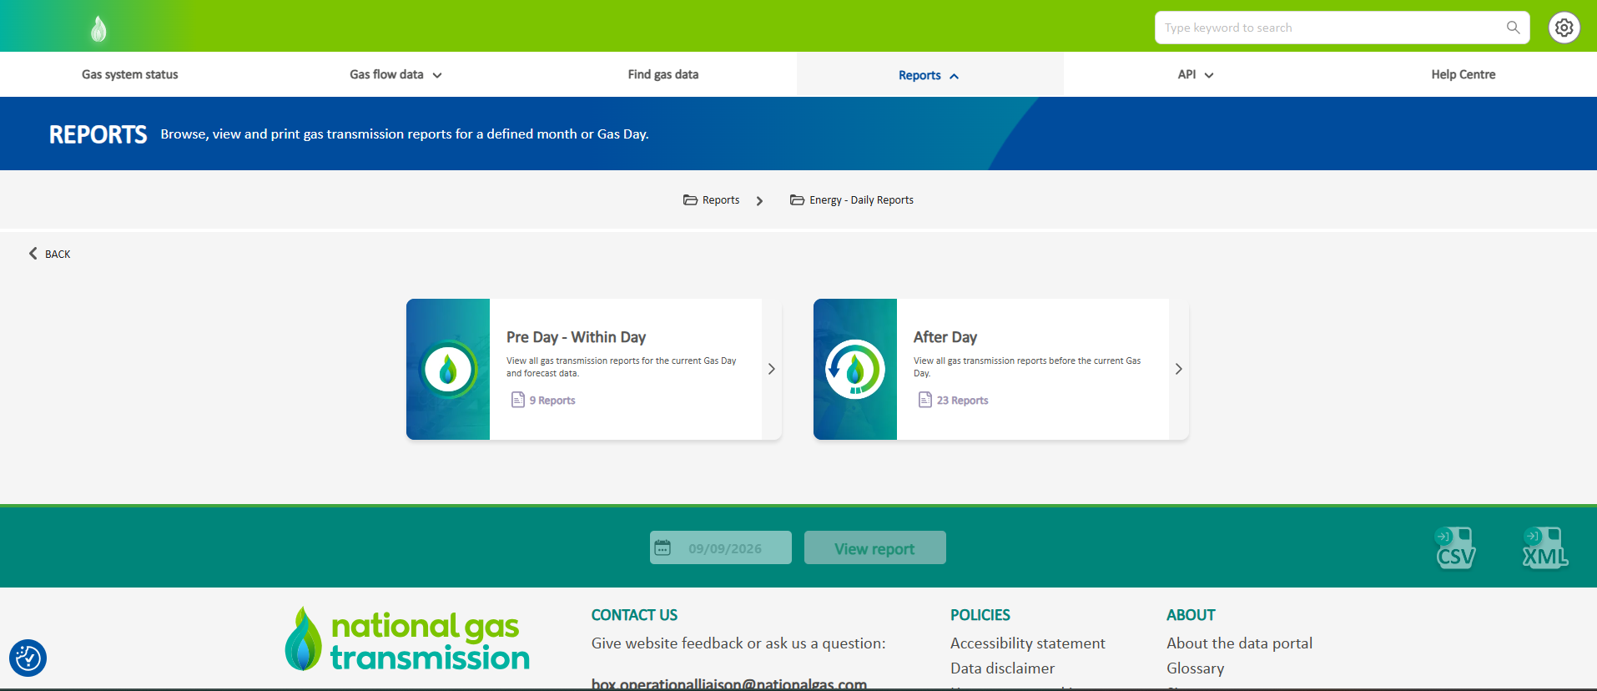
After selecting “Energy – Daily Reports” button, please select “Pre Day – Within Day” from the options displayed on the landing page shown above.
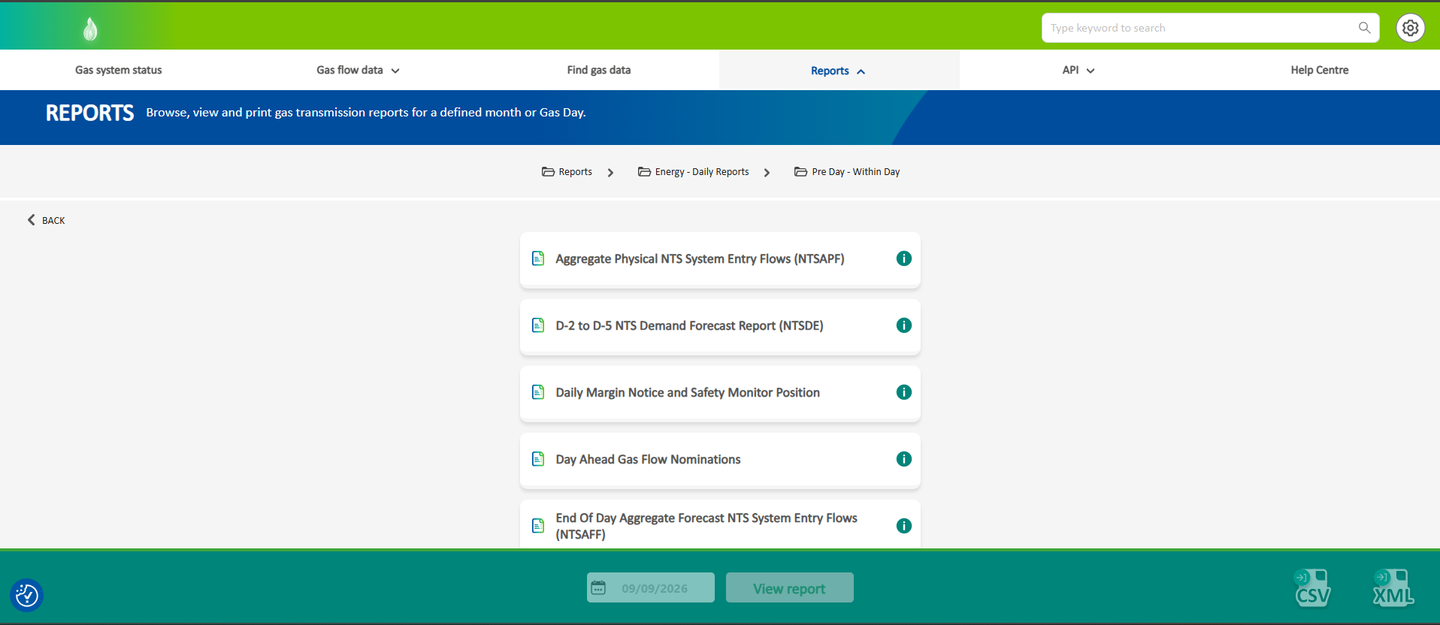
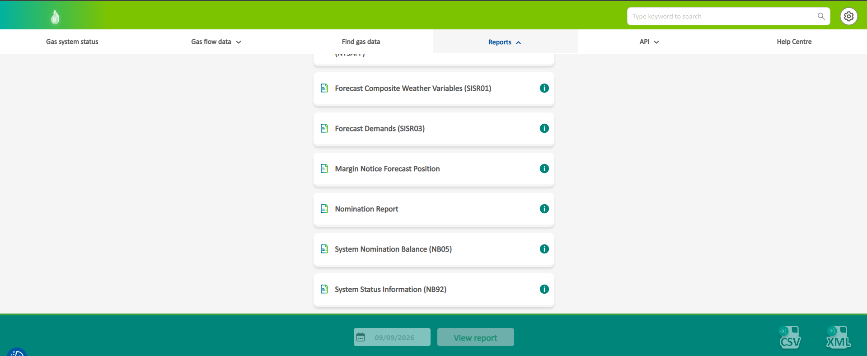
Once the reports are published within the Gas Data Portal from 30 September 2026, use the scroll functionality to find the following Margins Notice Reports:
- Daily Margin Notice and Safety Montior Position
- Margin Notice Forecast Position
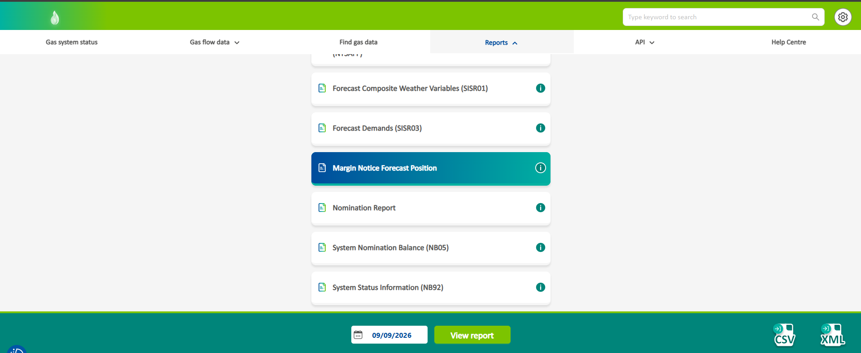
Once the report has been selected, the user will be able to view the report and change the date to view historical reports.

Margins Notice Reports – Navigation Guide #2
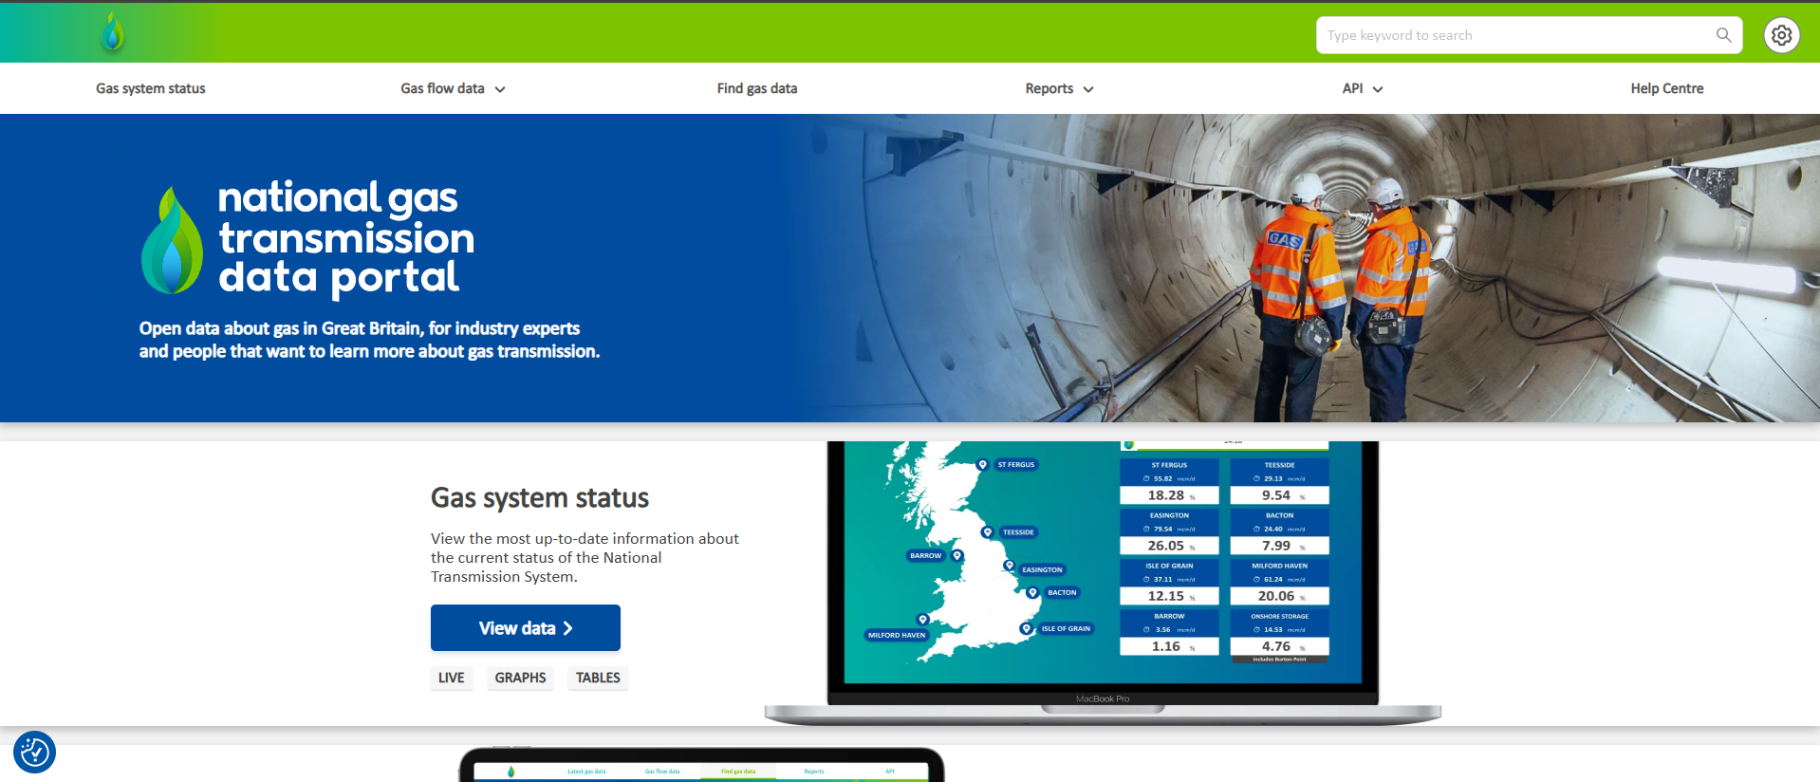
On the main page of the gas data portal, please select the “Gas system status” button within the main header.
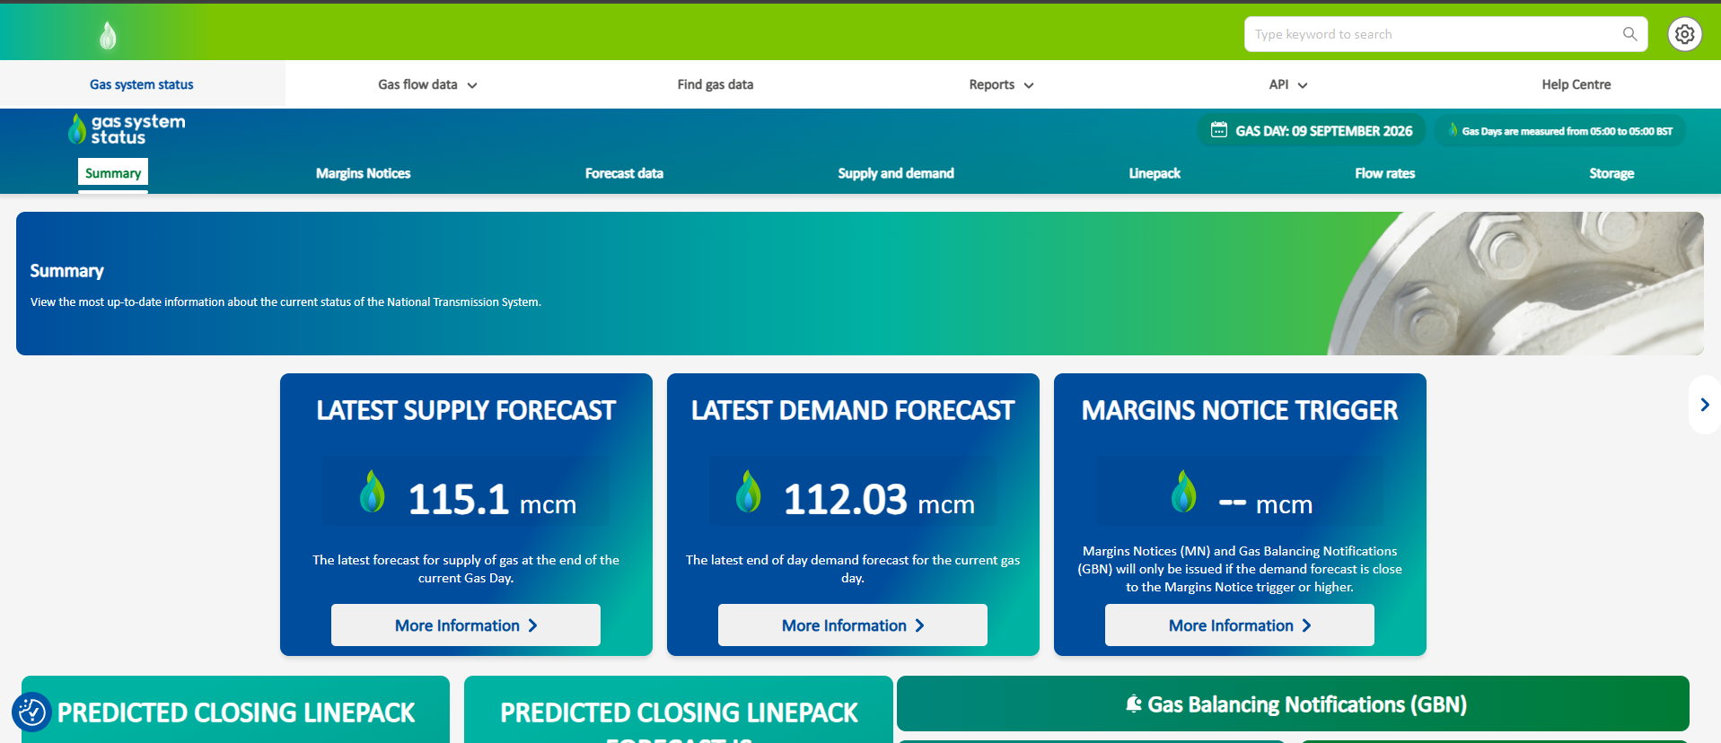
After selecting “Gas system status” button, please select “Margins Notices” from the sub banner, as shown above.
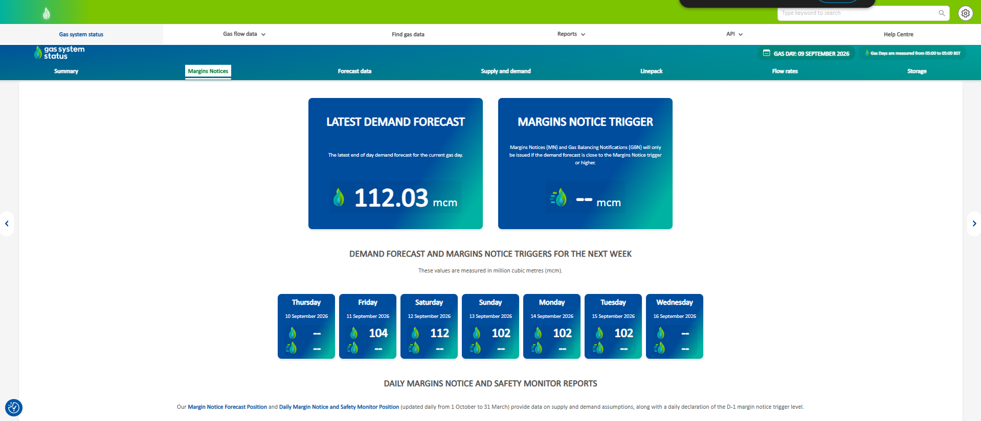
After selecting “Margins Notices” button, you can select either of the links shown above to take you that specific report’s landing page.
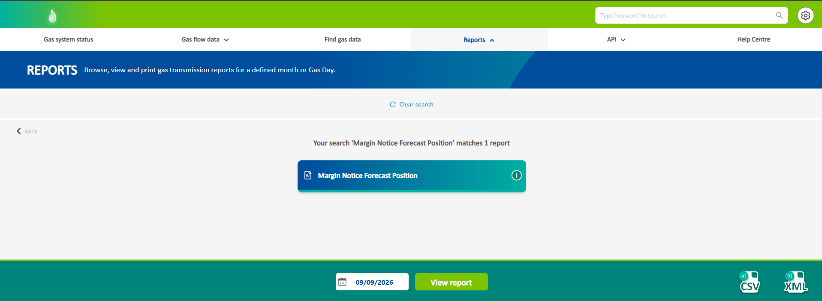
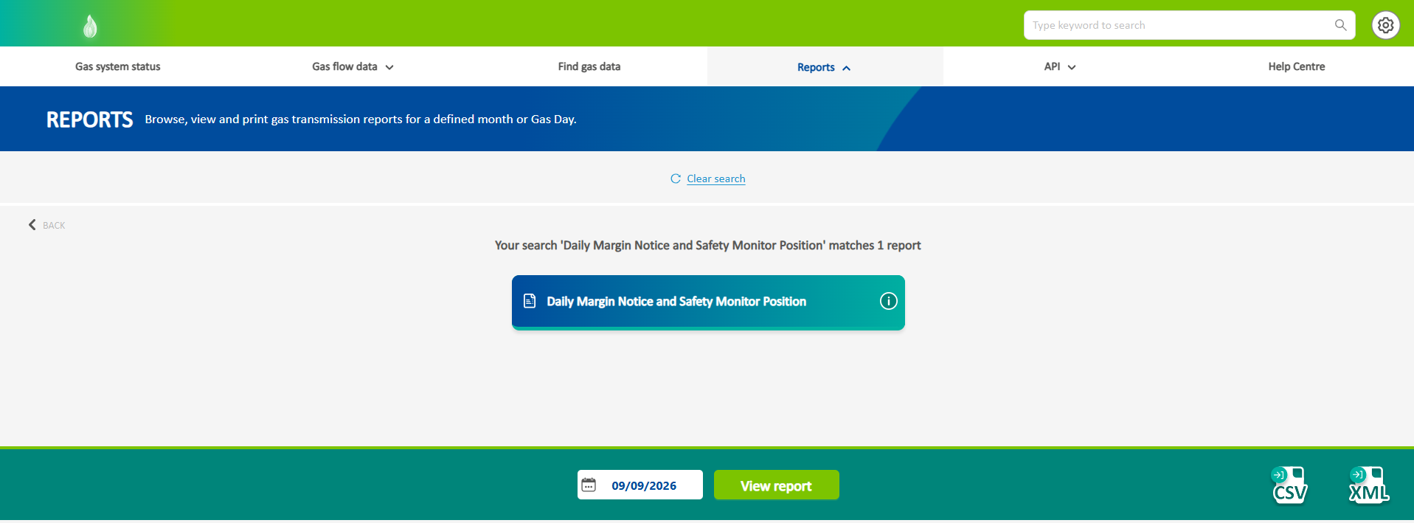
After selecting either of the links, users will be taken to the landing pages shown above. Once a report is selected, the relevant functionality buttons become enabled, as highlighted above. Users can then view the report for the selected day or change the date to access historical reports

