Transmission Planning Code
2021

Contents
Contents 1
1 The Transmission Planning Code 2
2 Legislative framework 4
3 Network capability planning 7
4 Entry capacity 16
5 Exit capacity 20
6 Network analysis and assumptions 23
7 Network development options 36
Appendices 41
8 Appendix A: Legislative framework 42
9 Appendix B: Policy and guidelines for NTS planning 46
10 Appendix C: Determination of the technical capacity of the National Transmission System - compliance with Regulation (EC) No 715/2009 55
11 Appendix D: Long-term scenarios 58
12 Appendix E: Accounting for uncertainties 62
13 Appendix F: Glossary 76

The Transmission Planning Code

Document scope
The National Transmission System (NTS) is the high pressure natural gas transportation system in Great Britain designed to operate at pressures of up to 94 bar(g). Gas is transported through steel pipelines from coastal reception terminals and storage facilities to large consumers (such as power stations and industrial sites), storage facilities and Distribution Networks connected to the system.
National Grid owns and operates the NTS and we have a duty to plan and develop the system in an economic and efficient manner. This document describes our approach to planning and developing the NTS in accordance with our duties as a gas transporter and other statutory obligations relating to safety and environmental matters.
We publish this document in accordance with Special Condition 9.11 of National Grid’s Gas Transporter Licence (the Licence). Special Condition 9.11 Part B has three requirements for the Transmission Planning Code (TPC), firstly it requires us to maintain a TPC that:

- must cover all material technical aspects relating to the planning and development of the pipeline system to which this licence relates that may have a material impact on persons connected to or using (or intending to connect to or use) that pipeline system.
Secondly that the TPC describes the methodology for determining the physical capability of the pipeline system to which this licence relates that specifies in detail how the licensee takes into account:
- its Entry Capacity release obligations pursuant to Special Condition 3.13 and its Exit Capacity release obligations pursuant to Special Condition 9.13
- the amount of capacity that may technically be transferred or traded between NTS Entry Points
- the impact of incremental gas flows on the capability of the pipeline system to which this licence relates at each NTS Entry Point and each NTS Exit Point
- the Statutory Network Security Standard.
The third and final requirement is that the TPC must include the detailed planning assumptions that the licensee uses in respect of:
- the likely developments it expects in the patterns of the supply of gas to, and the demand for gas from, the pipeline system to which the licence relates
- the likely developments it expects in the levels of the supply of gas through and the demand for gas from that pipeline system
- the likely operation of the pipeline system to which the licence relates for any given pattern or level of supply of gas or demand for gas.
We must comply with the TPC in planning and developing the NTS. We must also review the TPC at least every two years, after consultation with the gas industry. Modifications to this code must be approved by the Gas and Electricity Markets Authority (the Authority) before they can be implemented.

Document structure
This document is structured as follows:
- Section 2 describes the principal pieces of legislation that have a direct bearing on the planning of the NTS as well as providing more detail on the 1-in-20 Security Standard. Appendix A goes into more detail on this topic whilst Appendix B gives more detail on the policy and guideline documents referred to in the planning and development of the NTS.
- Section 3 provides a high-level overview of the Network Capability Planning process including the planning assumptions that we use in respect of the likely developments of NTS Supply and demand patterns and the levels of supply and demand.
- Section 4 and 5 describe the commercial entry and exit capacity release processes and their part in the network development process. These sections also include the methodology for determining: the amount of capacity that can be transferred or traded between NTS Entry Points and the impact of gas flows on the capability of the system at Entry and Exit points. Appendix C contains the methodology for the determination of the technical capacity of the NTS in relation to interconnection points to comply with EU Regulation EC715/2009.
- Section 6 describes the network analysis models and assumptions that underpin them. Appendix D gives greater detail on the long-term supply and demand scenarios assumptions used respectively. Appendix E gives an account of how we manage uncertainties within modelling.
- Section 7 describes the network development options that National Grid will consider when developing the NTS.
- Section 8.2.1 describes the Statutory Network Security Standard we adhere to.
- Appendix F gives a glossary of terms and acronyms commonly used in this document.

Gas Planning and Operating Standards (GPOS): Changes and impact
National Grid has reviewed the suitability of 1-in-20 Security Standard to ensure that it continues to meet the needs of customers within a framework of shifting external and demands.
Standard Special Condition A9: Pipe-Line System Security Standard refers to the ability to meet a 1-in-20 demand, taking account of such operational measures as are available to the licensee and including within day gas flow variations on that day. As the demands placed on the system evolve, and its changing use affects the impact of within day gas flow variation, National Grid needs to ensure that the system continues to develop and operate efficiently whilst still meeting these needs.

Legislative framework
National Grid is required to comply with certain legal requirements in the planning and development of the National Transmission System (NTS) in Great Britain. This section covers the principal pieces of legislation that have a direct bearing on the planning of the NTS as well as providing more detail on the 1-in-20 Security Standard. A full summary of relevant legislation, policies and guidelines is contained in Appendix A: Legislative framework.

Gas Act 1986 (as amended)
The Gas Act is the primary UK legislation that governs the transport and supply of natural gas within Great Britain.
Section 9 of the Gas Act states a Gas Transporter has general duties in the planning and development of their system, which are:
“(a) To develop and maintain an efficient and economical pipe-line system for the conveyance of gas; and
(b) Subject to paragraph (a) above, to comply, so far as it is economical to do so, with any reasonable request for him –
(i) To connect to that system, and convey gas by means of that system to, any premises, or
(ii) To connect to that system a pipe-line system operated by an authorised transporter.”
National Grid Gas plc is required to hold a Gas Transporter Licence in respect of our gas transportation activities for the NTS. This licence is granted and administered by the Gas and Electricity Markets Authority, (the Authority), established by the Utilities Act 2000.

National Grid’s Gas Transporter Licence in respect of the NTS
We are bound by the terms of its Licence. The Licence contains a number of Standard, Standard Special and Special Conditions that we must abide by in developing and operating the network and in conducting its transportation business. The Licence obligations that are relevant to the planning and development of the NTS are described below.

Standard Special Condition A9: Pipe-Line System Security Standards
This condition sets out the security standard for the NTS, which is that the pipeline system must, taking into account operational measures, including within day gas flow variations, meet the peak aggregate daily demand for the conveyance of gas to supply premises, which is

- having regard to historical weather data derived from at least the previous 50 years and other relevant factors, is likely to be exceeded (whether on one or more days) only in 1 year out of 20 years

Additional clarifications
The Pipe-Line System Security Standard does not define or refer to any demand levels at which NTS capability should be assessed, other than the peak 1-in-20 demand. There is also no reference to supply patterns or levels. However, the distribution of supplies across the NTS, for a given demand level, can significantly affect the capability to meet the minimum safety and contracted pressures that we have agreed with our customers.
The existing Pipe-Line System Security Standard also refers to within-day gas flow variations (i.e. supply and demand being out of balance) but it does not define the sources and magnitude of within-day variation that should be used to assess NTS capability.
The behaviour of these supply patterns and within-day gas flow variations is regularly reviewed, creating clearly defined event criteria against which NTS capability is assessed. Our principle aim is to assess network capability against any event or combination of events likely to occur on more than 1 day in any 20-year period. We will consider all appropriate network development options, which includes, for example, commercial constraint management actions, should the NTS have insufficient capability.

Pipelines Safety Regulations 1996
The Pipelines Safety Regulations (PSR) 1996 are the principal health and safety legislation in the UK concerning the safety and integrity of pipelines. They apply to all relevant onshore UK pipelines to ensure that these pipelines are designed, constructed, operated, maintained and decommissioned safely. They class certain pipelines that transport certain “dangerous fluids” as Major Accident Hazard Pipelines (MAHPs). All natural gas pipelines operating above 7 bar(g) fall into this category.

Gas Safety (Management) Regulations 1996
The Gas Safety (Management) Regulations (GSMR) 1996 require each gas transporter to prepare a safety case document that sets out in detail the arrangements in place to safely manage its gas network.
Schedule 1, paragraph 17 states that the safety case must contain:
“Particulars to demonstrate that the duty holder has established adequate arrangements to ensure that the gas he conveys will be at an adequate pressure when it leaves the part of the network used by him.”

Planning regime
We have legislative obligations relating to consent authorisations required when developing elements of the NTS in the form of the Planning Act 2008 and the Town and Country Planning Act 1990. Generally, the Planning Act 2008 will apply to the construction of NTS pipelines whereas the Town and Country Planning Act 1990 will apply to the provision of fixed assets such as compressor stations and pressure reduction installations.

Emissions
We have regulatory obligations relating to emissions placed upon us by the Environment Agency (EA), the Scottish Environment Protection Agency (SEPA) and Natural Resources Wales (NRW) for sites in England, Scotland and Wales respectively in the form of:
- The Pollution Prevention and Control (Scotland) Regulations 2012 (PPC)
- The Environmental Permitting (England and Wales) Regulations 2016 (EPR).
- Greenhouse Gas Emissions Trading Scheme Order 2020
These national regulations are driven, in part, by EU directives and policies such as:

- The Industrial Emissions Directive (IED)
- The Medium Combustion Plant Directive (MCPD)
- The European Union Emissions Trading System (EU ETS) within the UK

European Union regulations

Following the UK’s decision to leave the EU in June 2016 and the Trade and Cooperation Agreement that was subsequently signed between the UK Government and the EU in December 2020, the UK is no longer obliged to follow any new or amended EU Regulations and Directives. However, the European Union (Withdrawal) Act 2018 provided for EU law that existed prior to the UK’s exit to be incorporated into UK law, subject to the removal of inoperable provisions of EU Regulations as a consequence of the UK longer being an EU member state. Accordingly, rules relating to the operation of the NTS that were specified within the relevant EU regulations are now set out in UK legislation in the form of ‘Retained EU Law’. Effectively, this means that most of the obligations that National Grid was previously subject to in relation to EU Network Codes and other relevant EU Regulations continue to apply.

Security of Supply Regulation
The existing EU Regulation that has most relevance to this document, and that is contained in Retained EU law legislation, is Regulation (EU) 2017/1938, which aims to enhance security of supply by providing common assessment of EU member states’ energy security arrangements. Infrastructure resilience is measured against an N-1 standard; i.e. that in the event of a disruption of the single largest infrastructure, the remaining infrastructure has sufficient capacity to satisfy the total demand “during a day of exceptionally high gas demand occurring with a statistical probability of once in 20 years.” (Art. 5, para 1.). This obligation continues to apply to National Grid as retained EU law under The Gas (Security of Supply and Network Codes) (Amendment) (EU Exit) Regulations 2019.

Network capability planning
This section provides a high-level overview of the Network Capability Planning process, the National Grid’s Future Energy Scenarios (FES) consultation and Gas Ten Year Statement (GTYS).
Every year we undertake network capability planning over a ten-year planning horizon. Network capability analysis is developed using long-term supply and demand forecast scenarios developed through the FES process and other information gathered through commercial processes to book capacity on the system. Further details on the network analysis process and planning assumptions are contained in Appendix B: Policy and guidelines for NTS planning.

Future Energy Scenarios (FES) consultation
We are committed to stakeholder engagement so we listen to our stakeholders and act on what they tell us. The views of our stakeholders are crucial as we enter a period where the energy industry must meet the challenges of providing secure and affordable energy, replacing ageing assets and moving to low carbon sources of generation to meet environmental targets.
The annual FES consultation process, run by the National Grid Electricity System Operator (ESO), consists of a series of workshops, bilateral meetings, questionnaires and the FES conference. Through this process, the ESO listen to the views of stakeholders, engages in further discussion with them and acts on what they say when developing the next set of scenarios.
As the energy sector evolves at a rapid pace, so does our stakeholder base. The ESO continually review its stakeholder groups and engagement to capture the breadth and needs of stakeholders. During 2021, the ESO engaged with over 1700 stakeholders from the UK and abroad, which is an increase from 590 stakeholders in 2020. There is broad support for progressive, rather than radical, change in the scenarios which allows some consistency with previous years’ analyses.
FES questionnaires are circulated to a range of industry players (producers, importers, shippers, storage operators, delivery facility operators, transporters and consumers) requesting supply and demand forecast data and inviting views on underlying assumptions for supply and demand. Shippers are required to provide this supply and demand information under the UNC TPD Section O. Details of the FES stakeholder engagement process can be found on our website.
The FES document describes in detail the assumptions behind the main scenarios used in planning analysis and future energy scenarios. In the past, it produced a single forecast of gas and electricity demand. This approach no longer provides a sufficiently rich picture of possible energy futures. There are now four scenarios representing different views of probable futures. There are many possible futures, with considerable uncertainty regarding future levels of gas and electricity demand, sources of gas supply and levels of renewable generation. However, in Gas Transmission we believe that the four scenarios encompass the more probable future outcomes.

Planning cycle
We commence our annual planning cycle after the initial data has been gathered through the FES process. This data is used to compile long-term supply and demand scenarios. The process considers the capability that may be required to respond to entry and exit capacity signals from the market. We use detailed network models of the National Transmission System (NTS), under different supply and demand scenarios, to understand how the system may behave under different conditions over a ten-year planning horizon.
During this process, distribution network operators (DNOs) and NTS shippers can apply for exit capacity on the NTS to support their needs. NTS shippers may signal their requirements in the long-term entry capacity auctions under rules set out in the UNC.
We use the information received from these commercial processes to inform the final set of investments that are necessary to develop the system to satisfy our wider duties to develop and maintain the system in an economic and efficient manner. We will, primarily, consider:
- NTS capacity reserved through a Planning and Advanced Reservation of Capacity Agreement (PARCA)
- long term signals received for additional capacity above the prevailing obligated or contracted capacity levels, which can be met through capacity substitution
- long-term capacity bookings or reservations within obligated or contracted capacity levels.

Network capability analysis
We undertake network capability analysis to identify the ability of the NTS to accommodate a given supply and demand pattern, respecting the maximum and minimum pressure requirements of the network (including locational pressure cover described in Section 6.7.2), and the efficient and safe operation of the system.
Analysis may be undertaken to identify capability for different needs; for example, to identify the maximum flow that may be supported at an entry or exit point, or the level of exit flexibility that exists on the system. The type of analysis (steady state or transient) and supply and demand scenarios will vary according to the study required. However, the aim is to find the point at which the network becomes “constrained” i.e. has reached its limits for the given scenario.
We use this analysis to inform commercial capacity processes. For example, the level of flow that may be achieved at any network entry or exit point under certain supply and demand conditions compared to the obligations to release capacity to determine a “constraint volume” of gas at that entry or exit point. It should be noted that it is not possible to directly model the concept of capacity in the commercial sense within these physical network models as the entry and exit flow capability does vary from scenario to scenario.

Confirmation of existing projects
During the planning cycle, we analyse the first two years of the prevailing Investment Plan (See Section 4.4.2 of the Gas Ten Year Statement) to verify whether the projects sanctioned during previous planning cycles are still required. We consider:
- licence requirements to release obligated capacity levels
- commitments from entry capacity
- commitments on exit for flat capacity
- commitments on flexibility
- commitments on pressures.
We also maintain a regular dialogue with shippers, DNOs and developers to ensure that information on the progression of their projects is used to inform our investment decisions in a timely manner. In accordance with the UNC, shippers, DNOs and developers will be required to provide demonstration information to us to show that the customer project is proceeding before capacity is allocated and investment works commenced.
If we find that sanctioned projects are not required, as proposed through previous planning cycles (for example, due to changes in the underlying supply and demand forecasts, or new information becoming available), then analysis is carried out to determine for which year the projects should now be completed.

Investment planning analysis
Investment planning analysis is concerned with identifying the possible reinforcements that can be made to the pipelines and plant on the NTS to increase the capability of the system. We undertake investment planning analysis to determine the level of investment required to support changes to supplies and demands on the system.

Annual plan review
We check the network models developed during the annual planning cycle to ensure that:
- the correct planning assumptions are used
- project alternatives have been considered
- there is consistency across the ten-year planning horizon.
We document the audit findings in a plan review report alongside any recommendations for improving the network models and analysis techniques. This review document is used in the next planning cycle to update the network model and analysis assumptions.

Planning assumptions of flows of gas to and from the network
Figure 1 Simplified Network Capability Process
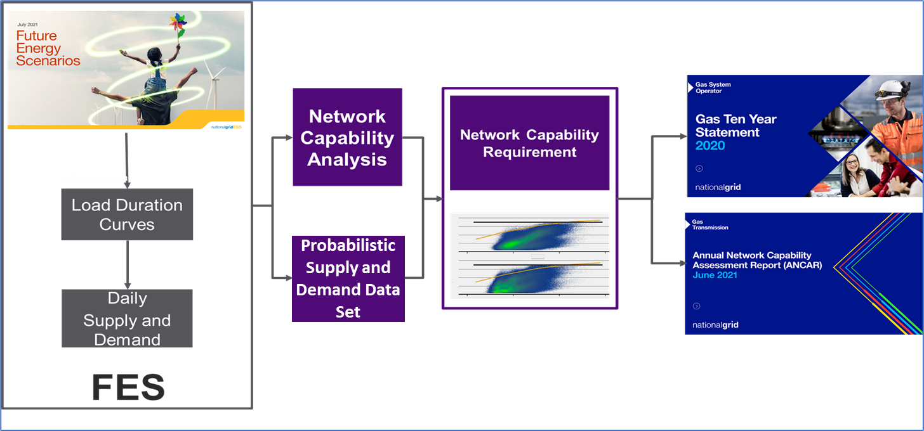
Network capability is the starting point for any new network development proposal as it indicates the network capability based on the current or proposed network. Overlaid on this capability is our projection of the future flows of supply and demand on the NTS. It is the combination of these two elements that allows us to assess the impact of these future flows on the network.
Figure 1 illustrates the process by which we take account of the likely developments in the pattern of flows of gas onto and off the NTS, and how the NTS will be operating into the future within a time frame that is necessary for planning purposes, expected to be the next 10 years.
The Future Energy Scenarios (FES) process is delivered independently by the Electricity System Operator (ESO) on behalf of the energy industry. It creates a range of plausible energy pathways out to 2050. National Grid Gas Transmission (NGGT) is a stakeholder both for the inputs and outputs of the FES process. This process is conducted on an annual basis and is stakeholder lead.
For a full understanding of the FES process and methodologies applied see the ESO FES methodology document and, more specifically, for the gas demand methodology see the Gas Demand Forecasting Methodology.
The FES publication provides annualised data outputs. These are then converted, by the ESO, into balance sheets. Balance sheets give flow values for all the supply and demand points on the NTS for each day and year, in any scenario. They also ensure that supply and demand balance. This process is executed through various models which are updated with data from stakeholders, historical profiles and our network analysts’ insights.
The values in the balance sheets are first used to create the Network Capabilities for all the Entry and Exit zones; that is the physical limits that the NTS zones can accommodate. For the Entry capability, the supply flows into an Entry zone are maximised to a point just before anywhere on the Network would be beyond an obligation or its working parameters. For Exit, the 1 in 20 demand value, for the zone in question, is used.
The balance sheet values are also used to create the Probabilistic Supply and Demand Data Set. The Probabilistic Supply and Demand Data Set model takes as its inputs the supply and demand information from the balance sheet. For every day of each chosen year, the model applies seven different composite weather variables (CWV) to the distribution network exit points on the NTS. It randomises the demand from NTS connected power stations, and it uses regression analysis on the effects of CWV on interconnectors, storage and direct connect industrial sites. The result is a set of 980 unique data points covering the range of potential supply and demands for each day and 357,700 data points for any year. These points are mapped onto our flame charts. This exercise can be carried on any chosen year out to 2050.
Each year, as new FES data becomes available, we carry out these analyses and publish our findings, as well as the methodology used, in the Annual Network Capability Assessment Report (ANCAR). We also release the data that is behind the frequency flow distribution both for Entry and Exit.
The ANCAR examines in detail the potential flows for the next ten years but uses as a backdrop the data beyond that period to give us a general direction of travel of gas flows. These flows are set against the current Network Capability. Consequently, an assessment of the frequency of any potential breaches of the network’s capabilities over the next ten years can be assessed. Appropriate remedial actions can then be formulated, these could be commercial or, if considered appropriate, the Gas Network Development Process, known as ND500, can be instigated.

Gas Ten Year Statement
The Gas Ten Year Statement (GTYS) details our latest supply and demand scenarios, proposed system reinforcement projects and investment plans. It is published at the end of the annual planning process and provides the platform on which the next annual planning process is built. In the GTYS we describe the projects that are determined to be part of our final Investment Plan. We will have considered any capacity reserved or allocated via a PARCA, as well as information received from the long-term entry and exit capacity bookings made by DNOs and shippers.
Since 2016 we publish the Gas Future Operability Planning (GFOP) document alongside the GTYS. This provides a clearer means to engage with stakeholders on the operability challenges facing the NTS in the future.

New Projects requiring entry or exit capacity
From time to time, there are enquiries made by customers on new projects designed to deliver additional gas supplies into the UK market or connect new storage facilities, interconnector pipelines or loads to the system.
We will discuss such prospective projects with customers to help them develop viable projects that deliver benefits for the UK security of supply. Both a physical connection and commercial capacity rights are required to physically input gas to, or offtake gas from, the NTS. These are currently acquired through separate processes; please refer to Section 4 Entry capacity and Section 5 Exit capacity.

Physical connection
For a customer to connect to the NTS, or to modify an existing NTS connection, they must first progress through stages of the formal application process for connection offers. This process starts after initial contact with us and varies depending upon the customer requirements. For example, initially, the customer can request and pay for us to provide an:
- indicative view of the connection layout
- overview of the engineering and design work which would be required (including any specific studies)
- early estimate of construction costs should they wish to continue along the connections process.
Prior to a detailed design stage and construction of the physical connection, the customer will be required to pay us to provide a formal offer for the connection to specify amongst other things:
- a connection completion date
- a programme of work
- delivery of specific design/engineering study reports
- a construction agreement.
The timescales for us to deliver outputs for each stage of the connections process will depend upon the stage itself and complexity of the project. On completion of each stage of the connections process, the customer can exit the process. The connections process is summarised in Figure 2 and Figure 3.
Following Project CLoCC (Customer Low Cost Connections), a Network Innovation Competition project, we have delivered changes to the connections process. Customers can now use an online gas connections portal to get an indication of connection options without incurring any costs. This allows customers to assess a number of possibilities before progressing to an application.
The concept of standard design connections was also delivered by Project CLoCC which, if suitable for a customer’s project, can reduce the time and cost of the connection offer and connection build.
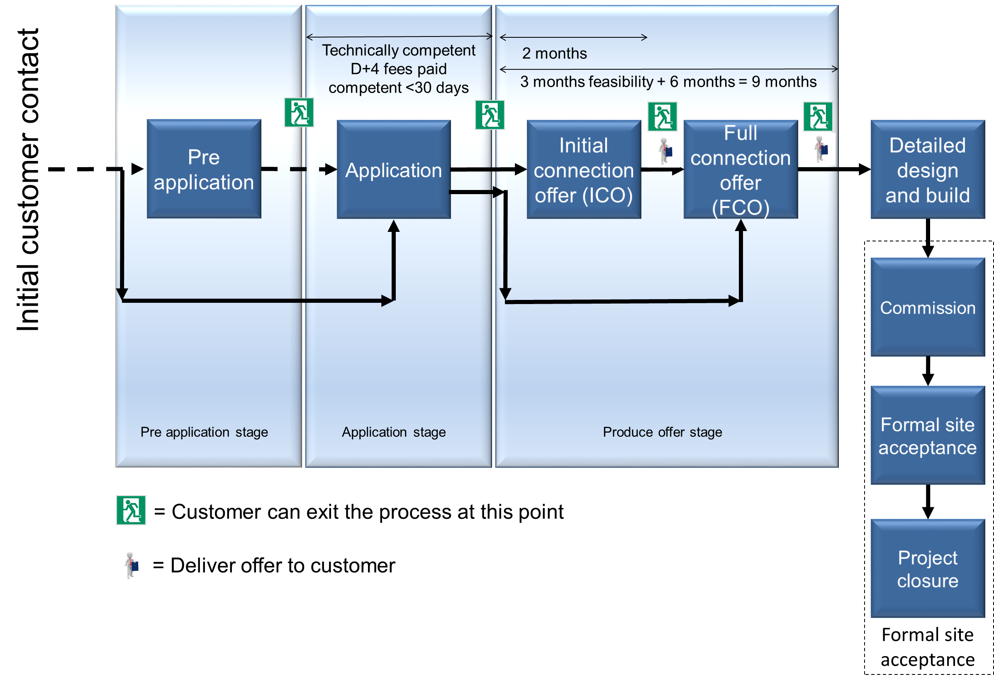
Figure 2 Connection application and offer stages with likely timescales
Figure 3 Connection applications stages
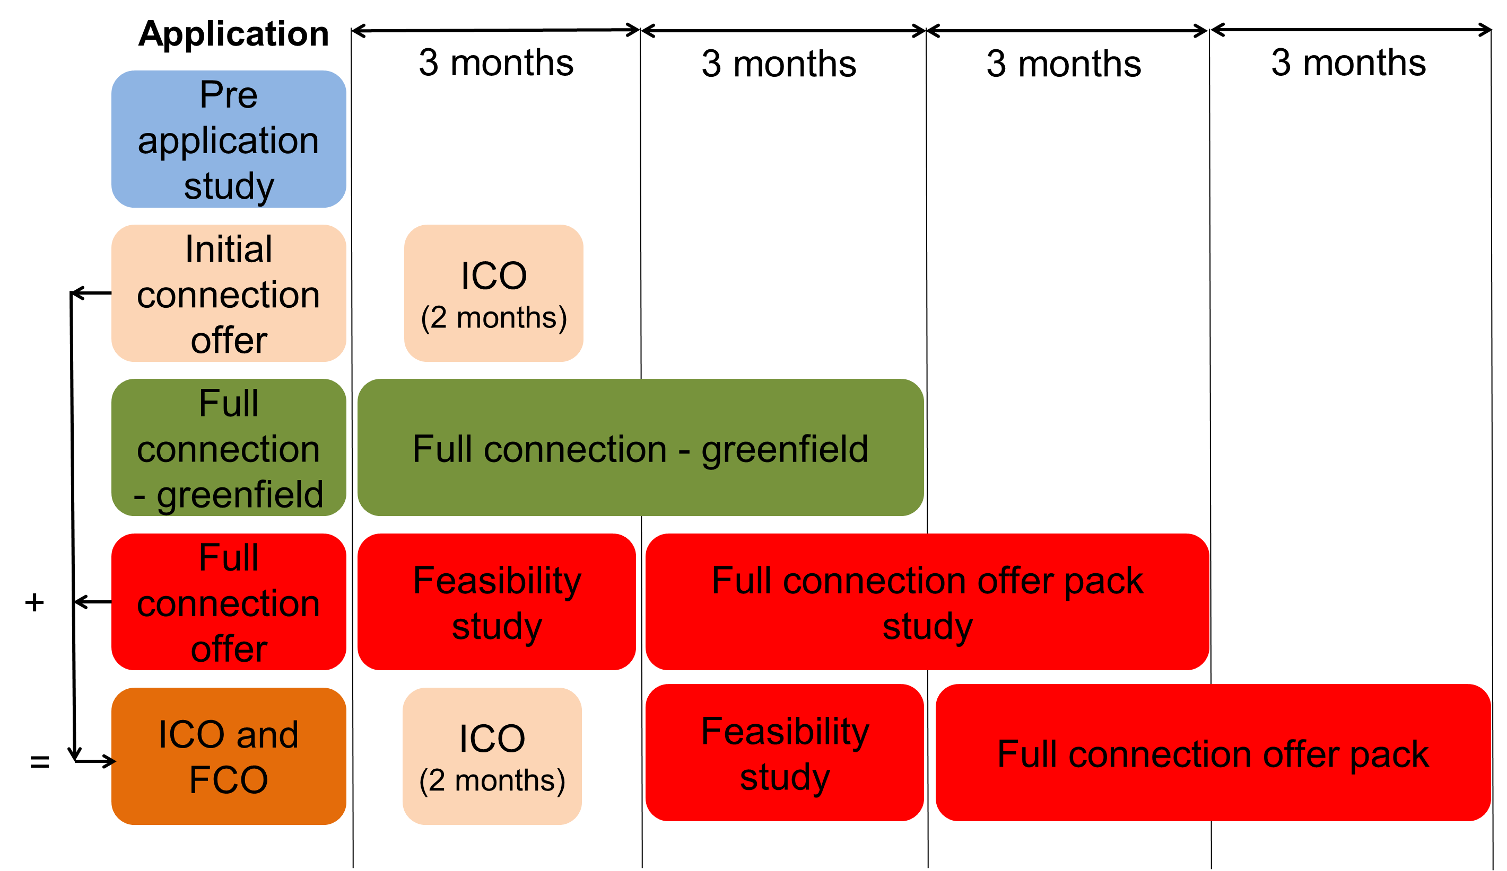

Securing entry and exit capacity
Users of the system should obtain entry and/or exit capacity rights on the NTS to flow gas. This may also trigger additional investment that may be required to support their potential gas flows onto and out of the NTS under the prevailing commercial arrangements described in the UNC. Currently, to trigger entry investment, firm NTS entry capacity and firm NTS exit capacity, requiring specific exit reinforcement to the system, can only be reserved and allocated through the signing of a PARCA with us.
A PARCA is a multi-phased bilateral contract, between us and a customer. It allows firm quarterly system entry capacity and firm enduring annual NTS exit (flat) capacity to be reserved for that customer, whilst they develop the initial phases of their own project. Any NTS capacity initially reserved via a PARCA would, subject to a need case for that capacity being sufficiently demonstrated and any necessary planning permissions being received, be allocated exclusively to the PARCA applicant or, where the PARCA applicant is not a UNC party, an NTS user(s) nominated by the PARCA applicant.
A PARCA would facilitate customers approaching us early in the development of their own project. They can reserve NTS entry and exit capacities without the need to fully financially commit to the formal capacity booking at that stage. Security is later required for reserving the capacity in phase 2 of the PARCA. This process thereby reduces a potential barrier to participation.

It should be noted that there may be a lead-time associated with customers obtaining access to the system. Under the requirements of the Planning Act, the anticipated lead time for the delivery of most reinforcement projects is up to 7 years (84 months). Customers are encouraged to enter into discussions with us at an early stage so that they fully understand the processes required to connect and use the system.
A PARCA is split into a number of phases with each phase designed to deliver a subsequent stage of Planning Act requirements.
Table 1 illustrates a generic timeline that was developed by us which illustrates the process steps leading up to a submission to the Planning Inspectorate and how the PARCA process overlays these steps.
For a more full description see our Planning and Advanced Capacity Agreement guide.

Table 1 PARCA phases with reference to the Planning Act
PARCA phase | Planning Act stage | Activity | Duration
0 |  | Pre-contract discussion between us and the customer
1 | Strategic Optioneering | Establish the need case and identify technical options | Up to 6 months
2  Page 12 |  | Develop Strategic Options Report (SOR) | Up to 6 months
 | Outline Routing and Siting | Identify preferred route corridor and siting; conduct studies | Up to 15 months
 | Detailed Routing & Siting | Undertake EIA (Environmental Impact Assessment) & detailed design | Up to 24 months
 | Development Consent Order (DCO) Application preparation | Formal consultation, finalising project, preparation of application documentation
 | DCO Application, Hearings and Decision | Submission and examination | Up to 15 months
 |  | Approval process
3 | Construction | Capacity bought by customer and  National Grid construction programme | Up to 24 months

Alternatives to investment
When considering a customer’s request for incremental capacity, in addition to physical investment, we will also consider all commercial options and operational arrangements that are available to us to determine the most efficient overall solution. These are described in more detail later in Section 7.

Securing entry and exit capacity at interconnection points
Separate processes to trigger investment at interconnection points (IP) came into force on 1st April 2017. These processes have some common aspects to the PARCA process that applies at non-IP, by providing a clear and structured process to signal interest in incremental capacity and the provision by us, in conjunction with adjacent transmission system owners (TSO), of technical reports to confirm the mechanisms, timescales and costs for the provision of this capacity. The differences in the two approaches derive from the need to develop joint proposals between adjacent TSOs, for which regulatory approval needs to be obtained, and are reflected in changes to the stage of the process analogous to phase 1 of a PARCA.
It should be noted that there may be a lead-time associated with customers obtaining access to the system. Under the requirements of the Planning Act, and combined with the extended timescales associated with the incremental process at IP, the anticipated lead-time for the delivery of most reinforcement projects is up to eight years and six months (102 months). Customers are encouraged to enter into discussions with us at an early stage so that they fully understand the processes required to connect and use the system.
The incremental process at IP is split into phases with each one designed to deliver a subsequent stage of Planning Act requirements. An approximate mapping to the phases of the PARCA process is given in Table 2.

Table 2 PARCA phases for interconnection points with reference to the Planning Act
PARCA phase | IP process | Planning Act stage | Activity | Duration
0 |  |  | Pre-contract discussion between us and the customer
1 | Market Demand Assessment | Strategic Optioneering | Establish the need case | Up to 4 months
 | Design Phase |  | Identify technical options | Up to 8 months
 | Regulatory Approval |  | Regulatory approval | Up to 6 months
2 |  |  | Develop Strategic Options Report (SOR) | Up to 6 months
 |  | Outline Routing and Siting | Identify preferred route corridor and siting; conduct studies. | Up to 15 months
 |  | Detailed Routing & Siting | Undertake EIA (Environmental Impact Assessment) & detailed design | Up to 24 months
 |  | Development Consent Order (DCO) Application preparation | Formal consultation, finalising project, preparation of application documentation
 |  | DCO Application, Hearings and Decision | Submission and examination | Up to 15 months
 |  |  | Approval process
3 |  | Construction | Capacity allocated to customer and National Grid construction programme | Up to 24 months

The Market Demand Assessment window was completed for the first time on 1 April 2017. Subsequent windows will open every two years and they are triggered by the opening of the annual yearly auction.

Entry capacity
This section covers the commercial entry capacity release processes and their part in the network development process.

Long-term system entry capacity
We make National Transmission System (NTS) entry capacity available in a series of auctions. Signals (bids) received from long-term auctions are used within the planning process to inform the need for investment. The quarterly system entry capacity (QSEC) auction can also be used to trigger additional capacity release via entry capacity substitution. Where specific reinforcement to the system is required, to meet a request for incremental NTS capacity, it will only be released where a Planning and Advanced Reservation of Capacity Agreement (PARCA) has been signed (please see Section 3.5.2 for more information on PARCAs).
At non-interconnection points, we must, under the terms of our Licence, prepare a proposal for releasing funded incremental obligated entry capacity, as a result of a signed PARCA. This proposal is then submitted to the Authority for approval. In addition, the Uniform Network Code (UNC) requires that notification of entry capacity allocations to shippers who have bid in the QSEC auction occurs within two months of the end of the auction invitation period.
A similar process now exists at interconnection points, beginning with a demand window and involving consultation on the proposal prior to submission to the Authority.
To fulfil our obligations, under both the Licence and the UNC, within the required notice periods, we will undertake network analysis before the annual long-term auctions. The basic steps that will be taken before and after the long-term auctions are shown in Figure 4 and they are described in the following sections.

Development of supply and demand scenarios
Supply and demand scenarios are determined using the latest Future Energy Scenarios (FES) data as described earlier in this document. For entry capacity assessment, other demand scenarios may be used to test demand sensitivities. Demand is assessed at peak 1-in-20 conditions, average conditions and severe conditions, as appropriate, through the load duration curve. Analysis is undertaken for each relevant year of the planning horizon.
More information can be found in Appendix D: Long-term scenarios.

Network capability analysis for entry capacity
Network capability analysis is undertaken to identify the capability of the NTS to support required flow patterns under the supply and demand scenarios developed from the FES scenarios.
We review entry projects, sanctioned in previous planning cycles, to verify if they are still required. During the review, we also consider:
- licence requirements to release obligated capacity levels
- commitments from entry capacity
- commitments on exit for flat capacity
- commitments on flexibility
- commitments on pressures.
We also maintain a regular dialogue with shippers, distribution network operators (DNOs) and developers to ensure that information on the progression of their projects are used to inform our investment decisions in a timely manner. In accordance with the UNC, shippers and developers will be required to provide demonstration information to us to show that the customer project is proceeding before capacity is allocated and investment works commenced.
If it is found that sanctioned projects are not required as proposed through previous planning cycles (for example, due to changes in the underlying supply and demand forecasts, or because of new information provided to us by shippers or new information made available in the public domain) then analysis is carried out to determine in which year the projects should be completed.

Investment planning analysis for entry capacity
Investment planning analysis is undertaken where:
- a shortfall, or bottle neck, is observed in the capability of the NTS to support the required flow under the supply and demand patterns tested
- alternative commercial solutions are not economic, under the terms of the Entry Capacity Release Methodology Statement (ECR).
Each supply and demand scenario may generate several investment projects for consideration if the supply patterns vary away from the FES scenario supply patterns.
An indicative investment plan is determined by considering investment projects and other options across the range of supply and demand scenarios. This is done to develop options that best meet the anticipated flow patterns of the system, whilst paying due regard to our wider NTS’s obligations. These obligations include, but are not limited to, to developing the NTS in an economic and efficient manner and to maintain a safe and secure system. At this stage these investment projects are only viewed as indicative. They may be modified in the light of further detailed analysis and investigation. These supplementary analyses may also consider routeing or siting difficulties arising from environmental, safety and wider societal impacts.
The indicative investment plan is updated subject to demonstration information associated with customer driven projects. If required, the FES scenarios are adjusted accordingly.

Analysis of long term system entry capacity signals
Whilst the QSEC and IP annual yearly auctions provide an important source of planning information on the levels of user commitment for baseline capacity, it is only through the signing of a PARCA that incremental entry capacity requiring network investment can be released. The final investment plan, for the annual planning cycle, is determined after consideration of any capacity reserved or allocated via a PARCA, as well information received from the long-term QSEC and IP annual yearly auctions and incremental capacity release processes.
Shippers can place entry capacity auction bids in accordance with the rules set out in the UNC. Once the auction information is received, we apply the ECR methodology in line with our duty under the Licence to determine whether additional entry capacity should be made available at any entry point and the amount of incremental entry capacity that should be made available.
Under our UNC obligations, 24 months is available to us to release capacity, identified through a PARCA, following allocation of capacity via a QSEC auction. Where possible, we carry out analysis ahead of an auction to identify what investment could be required considering any capacity reserved or allocated via a PARCA and an anticipated pattern of bids. This analysis may need to be modified if an unanticipated pattern of bids is received in an auction.
We can only permanently increase the level of entry capacity at an aggregated system entry point (ASEP) having first assessed how much entry capacity may be substituted to meet the increase in accordance with the terms contained within its entry capacity substitution methodology statement (ECS). Entry capacity substitution is the process of substituting unsold firm entry capacity from one or more ASEPs to another ASEP where demand for entry capacity exceeds the available obligated capacity quantities for the relevant period.
We are also required to submit an incremental obligated entry capacity proposal to the Authority. It must describe how much incremental obligated entry capacity has been released as a result of applying our ECR methodology.
Figure 4 Entry capacity investment planning process

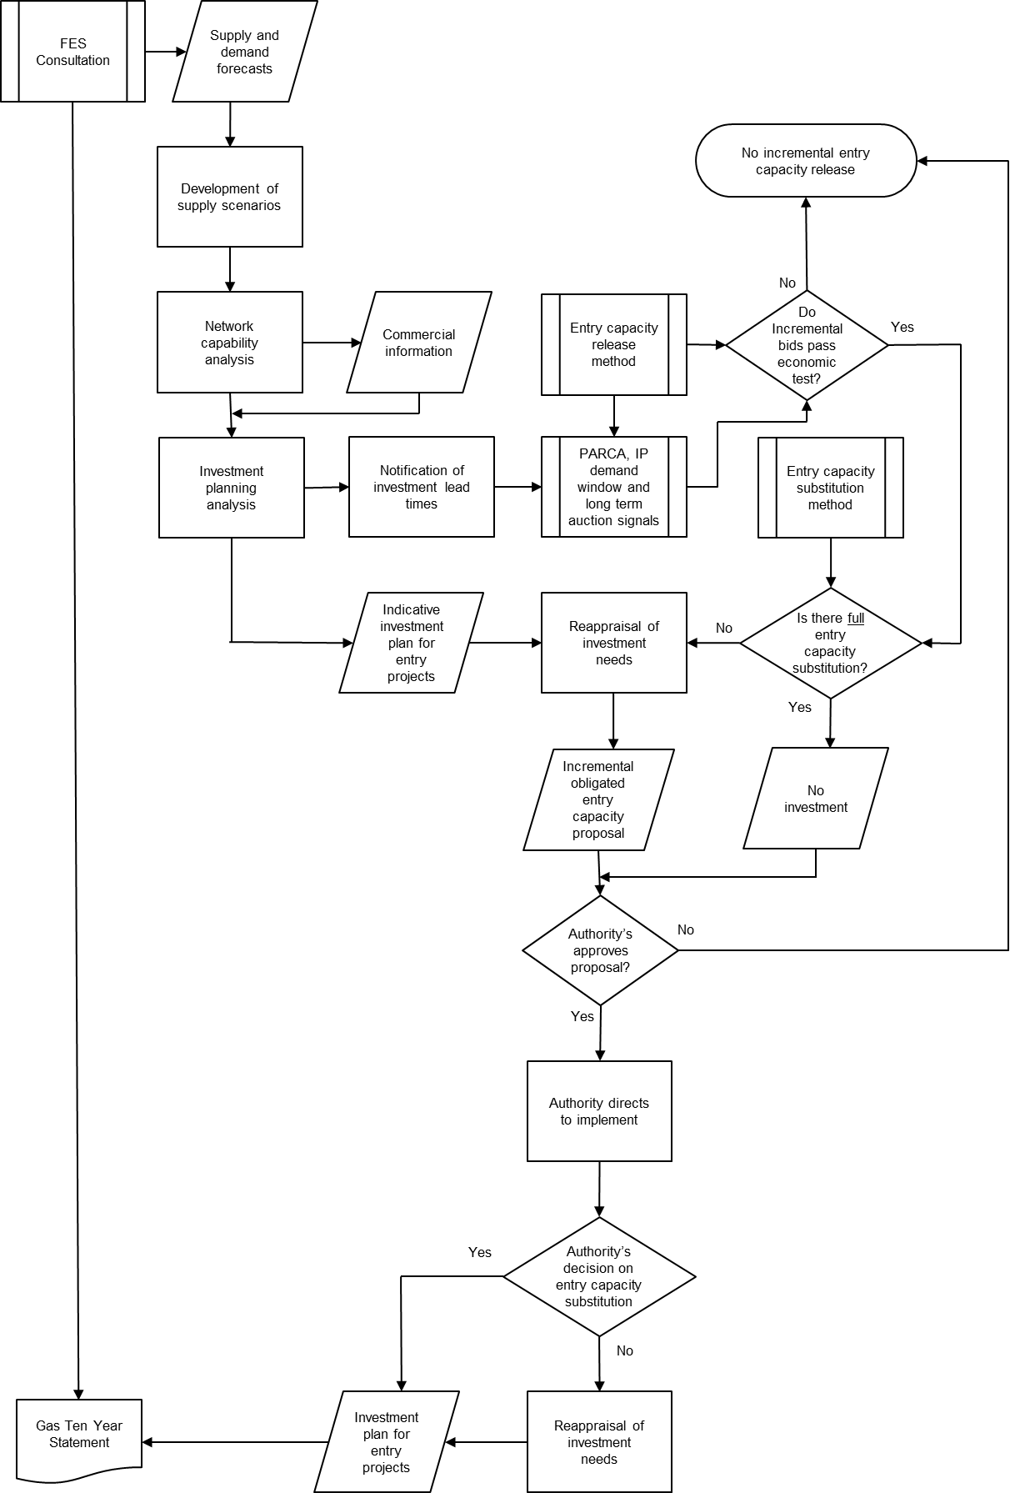
We do not undertake analysis for entry capacity transfer and trade processes as part of our planning cycle, as these are only applicable in the shorter term and so do not form part of the long-term investment process. These processes are described in the Entry Capacity Transfer and Trade Methodology Statement (ECTT).
We do not proceed with projects identified to deliver incremental obligated entry capacity if either of the following cases apply:
- Insufficient user commitment has been signalled, through a combination of capacity reserved and allocated through the PARCA arrangements and the QSEC auction, to justify the economic case for these projects.
- The Authority determines that we should not implement the incremental obligated entry capacity proposal made by us under Special Condition 9.17 of our Licence.
We re-evaluate projects identified to deliver incremental obligated entry capacity where the incremental entry obligated capacity proposal is modified in line with Special Condition 9.17 of our Licence.
We believe that such actions are consistent with our wider obligations to develop the NTS in an economic and efficient manner.

Exit capacity
This section covers the commercial exit capacity release processes and their part in the network development process. We are required by our Licence (Standard Special Condition A57. Exit Capacity Planning) to have in place processes and to undertake activities for the purpose of managing its NTS exit capacity planning and ensuring its booking process is efficient, for all the parties involved, to a reasonable and proportionate extent.

Long-term exit capacity bookings
The processes used to book long-term exit capacity differ from those used to book long-term entry capacity.
Under enduring exit capacity arrangements (from 1 October 2012), National Transmission System (NTS) exit (flat) capacity for both distribution network operators (DNOs) and shippers must be secured through one of the following:
- an annual application window (held in July of each year)
- an ad-hoc application (between October and June of the gas year)
- a Planning and Advanced Reservation of Capacity Agreement (PARCA).

Under Commission Regulation (EU) 2017/459 (which has been adopted into UK legislation), which is the EU network code on capacity allocation mechanisms, from 1 November 2015 long-term interconnection point (IP) exit capacity must be secured through the IP annual yearly auctions, detailed in the European Network of Transmission System Operators for Gas (ENTSOG) auction calendar.
Where specific reinforcement to the system is required, developers can only secure capacity through a PARCA. NTS exit (flexibility) capacity and pressure requirements for DNOs can be indicated through the PARCA process and, subject to the allocation of capacity via that process, will continue to be booked through the Offtake Capacity Statement (OCS) process.
Further detail on the release of exit capacity on the NTS is given in our Exit Capacity Release Methodology Statement (ExCR).
The exit process is illustrated in Figure 5 and discussed in more detail in the following sections.

Development of supply and demand scenarios
We develop supply scenarios for assessing changes to exit capacity bookings that focus on local sensitivities to supply conditions that are known to exist on the NTS. For example, supply scenarios may be developed to explore the conditions on a part of the network when liquefied natural gas (LNG) importation or storage withdrawal is assumed, compared to the situation where LNG importation is not present and storage injection is required. Demand scenarios assessed may include several possible demand sensitivities at each level of demand analysed, for example where demand flows:
- occur in line with Future Energy Scenarios (FES) for all exit points on the NTS
- occur in line with DNO OCS bookings and FES scenario flows for directly connected NTS loads
- are associated with storage sites and interconnector pipelines
- are associated with large loads or loads located in sensitive areas of the network.
The demand sensitivities are developed according to the location of the exit capacity being assessed.
Demand is assessed at peak (1-in-20 conditions), and at average and severe conditions through the load duration curve (as appropriate). Analysis is undertaken for each relevant year of the ten-year planning horizon. More information on the topic can be found in Appendix C: Determination of the technical capacity of the National Transmission System - compliance with Regulation (EC) No 715/2009.

Network capability analysis for exit capacity
Network analysis is undertaken during the OCS exit capacity allocation processes to identify the existing capability of the NTS to accommodate changes in the NTS exit (flat) capacity requests made by DNOs. Further capability analysis may be undertaken from time to time because of enquiries made by customers to connect new loads to the NTS or increase existing loads on the system, typically via a PARCA.
Exit projects previously identified will be reviewed to verify whether the projects are still required. We also maintain a regular dialogue with shippers, DNOs and developers to ensure that information on the progression of their projects are used to inform our investment decisions in a timely manner. In accordance with the Uniform Network Code (UNC), shippers and developers are required to provide demonstration information to us to show that the customer project is proceeding before capacity is allocated and investment works commenced.
If it is found that sanctioned projects are not required as proposed through previous planning cycles (for example, due to changes in the underlying supply and demand scenarios, or as a result of new information provided to us by shippers or new information made available in the public domain) then analysis is carried out to determine in which years the projects should be completed. More information on this process can be found in Section 7 Network Development options.

Investment planning analysis for exit capacity
Investment is undertaken for requested increases in NTS Exit (Flat) Capacity where alternative commercial solutions are not economic; subject to the signing of a PARCA and under the terms of the ExCR. Such increases may require a feasibility study to be initiated to assess possible options in order that the appropriate investment planning analysis may be undertaken. Investment is not undertaken on the NTS for increases in NTS Exit (Flexibility) Capacity or Assured Offtake Pressures (AOP).
NTS Exit (Flexibility) Capacity and requests for increases in AOP within the capability of the system will be allocated to DNOs through the OCS process.
We assess requests for changes in the following order:
- NTS Exit (Flat) Capacity
- NTS Exit (Flexibility) Capacity
- AOP.
Off-peak data, provided by DNOs under the UNC OAD Section H process, is not treated as a long term booking of NTS Exit (Flat) Capacity or NTS Exit (Flexibility) Capacity.
Parties that are directly connected to the NTS are required to register capacity in the short term under the process defined by the UNC TPD Section B.
Increases in exit capacity may be requested in line with the ExCR. We can only permanently increase the level of exit capacity, at an exit point, subject to the signing of a PARCA. We must first assess how much exit capacity may be substituted to meet the increase as a result of applying its Exit Capacity Substitution and Revision Methodology Statement (“ExCS”). Exit capacity substitution is the process of substituting unsold NTS exit baseline capacity from one or more NTS Exit Points to another NTS Exit Point where demand for exit capacity exceeds the available capacity quantities for the relevant period.
Enquiries may be made at any time about potential increases in load, or new loads connecting to the NTS, although there may be a lead time before additional capacity can be made available. Information on new and existing loads is collected through the FES process, so the annual planning cycle includes the best-known information to us on directly connected NTS loads, including any previous enquiries made by Shippers or developers. Any investment required as a result of load enquiries received by us will therefore be consolidated into the next or future planning cycles.
Figure 5 Exit capacity investment planning process
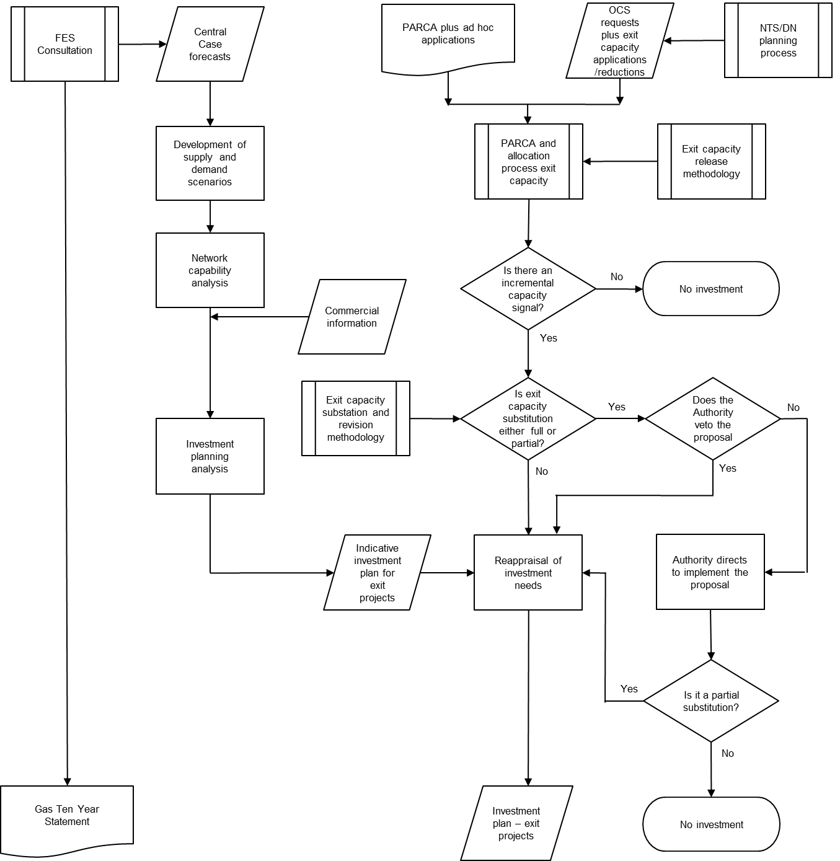

Network analysis and assumptions
This section covers the network analysis models and the assumptions that underpin them.

Basis of network analysis models
We use network analysis software to undertake planning analysis. The software allows the user to work with a detailed mathematical model of the National Transmission System (NTS) to understand the likely flows and pressures on the system given set of supply and demand assumptions. The user can vary the parameters of the model, including the supply and demand data to understand the physical limitations of the network. New pipelines, compressors and regulators are added to existing points on the model, as required, to overcome system constraints. The model is then used to analyse the enhanced network.
The network analysis undertaken for the NTS is derived from a base network model known as the Master Network. This contains the key elements of the NTS including pipes, valves, regulators and compressors. These components are the main elements to control and route the flow of gas through the system from supply points to offtakes.
The Master Network is generated at the beginning of the annual planning cycle and it includes all pipelines and plant planned for completion for the first winter in the ten-year planning horizon. The Master Network is validated using actual operational data from a high demand day from the previous winter period, in accordance with IGEM/GL/2. The findings of the validation exercise are included in the Master Network.
The Master Network does not contain any supply or demand information. The supply and demand data is entered into the network for the scenarios requiring study. These scenarios are analysed until the network reaches a mathematical solution. Further analysis is undertaken as necessary to reconfigure and reinforce the system to ensure that the flow pattern is within safe plant and pressure limits. All network models are traceable back to the parent Master Network for that planning cycle.

Analysis assumptions
On the NTS there are two critical times during the gas day for analysis, the times associated with maximum and minimum linepack (gas stock) in the system.
Maximum linepack is usually available close to the start of the gas day; typically, at 06:00. This linepack can then be used over the day to meet diurnal fluctuations in supply and demand, typically reaching a minimum at 22:00. The 06:00 and 22:00 times are used for planning purposes, although maximum and minimum linepack conditions observed on a gas day can vary around these times, depending on the prevailing flow patterns within the system.
These conditions may be modelled individually through steady state analysis or concurrently using transient analysis with suitable supply and demand profiles. These profiles reflect the drivers of linepack depletion, through supply profiling, diurnal demand behaviour and demand behaviour of gas fired power stations. Derived profiles can be based on commercial obligations, historic behaviour or future commercial requirements.

Steady state analysis
Long-term planning analysis (undertaken more than a year ahead of the gas day) can be carried out using steady state network analysis when looking at broader trends and behaviours as this gives a reasonable approximation of the likely network conditions. It is quicker than transient analysis and can be appropriate once forecasting uncertainties increase. Steady state analysis assumes that flows are not profiled across the gas day, and so can be used as a tool to help identify the capability of the transmission system. We also utilise steady state analysis as a comparative and investigative tool before doing transient analysis, especially in capability analysis.
A steady state network with linepack maximised can be used to represent the near start of day condition (06:00) and a network with linepack minimised can be used to represent the minimum stock condition (22:00).
Where projects or constraints have been identified using steady state, transient modelling is conducted to investigate and refine potential solutions.

Transient analysis
Transient analysis models the changes that may be seen within a gas day. Flow profiles for supplies and demands are entered, along with changes in operating set points for compressors and regulators, to understand variations in pressure, flow and linepack across the system through the day.
Transient networks used for network capability analysis and investment planning analysis are analysed and solved to ensure that minimum pressures at 06:00 and 22:00 are not breached, and the total NTS linepack levels are maintained to ensure linepack balance across the day.

Within-day flow variations
Historically, diurnal storage capability, or the ability to meet demands with a daily profile, had been provided predominantly by the Local Distribution Zones (LDZs) i.e. the regional transmission systems and connected low pressure distribution networks, with some support from the NTS.
The Distribution Networks (DN) sell-off created a requirement to formalise the agreement of NTS diurnal storage support and agreed offtake pressures for the DNs. An NTS exit (flexibility) capacity product was defined which allows the DNs to profile their offtake flows and hence gain access to diurnal storage support, which is accessed through the Offtake Capacity Statement (OCS) process.
As the use of the NTS has evolved, the usage of this diurnal storage capability has increased, not only from DN requirements, but through gas fired power generation responding to the changing electricity market conditions. On the supply side, there is increased profiling behaviour as the supply make-up moves increasingly to larger and more commercially responsive interconnector, Liquefied Natural Gas (LNG) and storage sites.
The ability of the NTS to provide diurnal support is largely as a by-product of the DNs varying pressure requirements. The DNs require their highest pressures close to the start of the gas day (typically 06:00) when their linepack and hence pressures are highest but require lower pressures towards the end of the gas day when their linepack levels and hence pressures are at their lowest (typically 22:00).

Planning for within-day flow variations
Within-day flow variations are factored into the planning of the NTS through two distinct approaches, foreseeable and unforeseeable. Foreseeable within-day flow variations include:
- DN offtake profiles to meet the DN demand profile
- gas fired power generation profiles to meet the electricity demand profile
- supply behaviour, flat or profiled.
These can be modelled explicitly as network models can be built and analysed based on historic or forecast offtake and supply profiles. The underlying assumption is that these can be either forecast (or otherwise accounted for) and will be factored into supply levels and balancing actions.
Unforeseeable within-day flow variations might be categorised as demand errors and might occur at any time and with any geographic distribution. These may be caused by gas fired power generation responding to the sudden loss of wind powered generation. These events cannot be modelled explicitly but a level of linepack cover, representing an operational linepack buffer, is included in the planning process via the application of the design margin. These within-day flow variations will not have been forecast and hence balancing actions might only be taken in a reactive manner.

Design margin
The design margin comprises two elements: a flow margin and pressure cover. A flow margin is applied to pipeline flows. Pressure cover, or minimum pressures, are set at the extremities of the system within the network model. These elements account for uncertainties that arise when undertaking network analysis ahead of the gas flow day.
The use of a design margin for design purposes is described in our Safety Case for the NTS (Section 17 - Adequate Network Pressure), it states:
“17.7 In the process of NTS Network Analysis an allowance needs to be made for variances in operational gas flows from the assumptions made in the design analysis. This is referred to as a "design margin". This is necessary to provide a margin of cover for a list of effects or events wherein the actual flows and pressures on the NTS will temporarily differ from those in the design analysis. This margin takes the form of a percentage increase in flows used for network analysis.
17.8 The values of the design margin are reviewed periodically in accordance with the changes in operating regimes and the type of network analysis undertaken. The margin is broken down into the following elements:
i. An allowance for compressor station tripping
ii. An allowance for forecasting errors
iii. An element for supply alerts.
17.9 In addition to the above allowances a further margin is added to provide cover at specific extremities to the NTS system, known as pressure cover, and will be applied within the network design analysis. The aim of this element is to ensure that the extremities of the NTS have sufficient locally available line pack to prevent deterioration below the agreed network pressure at the extremities.
17.10 The level of design used and pressure cover will be assessed and the assumptions stated in the Transmission Planning Code. From time to time the value will be externally assessed and any recommendations considered for inclusion.”

Flow margin
As usage of the NTS has developed, the significant variation in within day supply and demand flows requires explicit planning. The magnitude to which the flow margin provides allowance for this level of variation and the associated uncertainties is less clear. Following an investigation into the suitability of the flow margin, we assume a flow margin of 0% and use specific locational pressure cover. This gives us an improved means of ensuring that the NTS has sufficient resilience to cope with such operational uncertainties such as large supply losses, unforeseen increases in demand and compressor trips.
Historically, the flow margin was used to account for unforeseeable within-day flow variations and other operational uncertainties on the NTS. The flow margin is composed of two separate components referred to as the transient and transmission components.
The transient component encompassed compressor trips, demand forecasting errors, suppliers’ alerts (losses), supply variation away from the assumed steady 24-hour rate and operational state changes.
The transmission component encompasses any demand and supply related changes to the underlying assumptions used during the period between the launch and commissioning of an NTS project.
As described in paragraph 17.10 of our Safety Case, we shall, from time to time, undertake reviews to validate the flow margin. Future changes to the flow margin will be agreed with the Health and Safety Executive and implemented through revisions to the Transmission Planning Code.

Pressure cover
Pressure cover is calculated for the NTS entry and exit points identified as the most sensitive to various system events. These points are determined by considering the assured offtake pressures and maximum operating pressures, the neighbouring supply and demand connections and the proximity of system assets.
Using specific network analysis, we calculate pressure cover assessing the impact of a defined event on system pressures at the NTS entry or exit point across the gas day. Based on the likelihood and impact of defined events, and in line with our methodology for procuring operating margins in the groups shown below, different pressure covers provide resilience for different system events. See Table 3.
Table 3 Operating margin groups and their pressure covers
Operating margin group | Associated pressure cover used in  network capability analysis
Group 1 - Beach supply failure and  forecast demand change | Unforeseen supply losses,  unforeseen electricity generation demand increases
Group 2 - Compressor failure and  pipeline failure | Unforeseen asset trips
Group 3 - Orderly rundown | n/a

Pressure covers for supply losses and electricity generation increases (Group 1) are calculated separately but considered together, with the larger of the two covers used (known as the supply and demand cover). Pressure cover for specific asset trips (Group 2) is calculated and used in combination with the supply and demand cover. These covers are then applied at the sensitive entry and exit points and used in network capability analysis. Pressure cover is not used for orderly rundown; this is only covered by operating margins (OM).
Pressure cover is calculated across a range of supply and demand patterns (see Appendix D: Long-term scenarios, for further details). Pressure cover which is specific to the demand level and assets used is then used in our network capability analysis. For example, should electricity generation demands in a zone of the NTS be assumed to be at maximum flow levels and cannot suddenly increase further, then this aspect of the supply and demand cover is not used. Also, should a particular asset not be required to support system pressures, then any asset trip pressure cover associated with this site is not used.
Pressure cover provides time for our Control Room to manage events on the system. This time is split into two categories (see Table 4):
- Event management - a period of up to 2 hours allowing our Control Room to formulate a response to an uncertainty event and attempt resolution.
- Operating margins (OM) – If 1. is unsuccessful, then the period between our Control Room ‘calling’ OM and the physical response. This period is defined within OM contracts.
Table 4 Pressure cover event types and time categories
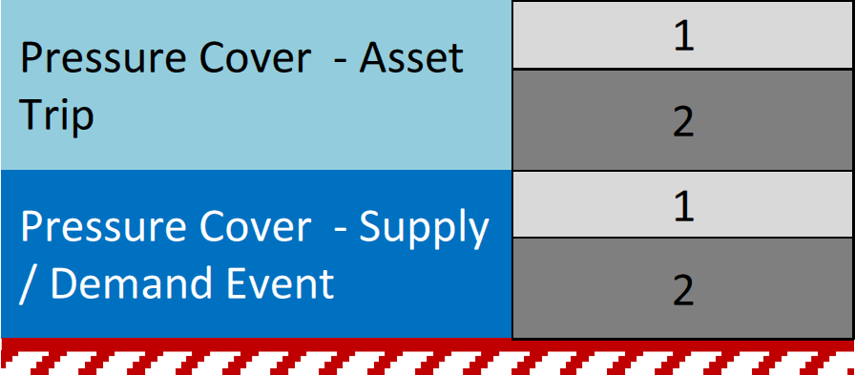
The OM service is used to maintain system pressures in the period post-event. Pre-event, other system management services become effective (e.g. national or locational balancing actions). The OM pressure cover allows for the time lag between our activating the service and the service provider’s physical response. Due to these network safety implications, we ensure that the OM pressure cover is always met in our network capability analysis. As there is a cost associated with reserving OM gas, the event management cover provides our Control Room with additional time to manage events efficiently without having to call on OM regularly and therefore incurring costs for users of our network.
Should the NTS have insufficient capability to meet required levels of pressure cover for a given supply and demand pattern, we will consider all available network development options (Section 7) which includes improved network resilience. This may take the form of targeted maintenance to improve reliability of assets, reducing the levels of required pressure cover.

Operational analysis
The network analysis assumptions described in this section are applied to all network capability and investment planning analysis undertaken by us for the ten-year planning horizon.
We use these assumptions as a basis for network analysis undertaken in operational timescales. We also use other information that is available at the time to supplement these assumptions. For example, this may include information on commissioning programmes for new connections to the system or temporary operating restrictions required on plant for short-term constraints.
Operational analysis is undertaken in the shorter term to:
- ensure security of supply is maintained
- determine strategies to facilitate the safe and efficient operation of the NTS
- assess the impact of operational constraints (such as maintenance activities or plant operating restrictions) on the physical capability of the system
- determine the physical capability of the network to support commercial processes, such as Entry Capacity Transfer and Trade (ECTT).

Operational balancing actions
Operational balancing actions form part of the operational measures referred to as part of the 1-in-20 security standard.

Operational balancing actions
Within-day flow variations on the system may generate gas flows and pressures that the system cannot, or is unlikely to be able to, accommodate. When such flows are unacceptable from a transportation capability perspective, we may choose to use any operational flexibility, including NTS compression and linepack to manage the situation, or to use a wider range of tools, which include:
- buy or sell locational gas
- scale back interruptible NTS entry capacity
- restriction of short term access to system flexibility
- buy back firm NTS entry and exit capacity
- scale back off-peak NTS exit capacity
- flow swaps
- offtake flow reductions
- use other capacity tools, such as capacity management agreements.
For further information on the range of operational measures, and how and when they are applied please refer to National Grid’s System Management Principles Statement (SMPS).

Operating margins (OM)
OM requirements are quantities of gas to be delivered to the NTS, or for quantities of nominated gas to be taken off the NTS or to be reduced or delayed for operation balancing purposes. We can utilise OM provisions where:
- we determine that, at any time during the gas day, there is an operation balancing requirement which cannot be satisfied by taking other system balancing actions
- as result of damage or failure on any part of the NTS (other than programmed maintenance), there is an operation balancing requirement irrespective of whether the requirement can be met through balancing actions
- there is a gas supply emergency.

Supply flows
Supply flows are required data for the network analysis models, and are derived for the supply scenario that is being considered. Further information can be found in Appendix D.
It is necessary to allow for a quantity of gas to be included with the total supply flow for fuel gas used at compressor stations. This gas will be assumed to be delivered from the largest entry point on the system or the final supply balancing point, as appropriate. The volume, typically less than 0.5% of national demand, is determined by the network analysis software based on the operation of compressors within the model.

Demand flows
Demand flows are required data for the network analysis models, and will be derived for the demand scenario that is being considered.
DN flows are modelled with a profile consistent with their NTS exit (flexibility) capacity booking for each relevant offtake at peak conditions. They must also be consistent with data provided via the Uniform Network Code (UNC) defined OCS process for off peak demand levels. Further information can be found in Appendix D: Long-term scenarios.
Power generation offtake demand flows are modelled with a profile considering historical power generation profiles. These are limited by the requirement to flow to a maximum rate of 1/24th of the exit capacity holding.

Storage and interconnector flows
Storage sites and interconnectors are modelled depending on their assumed behaviour within the supply and demand scenarios being modelled.
Storage sites and interconnectors are normally modelled as supplies under high demand scenarios or when gas prices are high, unless the supply scenario used dictates otherwise.
Such flows may need to be modelled as demands on the system under certain conditions, for example in the summer months or when gas prices are relatively low, or for contractual reasons (for example where contractual storage re-filling and emptying cycles are observed).
It is also possible that these sites do not flow at all under certain supply or demand scenarios.

Ramp rates
Rapid load changes imposed on the pipeline system, caused by entry or exit flow rates during a gas day, can cause abnormal operating conditions. These conditions may have a deleterious impact on compressors and existing points of offtake or could affect the safety and security of the NTS. These would normally occur during transient conditions, such as during start-up or during shutdown operating scenarios, when flow fluctuations are at their greatest. These transient events, known as ‘Fast Transients’, are usually observed over short timescales, typically less than 30 minutes. The standard ramp rate offered is currently 50 MW/min.
We consider the impact of ramp rates requested above the prevailing standard ramp rate to maintain the safety and integrity of the system. This may require additional studies to be undertaken to consider the operating scenarios proposed (e.g. rapid load changes, emergency shutdown events, etc.) at the cost of the party making the request.
The agreed limits for ramp rates are incorporated within the relevant entry, exit or storage contracts made with the operator of the connected facility before gas flow can commence.
Due to the interrelationship between some third-party facilities and the NTS, the third-party may have to demonstrate to us that the facilities and operating strategies proposed do not have a detrimental effect on the NTS.

Maximum entry and exit flows
The physical capability of installations connected to the system, such as reception terminals and offtake installations, may impose limits on the maximum flows that can be attained at an NTS entry or exit point. For example, these limitations may arise from site pipework configurations or pipework capacity constraints (where unacceptable pressure drops or excessive gas velocities would otherwise be observed through the pipework). We will observe the maximum flow limits imposed by such physical limitations at entry and exit points in the analysis we undertake.

Standard volumetric flows
The volume of any gas varies with temperature, pressure and molecular composition. It is usually quoted in relation to reference conditions. Metric standard conditions for a gas assume a temperature of 15ºC, pressure of 1.01325 bar and dry gas and are used to describe “standard volumes” of a gas.
The hydraulic models within the network analysis software used by us often express flows as standard volumetric flows (mscm/d) whereas commercial flows are usually described in energy terms (GWh/day or kWh/day).
Supply and demand flows is supplied to the network analysis models as standard volumetric flows assuming a standard calorific value (CV), which is equivalent to an energy flow in GWh/day. The network analysis software uses CV data entered at supplies to calculate CVs throughout the network, including demands. This allows the program to convert the demand flow data entered by the user to standard volumetric flows required with the hydraulic models. These assumptions are used to ensure that energy flows for commercial purposes (e.g. obligated entry and exit capacity levels) can be consistently and correctly applied within the network analysis models.
The standard CV is set at 39 MJ/m³, which approximates to the average CV of the gas in the system. Flows quoted using different CV assumptions will be converted to standard volumetric flows at the standard CV before input to the network analysis models to provide a consistent basis for the analysis.

Entry and exit pressures
Pipelines and plants are designed to operate within certain pressure ranges for safety and design reasons. Network capability depends not only on the supply and demand patterns and levels within the network, but also the maximum and minimum pressure limits that must be observed to remain within the design limits of the network’s component parts to ensure safe operation.
Maximum pressure limits are observed at entry points and within the system. They arise at points where gas flows from a system that is operated to a higher pressure.
Minimum pressure limits are observed at exit points. They are required to support downstream systems or loads. Some exit points require a higher pressure at 06:00 or 22:00 depending on the requirements of their downstream systems. These are assured offtake pressures (AOPs) for a distribution network operator and anticipated normal operating pressures (ANOPs) or other contractually agreed pressures for other customers directly connected to the NTS.
The gas pressure that can be supported at an exit point may be affected by any of the following:
- the presence of other significant loads in the vicinity
- the location of terminals that may turn down significantly (or be shut down) on different days
- the location of compressors and their likely operation throughout the year
- the presence of storage facilities in the vicinity
- system configurations that may change throughout the year
- the effects on agreed AOP and NTS exit (flexibility) capacity
- the effects of maintenance of plant in the vicinity
- pipeline maintenance, inspection, remedial work and modification activities in the area.
As discussed in Section 6.7, in addition to the minimum and maximum pressure limits, planning and operation also considers a level of event driven resilience, ensuring that the system is planned and operated such that unforeseen events can be managed both safely and efficiently by our Control Room. This resilience is in the form of a pressure cover, which is applied to either entry points or system extremities.
Network analysis is undertaken to determine network capability, we model the system to observe the maximum and minimum pressure limits, including associated pressure covers. Where the analysis shows that a pressure cannot be maintained, the supply and demand scenario under analysis is deemed to indicate a “failed” network. Network capability is deemed to have been reached at the point where maximum pressures and minimum pressures on the network can only just be sustained within operational tolerances. The resulting network is also known as a “constrained” network.
A “constrained” network indicates a requirement to mitigate a given constraint, either due to inability to meet direct system requirements or to provide sufficient resilience to system events.
The following pressure limits will be observed within the analysis:
- maximum operating pressures (MOPs) for pipelines, compressors and entry terminals
- AOP at exit points
- ANOP at exit points
- minimum contractual pressures within ancillary agreements at exit points.

Maximum operating pressures
IGEM/TD/1 Edition 5 states, “The sustained operating pressure of a pipeline system shall not exceed MOP.”. These guidelines recognise that excursions above this level may occur, due to the variations of pressure regulating devices and instruments used to monitor pressures. Information on such excursions is included within the major hazard safety performance indicators reported to the Health and Safety Executive each year. Control pressures used for network analysis models are set marginally below the MOP of the pipeline. Compressors and entry terminals are set to be consistent within their operational set points used on pressure protection devices.

Assured offtake pressures
The AOP requirements for each offtake to a distribution network is modelled on the minimum design pressures of the system at these points. AOPs will be agreed between the NTS and DNOs as part of the annual Offtake Capacity Statement process, described in the UNC Transportation Principal Document (TPD) Section B. Distribution network operators (DNOs) may request a change in an AOP under this process; however, we are not obliged to accept a request for an increase in pressure at an offtake.
Pressure requests are subject to inspection and targeted analysis where it is deemed to be appropriate. Incremental pressure requests will be rejected wherever it is assessed that they are:
- unsustainable with planned and actual infrastructure
- require investments to be brought forward in the investment plan
- increase operational costs (particularly compression costs)
- reduce capability at NTS entry points
- reduce available system flexibility capacity
- impact on other offtake points in the areas.
A range of supply and demand scenarios may be used in this assessment.

Agreed pressures
Under normal operation our Control Room can request and agree reduced (or increased) pressures with DNOs on a day by day basis, through the Agreed Pressure Process. Where pressures different to the AOPs are regularly agreed under typical operation, these are considered, alongside AOPs, when assessing efficient operation of the NTS.

Anticipated normal operating pressures
There are a number of ANOPs, which form part of the Network Exit Agreement (NExA) for large consumers. These pressures may only be changed after giving the customer 36 months’ notice.
ANOPs are governed by the UNC TPD Section J. This allows a shipper to request a specified pressure higher than the 25 bar(g) generally applicable to directly connected NTS loads. The ANOP is the lowest pressure we expect, under normal operating conditions, a given quantity of gas will be available for offtake at a given exit point.
All ANOPs are modelled as minimum pressures for the first three years of the ten-year planning horizon. From the fourth year of analysis onwards, if an ANOP cannot be maintained under any scenario considered, we will give notice to the customer for a reduction in the ANOP, under the terms of the relevant NExA agreement.

Contractual exit pressures
A shipper may request that we enter an ancillary agreement to meet a required pressure. Such an ancillary agreement may require the shipper to fund the additional costs incurred by us to guarantee the pressure. This pressure is then made available under all operating conditions in accordance with the agreement. Examples of such costs are reinforcement costs or additional compression required to support the contracted pressure.

Compressors
Gas compressors are the key plant items used to:
- maintain pressures and overcome pressure decay on the NTS
- boost system pressures to support exit pressure commitments
- reduce the pressure at entry points to increase the system entry capacity
- facilitate movement of stored gas in the system from one area of the system to another.
Compressor performance characteristics are basically defined by four curves relating to maximum speed, minimum speed, surge and choke. The four curves determine the operational envelope for the compressor. The compressor operates safely within this envelope. However, different process efficiencies are observed at different points within the envelope and this affect the fuel used to compress gas passing through the compressor. The envelope and efficiency characteristics varies between compressor units.
Where the network analysis models show that compressors must operate outside its envelope, to achieve a particular flow and discharge pressure and where reconfiguring the network does not remove this problem, it is possible that a compressor re-wheel or upgrade is required to ensure that the compressor can be safely operated.
Compressors may be operated under a number of different control mechanisms, for example, to achieve a target suction pressure, discharge pressure, or flow.
Limiting factors in compressor performance are related to the safe operation of the compressor train itself and include the maximum or minimum speed attainable from the gas generator or electric drive used to power the compressor. Other factors include:
- the minimum gas flows that may be safely permitted through the compressor
- the maximum power available from the drive unit to turn the compressor
- the maximum discharge temperatures that may be reached on the outlet of the compressor station
- boundary control systems used to protect downstream pipelines from over-pressurisation.
The network analysis software used by us allows detailed modelling of compressor envelopes, control mechanisms, limiting factors and compressor fuel usage.

Minimum and maximum speeds
The physical capability of compressors is related to the maximum and minimum speed of the associated power turbine and compressor speed. This means that compressor units require a certain flow to be achieved before they can be used to compress gas.
The requirement to limit compressors to operate within the minimum and maximum speed limits imposed by the compressor envelope may constrain network capability.

Minimum and maximum flows
In addition to the minimum flow required to turn a compressor on to compress gas, compressors must be operated to ensure that they do not operate under surge conditions (where there is a high compression ratio relative to the flow) as this can damage the compressor.
High flows through the compressor can result in it operating under choke conditions, where high flows are achieved, at a relatively low compression ratio. Choke conditions do not always constrain compressor operation, but could indicate inefficient operation. High flows at or near the maximum speed for the compressor can lead to mechanical problems.
The requirement to limit compressors to operate within the surge and choke limits imposed by the compressor envelope may constrain network capability.

Maximum power
The maximum power available from a gas driven compressor unit is dependent on various factors including ambient inlet air temperature. Generally, the colder the air temperature, the more power that can be derived to compress gas. Gas quality is another factor that can have an impact on compressor performance. The maximum available power therefore varies throughout the year, and is lower for summer conditions than for winter conditions. The maximum power available from an electrically driven compressor unit is not dependent on ambient air temperatures.
The maximum power that is used within network analysis models is the base power level that may be achieved under normal operating conditions.
The network analysis undertaken for the NTS considers the limiting effect of seasonal variations in temperature on power available at gas driven compressor units by relating available power to total NTS demand at different points on the load duration curves. This may constrain network capability, especially at lower demand conditions.

Discharge temperatures
Compressor station discharge temperatures are generally limited to between 45ºC and 50ºC (depending on the downstream pipeline specifications) as otherwise damage can be caused to some downstream pipeline coatings. Where consistently high temperatures are seen on the outlet of a compressor, aftercoolers may be used to reduce the gas temperature to acceptable levels and improve downstream transmission capability by virtue of a lower temperature. Where aftercoolers are not present, network capability may be constrained due to the requirement to operate to safe temperature limits.

Suction and discharge pressures
Due to gas flow characteristics and the relationship between pressure, velocity and the associated pressure losses caused by friction, it is generally more efficient to utilise the furthest upstream compressors towards their maximum discharge pressures in the first instance to minimise pressure losses and fuel consumption. Compressors near large entry points are controlled on a suction pressure set point to enable high flows from these entry points to be accommodated. However, downstream conditions including demand levels and distribution have a key effect on the ability to use compressors effectively.
We seek to maximise the use of compression by operating compressors towards their maximum discharge design pressures or minimum suction design pressures when undertaking network analysis, subject to other constraining factors such as:
- emissions levels
- discharge temperatures
- efficient fuel usage
- compressor performance envelopes.

Compressor standby and station configuration
Compressor stations across the NTS are designed to meet the anticipated range of flow conditions. Some sites may be used for high demand conditions only, whereas other stations are equipped to allow a variety of different units to be used in parallel and in series configuration to achieve different pressure and flow characteristics.
We ensure that compressors configurations are used effectively within network analysis models. We consider the range of configurations that may be used to accommodate flow patterns on the system to maximise the capability of the system, subject to other constraining factors (see above).
Compressor failure (non-availability) is more likely to occur than a 1-in-20 demand day. Hence within or prior to a 1-in-20 demand day a compressor may have failed. Therefore, we need compressor standby to comply with our obligation to develop the network to meet the 1-in-20 security standard. Standby is identified to ensure that the required transmission capability is maintained in the event of a credible loss of any single compressor unit or operationally linked unit i.e. common mode of failure at a site.
When assessing standby requirements, we consider:
- required transmission capability; this is reviewed on an annual basis considering forecast supply and demand, capacity and other obligations
- forecast compressor run hours; this considers a range of forecasted supply and demand levels
- economic and efficient system operation; the trade-off between standby and other commercial solutions e.g. capacity buy-back, supply turn up
- maintenance; system access (outages) associated with maintenance requirements
- electricity and gas fuel security; the failure of electricity supply for an electric drive may require gas compression standby.

Emissions
We are responsible for ensuring our compressor fleet meets legislative requirements relating to emissions under the Industrial Emissions Directive and UK ETS Directives. Different gas compressor units used on the NTS may have different emissions levels when they are operated. Emissions levels can change across the compressor performance envelope. In general, older machines may have higher emissions than more recently installed units. The network analysis undertaken to model the NTS will consider the appropriate priority for using compressor units to ensure that emissions levels are minimised wherever possible. Electrically driven units do not contribute to site emissions (emissions from these are already accounted for in the power generation sector).
In particular, the total number of running hours agreed with the environmental agencies will be observed for sites with high emissions levels, when undertaking investment planning analysis. Additional investment to reduce emissions levels from sites may be required alongside any reinforcement projects identified to support changes in supplies or demands.

Regulators
Regulators are used to control and direct the gas flows in the system using either pressure or flow control. They may be bypassed when not required. They are also used as pressure protection devices. Regulators induce a pressure drop when used to control flows or pressures, and they may be limited to a maximum design flow or pressure drop which is modelled in the analysis. A zero-pressure drop is assumed where a regulator is bypassed.
We ensure that regulators are used effectively within network analysis models, in conjunction with compressor and multijunction configurations to maximise the capability of the system. The configurations used will be subject to other constraining factors such as:
- compressor emissions levels
- discharge temperatures
- efficient fuel usage
- operation within compressor performance envelopes.

Multi-junctions
Multi-junctions are complex arrangements of pipework, valves, regulators and other plant that are used to interconnect pipeline systems and control the flow of gas through the main pipelines in the NTS. Multi-junctions can be located close to compressor stations, and so there is a close interaction between the configurations used at these sites.
The configuration of multi-junctions can have a considerable effect on the network capability and the distribution of gas quality achieved across a distribution network. We will ensure that different operational configurations at multi-junctions are used effectively within the network analysis models, to maximise the capability of the system, subject to other constraining factors such as:
- emissions levels
- discharge temperatures
- efficient compressor operation
- calorific value (CV) shrinkage levels.

Gas quality and temperature
We model gas quality and temperature effects using the network analysis software to ensure accuracy and to monitor their effect on the pressure and flows calculations within the network. The effect of pipeline altitude above sea level on gas pressure within the pipeline is also modelled.
Temperature effects modelled include:
- heat losses through pipe walls to the surround ground
- cooling as gas travels through regulators and aftercoolers
- heating as gas travels through a compressor
- ambient air temperature on the operation of compressors and aftercoolers
- ground temperature effects on gas in the pipelines.
We use estimated gas quality and temperatures for supplies as inputs to the network analysis models and as gas flows through the network. Estimated values are derived from data provided by producers and Shippers, as well as historically observed values.
In order that consistent CVs are used for planning across the NTS and DNs, estimated CVs are provided by us to the DNOs. The CV assumptions quoted by DNs in their OCS and UNC Offtake Arrangement Document (OAD) Section H data are used to convert demand information to standard volumetric flows at a standard CV.

Wobbe index
The Wobbe index describes the way in which the gas burns. Any gas taken from the NTS must not be less than 47.2 MJ/m3 and not greater than 51.41 MJ/m3 under normal circumstances as described in the Gas Safety (Management) Regulations (GSMR). If a lower Wobbe index is observed at offtakes, during the analysis, the network is reconfigured to bring the impacted offtakes back into specification. It should be noted that this may constrain network capability.

Flow weighted average calorific value
Where the CV at an offtake is calculated as more or less than 1 MJ/m3 compared to the flow weighted average across a local distribution zone within a DN, there may be an impact upon shrinkage and unbilled energy.
Where this occurs, the network is reconfigured to bring the impacted offtakes back into specification. It should be noted that this may constrain network capability.

Network development options
This section covers the options that we will consider as part of developing the National Transmission System (NTS).

Network development options
When a network constraint is identified there are options we consider to meet network requirement needs. The following options do not require capital expenditure but they are considered alongside any identified indicative investment projects:
- do nothing; this is a valid option if analysis shows the risk introduced is acceptable and can be managed operationally (including through capacity buy backs) or there is existing physical capability
- capacity substitution (described earlier in the Sections 4 and 5)
- network reconfiguration
- compressor utilisation
- pressure options – e.g. permanent reductions in assured offtake pressure (AOP) or anticipated normal operating pressure (ANOP)
- commercial capacity management and contractual solutions
- improved network resilience.
These options are not mutually exclusive. It is possible for a combination of these being used to meet an individual capacity signal. Where a constraint is associated with a network uncertainty event, a solution may be available through:
- reducing the likelihood of it occurring
- reducing its impact on the system
- reducing the time required to perform suitable mitigating action.
The solution may take the form of targeted maintenance to improve reliability, improved management tools or reduced contract times.
Each of these options will be evaluated with due consideration being given to our wider obligations to ensure that the NTS can support 1-in-20 peak demand conditions and to develop the NTS in an economic and efficient way.

Network reconfiguration
Reinforcements identified during the development of the investment plan in any gas year being modelled may be found to be unnecessary if alternative network configurations are used. However, this may also have undesirable effects such as increasing the anticipated levels of calorific value (CV) shrinkage that is experienced on the system. This, in turn, will increase compression costs or emissions levels, or have an impact on reinforcements required for later years. Such impacts are assessed before consideration is given to rejecting the reinforcement project.

Compressor utilisation
It may be possible to utilise compressor units normally reserved for standby or operate units at peak power levels for short periods (see Section 6.17.1). These approaches are not without risks as they may affect maintenance costs and asset life. They are only considered in exceptional circumstances where other options are limited or not available.

Pressure options
It may be possible to defer or avoid investment if ANOPs at exit points are reduced in line with the 36 month notice period that must be given to customers. We are obliged to maintain all prevailing AOPs agreed through the Offtake Capacity Statement (OCS) process and all contractual pressures determined by ancillary agreements. We can formally request permanent reductions in offtake pressures from distribution network operators (DNOs) by 30 April in each gas year. DNOs have until 30 June to accept or decline these requests.

Commercial capacity management and contractual solutions
Investment projects are deferred or avoided if we enter into capacity management agreements to manage the potential risks arising from constraints and associated capacity buy back at entry or exit points (in accordance with UNC and Licence mechanisms to manage constraints). Further risk analysis is required to determine if such an agreement is a viable option.
Figure 6 outlines the high-level process for considering investment as against contractual solutions, in relation to entry capacity.
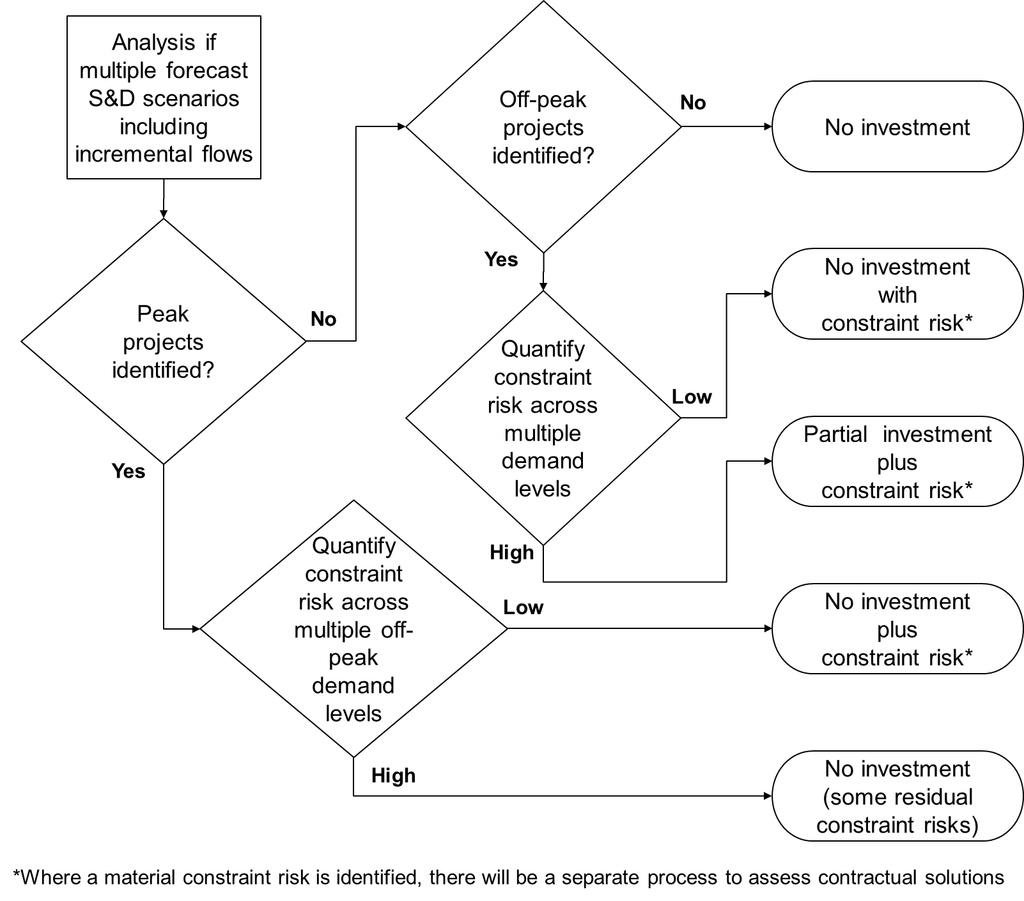
Figure 6 Investment versus contractual solutions for entry capacity

Figure 7 outlines the high-level process for considering investment as against contractual solutions, in relation to exit capacity.
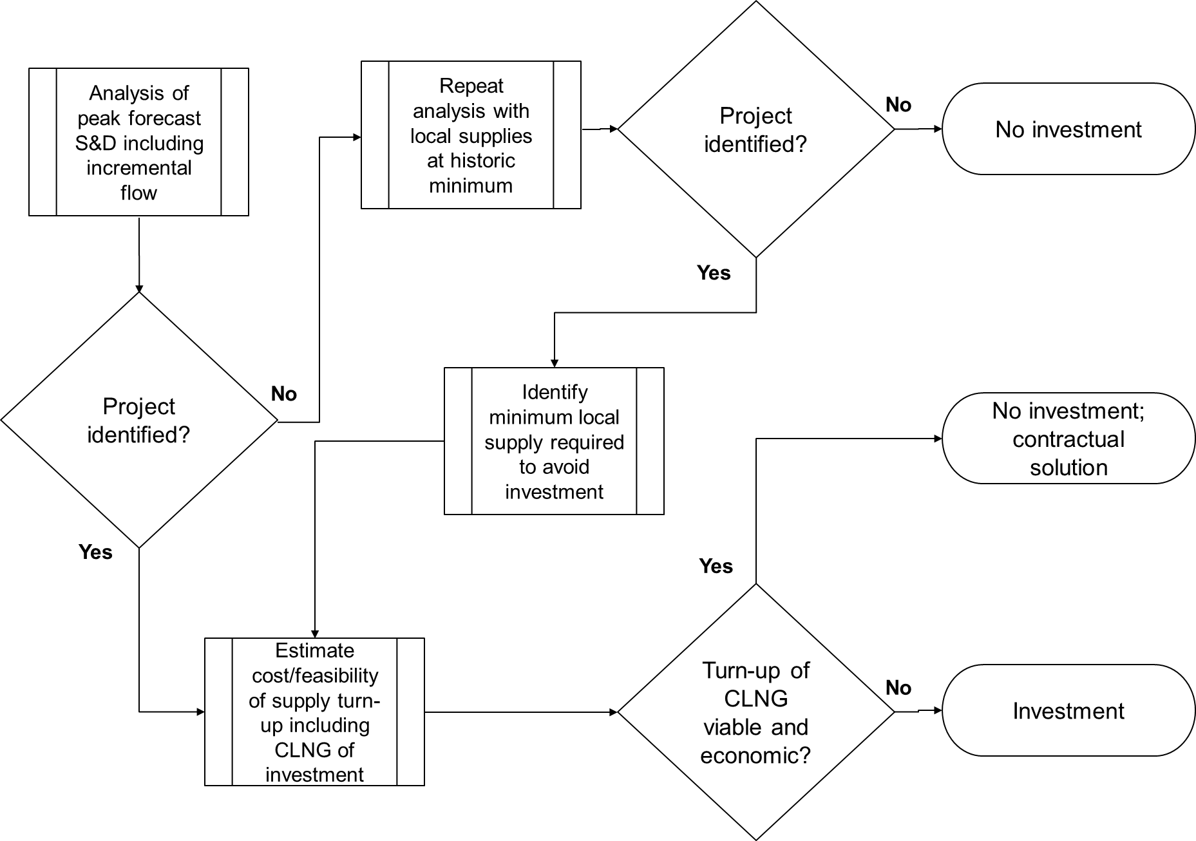
Figure 7 Investment versus contractual solutions for exit capacity

When we have sufficient confidence in an auction or capacity signal received from our customers, or that our analysis shows a need for enhance capability for new flow patterns, to maintain the existing levels of service, we assess the most efficient means of meeting the requirements.
Where we consider these are unlikely to be met through operational or short-term commercial options, we will assess the likelihood of a successful enduring contractual solution against the potential investment requirement. This could be a number of years ahead of receiving a formal auction or capacity signal.
Potential contract solutions fall into the following categories:
- turn up; a customer agrees to increase supply (or demand) at a specified location
- turn down; a customer agrees to reduce supply (or demand) or to reduce their capacity holding at a specified location
- flow swap; a DNO agrees to increase supply (or demand) at one location and reduce it by an equivalent amount at a different (non-interacting) location.
Evaluation of the solution’s economic value will be dependent on the forecast distribution of frequency of use.

Reinforcement projects
This section lists the common reinforcement projects that are identified through the investment planning analysis undertaken for the NTS.
The reinforcements identified at this stage are viewed as indicative projects. They may be modified after further detailed analysis to consider their feasibility and long term viability. This may identify issues with routeing or siting arising from environmental, safety and wider societal impacts that mean the project is not progressed through to the construction phase.

Compressor re-wheels
When network analysis results indicate a compressor unit continually breaching its operating envelope, despite mitigating actions, but it is operating within the power limits of the gas or electric drive, it may be that a re-wheel (a redesign of the compressor performance characteristics) is required.

Compressor flow reversal
Where new entry points change the direction of flow in an area, reversal of a compressor site flow configuration is required. Although some sites have been designed to allow flexibility of configuration, others require redesign to allow the compressor to “pump” in the opposite direction.

Regulators
A regulator project may be identified for either pressure protection as a result of an uprating project or to allow a new network configuration (to allow flows to be controlled in a different way). Regulators may also need to be resized to allow for higher flows, or redesigned to allow flow in either direction.

Aftercoolers
Compressor station discharge temperatures are limited to between 45ºC and 50ºC. Above these temperatures damage is caused to downstream pipeline coatings. If discharge temperatures constrain compressor operation, it may be necessary to fit an aftercooler, which reduces the temperature of the gas leaving the compressor station. This may also improve the downstream pipeline transmission capability. However, aftercoolers induce a pressure drop and require energy (normally electricity) to operate them. So, the overall efficiency of the compression process and contribution to shrinkage must also be considered.

Uprating
It may be possible to add additional capability in the system by identifying uprating projects to test and re-certify pipelines and associated plant to increase their maximum operating pressure (MOP). The ability to uprate a pipeline depends on factors such as the construction of the pipeline, testing level and the pipeline materials minimum specified yield strength. For this reason, pipeline uprating is not suitable for all NTS pipelines. Pipeline uprating may need to be undertaken in conjunction with other projects such as compressor up-rating and re-wheels. It may be affected by safety issues such as proximity to dwellings.

New compressor stations or units
Where network capability is limited by available compression power and maximum or minimum system pressures it is sometimes possible to add further compressor units or develop new stations for areas of the network requiring increased compression.

Pipeline reinforcement
Where network capability is limited by maximum or minimum system pressures, pipelines may be duplicated (or triplicated) to reduce the pressure drops that are induced by gas flows. The network may also be reinforced by introducing additional pipelines to provide greater interconnection across the system and provide alternative routes for gas to flow from entry to exit points. An example of such an interconnection is the Trans-Pennine pipeline that links the East Coast and West Coast NTS pipelines.

Optimal reinforcement
It is possible that a number of reinforcement options are identified to meet network capability requirements. Reinforcement may be triggered by a requirement to increase network capability either under peak day conditions or away from peak day conditions. Reinforcement may also be required to enhance the network capability by modifying existing assets to alter the way that they are used.
A checklist of potential reinforcement projects is in Table 5. Although not exhaustive, it is used as a guide to ensure that alternatives are examined.
The cheapest capital cost solution may not be the optimal choice over the whole life of the asset. Therefore, the long-term value of each option will be assessed by considering the requirements of our stakeholders. This is achieved by assessing environmental factors, the economic and technical viability, the technology used, and the way it is designed, built, maintained, operated and decommissioned.
Table 5 Reinforcement projects check list
Project | Alternative project | Considerations
Compressor re-wheel | Upstream pipeline | Consider options for pipe diameters and lengths to obtain the most economical solution overall.
Regulator | Upgrade upstream or  downstream compressor | Consider compression ratio and  discharge temperature requirements to  ensure compressors can operate  within design limits
New or upgraded  compressor (including  the provision of  aftercoolers) | Upstream pipeline | Consider options for pipe diameters and lengths to obtain the most economical solution overall.
 | Uprate upstream  compressor and/or  pipeline | Consider effect on compressor power  requirement to ensure uprating is  feasible within design limits.
 | Combination of smaller  compressor units | Consider benefits of additional  operational flexibility provided by  numerous smaller compressor units  against higher cost requirement.
Pipeline reinforcement | Upgrade downstream  compressor | Consider compression ratio and  discharge temperature requirements to  ensure compressors can operate  within design limits
 | Uprate upstream  compressor and/or  pipeline | Consider effect on compressor power  requirement to ensure uprating is  feasible within design limits
 | Compressor flow reversal | Consider whether an existing  compressor may be used to flow in a  different direction or configuration

Appendices
Transmission Planning Code

Appendix A: Legislative framework
National Grid is required to comply with certain legal requirements in the planning and development of the NTS in Great Britain. The key legislation affecting network planning and lead times for investment is described below.

Gas Act 1986 (as amended)
The Gas Act is the primary UK legislation that governs the transport and supply of natural gas within Great Britain.
Section 9 of the Gas Act states a Gas Transporter has general duties in the planning and development of their system, which are:
“ (a) To develop and maintain an efficient and economical pipe-line system for the conveyance of gas; and
(b) Subject to paragraph (a) above, to comply, so far as it is economical to do so, with any reasonable request for him –
(i) To connect to that system, and convey gas by means of that system to, any premises, or
(ii) To connect to that system a pipe-line system operated by an authorised transporter.”
National Grid Gas plc is required to hold Gas Transporter Licences in respect of its gas transportation activities for the NTS and the four retained distribution network businesses. These licences are granted and administered by the Gas and Electricity Markets Authority (the Authority), established by the Utilities Act 2000.

National Grid’s Gas Transporter Licence in respect of the NTS
We are bound by the terms of our Licence. The Licence contains a number of Conditions, Standard Special Conditions and Special Conditions that we must abide by in developing and operating the network and in conducting its transportation business. The Licence obligations that are relevant to the planning and development of the NTS are described below.

Standard Special Condition A9: Pipe-Line System Security Standards
This condition sets out the security standard for the NTS. It requires that we plan and develop the NTS to meet the Security Standard. The NTS security standard is that the pipeline system must, taking into account operational measures, meet the 1-in-20 peak aggregate daily demand including within day gas flow variations.
The 1-in-20 peak aggregate daily demand is the level of daily demand that, in a long series of winters, with connected load held at the levels appropriate to the winter in question, would be exceeded in one out of 20 winters, with each winter counted only once. This is the Uniform Network Code (UNC) definition of the 1-in-20 peak day. It can be found in UNC General Terms (GT) Section C – Interpretation.
The 1-in-20 peak day is calculated from a statistical distribution of simulated historical peak days. An estimate is made of what demand would be in a particular gas year if historical weather was to be repeated and this process is repeated for each of the years in the weather history. From these simulations, there are a number of maximum daily demands (one for each gas year in the historic database) and the 1-in-20 peak day is calculated from each of these demands. It is not the highest demand in the last 20 years, nor is it the demand that would be expected in the coldest weather experienced in the last 20 years. The 1-in-20 peak demand level should be calculated from at least the 50 previous year’s historic data.
In meeting the 1-in-20 peak day demand the number of premises to which gas will be conveyed and their consumption, and the extent to which the supply of gas to those premises might be interrupted or reduced subject to a contract, should be considered.
The Security Standard takes into account available operational measures, for example:
- constraint management tools including buy back of firm NTS entry and/or exit capacity (see Section 6.9.1)
- operational balancing actions (see Section 6.9.1)
- Operating Margins gas (OM) (see Section 6.9.2)
- any other actions as outlined in our System Management Principles Statement (SMPS).
The Security Standard considers within day gas flow variations (Section 6.5). Sources of within-day variation could include foreseeable changes such as supply & demand profiling, including distribution networks’ (DN) diurnal variations, storage and unforeseeable changes such as forecasting errors, suppliers’ alerts and producer variation away from the assumed 1/24th rate. One of the key requirements of the TPC is to provide clarity on how we plan to meet the 1-in-20 Security Standard considering these factors. Further information can be found in Section 6.6).
The 1-in-20 Security Standard obligation does not apply directly to entry supplies although it is implicit that sufficient transportation capability must be made available such that the Security Standard can be met both in terms of the 1-in-20 peak demand level and a 1-in-50 severe winter. Hence, sufficient entry capability must be available. The 1-in-50 standard is a function of the requirement for transportation arrangements to be consistent with the suppliers’ “domestic customer supply security standards” regarding available annual supplies.
Prior to ‘exit reform’, a site could either be registered as firm or interruptible, with only firm demand considered for planning purposes and the assessment of the 1-in-20 Security Standard. Exit reform, whereby a combination of annual or daily firm or off-peak capacity can be held, has created issues in regard to forecasting the 1-in-20 demand level. A site may not hold firm exit capacity on an enduring basis but may be able to access it on an annual basis year ahead or even on a daily basis within-day, if there is any unsold obligated capacity at the relevant exit point, and hence in timescales shorter than the investment planning process. The risks associated with daily capacity are mitigated by an understanding that the DNs will book enduring exit capacity to comply with the Security Standard and their own 1-in-20 obligations. Simply relying on enduring bookings may be insufficient and sensitivity analysis surrounding those exit points that can access short-term obligated capacity is required.

Special Condition 9.10: Long Term Development Statement
Under this obligation, we must publish an annual Long Term Development Statement for the NTS that sets out the likely use of the NTS, and the likely developments of the NTS and any other facilities or pipeline systems that may affect the connection charging and transportation charging arrangements over the next ten years. We publish the GTYS each year, in accordance with this condition and the UNC’s TPD Section O, after consultation with the gas industry through the Future Energy Scenarios (FES) consultation process.

UNC Section B: Entry and

Exit capacity release processes
The details of the entry capacity release process are set out in Section B of the UNC and the Entry Capacity Release (ECR) Methodology Statement. We can only permanently increase the level of entry capacity at an aggregated system entry point (ASEP) having first assessed how much entry capacity may be substituted to meet the increase as a result of applying its Entry Capacity Substitution Methodology.

The details of the exit capacity release process are set out in Section B of the UNC and the NTS Exit Capacity Release (ExCR) Methodology Statement. We can only permanently increase the level of exit capacity at an exit point having first assessed how much exit capacity may be substituted to meet the increase because of applying its Exit Capacity Substitution Methodology.

Pipelines Safety Regulations 1996
The Pipelines Safety Regulations 1996 (PSR) was made under the Health and Safety at Work Act 1974. These regulations are the principal health and safety legislation in the UK concerning the safety and integrity of pipelines, and are regulated by the Health and Safety Executive (HSE). They apply to all relevant onshore UK pipelines to ensure that these pipelines are designed, constructed, operated, maintained and decommissioned safely. In particular, they class certain pipelines that transport certain “dangerous fluids” as Major Accident Hazard Pipelines (MAHPs). All natural gas pipelines operating above 7 bar(g) fall into this category.
PSR covers four areas:
- pipeline design
- pipeline safety systems
- pipeline construction and installation
- examination and maintenance.
Operators of MAHPs are required to notify the HSE before construction, use and modification of the pipelines.
The regulations require that construction of a new MAHP must not start until the operator has notified HSE at least six months prior to the start of construction (of the first stage of construction), although in practice the HSE are involved in discussions on the design and routeing of the pipeline ahead of this notification period. Notification of at least 3 months is also required in other cases, for example in advance of:
- major modifications or remedial work to the pipeline
- changes in safe operating limits e.g. pressure uprating
- changes in fluid composition or type as this may have an effect on pipeline integrity
- end of use of a pipeline (decommissioning and dismantling)
- changes in pipeline materials and equipment
- re-routeing of pipelines.
PSR further require that a pipeline operator has adequate arrangements in place to deal with an accidental loss of fluid from a pipeline, defects and damage to a pipeline or any other emergency affecting the pipeline. Operators of MAHPs must also have adequate emergency procedures, an appropriate organisation and effective arrangements in place to deal with an emergency involving a MAHP. Since pipelines may typically span large areas of the country, this requires the pipeline operator to liaise with local authorities along the route of the pipeline to ensure that they also have suitable emergency procedures in place to meet their obligations under PSR.

Pressure Systems Safety Regulations 2000
The Pressure Systems Safety Regulations (PSSR) 2000 aim to prevent serious injury from the hazard of stored energy as a result of the failure of a pressure system or one of its component parts.
The regulations require owners of pressure systems to demonstrate that they have:
- designed and constructed the pressure system to be safe with the appropriate protective devices where required
- established the safe operating limits of pressure systems
- a written scheme of examination in place prior to the use of the system
- maintain and repair the system to meet the required safety standards.
The written scheme of examination certifies the pressure system (including all protective devices, pressure vessels and pipework) for use and must be approved by a competent (independent) person. Examinations must be carried out by a competent person and must be reviewed at regular intervals as defined by the written scheme. The system must also be maintained properly to ensure that it is safe.
The main protective devices for the NTS are compressor stations, pressure reduction installations and boundary control systems.

The Gas Safety (Management) Regulations (GSMR)
The Gas Safety (Management) Regulations (GSMR) 1996 require each Gas Transporter to prepare a Safety Case document that sets out in detail the arrangements in place in four main areas:
- the safe management of gas flows through the network, particularly those parts of the network supplying domestic consumers
- the management of gas supply emergencies, including those measures in place to minimise the risk of a gas supply emergency occurring
- the management of reported gas escapes and gas incidents
- the management of gas quality and composition within safe parameters.
Schedule 1 of GSMR describes the scope of the Safety Case. In particular, Schedule 1, paragraph 17, states that the Safety Case must contain:
“Particulars to demonstrate that the duty holder has established adequate arrangements to ensure that the gas he conveys will be at an adequate pressure when it leaves the part of the network used by him.”
The Safety Case must be formally accepted by the HSE. Once accepted, there is a legal obligation on the gas transporter to comply with its Safety Case. Any changes to:
- safety management systems
- key technical policies and procedures concerning gas supply emergencies
- staff resource levels
- system operation changes
- organisational changes or changes to commercial arrangements that may require a material Safety Case revision.
will need approval by the HSE before they may be implemented.
Our Safety Case contains a section (Section 17: Adequate Network Pressure) that is relevant to the planning and development of the NTS to ensure that adequate pressure is maintained within the network under a range of operating conditions. This section of the Safety Case outlines the guidance documents used in the planning of the NTS (which are also described later in this document) and the use of validated network analysis models for planning (which is expanded upon in this document).

Appendix B: Policy and guidelines for NTS planning

Planning regime
We have legislative obligations relating to consent authorisations required when developing elements of the NTS in the form of:
- Planning Act 2008
- Town and Country Planning Act 1990.
In general, the Planning Act 2008 will apply to the construction of NTS pipelines whereas the Town and Country Planning Act 1990 will apply to the provision of fixed assets such as Compressor Stations and Pressure Reduction Installations.

Planning Act 2008
The Planning Act 2008 (as amended) introduced changes to streamline the planning system by establishing a single consenting regime. Following changes introduced through the Localism Act 2011, the Planning Inspectorate replaced the Infrastructure Planning Commission (IPC), with Nationally Significant Infrastructure Project (NSIP) applications being determined by the relevant Secretary of State. Six energy related National Policy Statements (NPS) have been produced by the Department of Energy and Climate Change, which were designated in July 2011. They set out the national policy framework for the development of energy infrastructure and provide the primary basis for decision making.
The Planning Act does not apply in Scotland and does not apply to gas transporter pipelines in Wales. In these Countries gas transporter pipelines are installed under permitted development rights by virtue of the Gas Act 1995 (as amended). In response to the requirements of the Planning Act and the impending review of planning requirements in Wales, we have developed a consistent approach for developing major infrastructure projects to be applied consistently across England, Wales and Scotland.

Nationally significant infrastructure projects (NSIP)
The construction of a gas transporter pipeline is considered to be a NSIP when each of the following conditions is met:
- the pipeline must be wholly or partly in England and either:
  - the pipeline must be more than 800mm in diameter and more than 40km in length
  - the construction of the pipeline must be likely to have a significant effect on the environment; and
- the pipeline must have a design operating pressure of more than 7 bar gauge and must convey gas for supply (directly or indirectly) to at least 50,000 customers, or potential customers, or one or more gas suppliers.
Gas transporter pipelines (including new pipelines and diversions) that are less than 800mm in diameter and 40km in length are only considered NSIP developments if the construction is likely to have a significant effect on the environment. The Infrastructure Planning (Environmental Impact Assessment) Regulations 2009 (see below) provide a ‘screening’ mechanism to establish whether the proposed works are likely to have a significant effect on the environment.
In England, works associated with a NSIP may be included within the Development Consent Order (DCO) application to be determined by the Secretary of State for Business, Energy and Industrial Strategy (BEIS).

Impact of the Planning Act
The Planning Act requires pre-application consultation and engagement with affected and interested parties during the development of the project. As previously mentioned, in response to these requirements, we have developed an approach for developing major infrastructure projects which sets out in a transparent way the stages of project development and when during the process relevant stakeholders are consulted. We have developed a generic timeline to illustrate the various stages in the project development process (see Table 6).
This approach includes greater documentation of network analysis, project optioneering, engineering design activity and wider consultation with stakeholders than in previous planning regimes. This increases the time required to complete the overall process, but means that stakeholders’ views are incorporated earlier, improving the certainty of the outcome. However, this new regime does not affect the actual build time to deliver new infrastructure, which will remain largely unchanged (subject to consent conditions, terrain and weather).
Table 6 Generic timeline for project developments
Planning Stage | Activity | Duration
Strategic optioneering | Establish the need case and identify technical options | Up to 6 months
 | Develop strategic options report (SOR) | Up to 6 months
Outline routing and siting | Identify preferred route corridor and siting studies | Up to 15 months
Detailed routing and siting | Undertake environmental impact assessment and detailed design | Up to 24 months
Development consent order (DCO) application preparation | Formal consultation, finalising project, preparation of application documents
DCO application hearings and decision | Submission and examination | Up to 15 months

As illustrated in Table 6, the overall planning process is anticipated to take up to 7 years (84 months). The current default lead time, from the receipt of a formal capacity signal to the release of incremental entry capacity, is defined in our Licence. This is shorter than the Planning Act timeline, so a significant quantity of the pre-application phase works and stakeholder consultation would need to be completed ahead of a formal signal for capacity in order that system reinforcement can be delivered in time for the release of the capacity.
The timeline quoted above is generic. It is based on experience from other applications under the Planning Act, guidance on the Government’s expectations on pre-application consultation and extensive discussions with a wide range of relevant stakeholders. We consider it to be representative of the timeline for a typical major linear infrastructure project. However, this timeline is not fixed and will vary on a case by case basis according to each project’s individual requirements.
We recognise that there are concerns amongst some industry participants regarding these timescales and we are working with the BEIS and the Department for Communities and Local Government (DCLG) to understand the full implications - as are other industry stakeholders. Notwithstanding the outcome of these on-going discussions, we will endeavour to improve upon these timescales wherever it is possible to do so and by learning lessons from other major projects under the Planning Act whilst maintaining the required quality of consultation and engagement necessary to ensure compliance with the Planning Act.

Town and Country Planning Act 1990
The Town and Country Planning Act 1990 is the land use planning system framework used to maintain a balance between economic development and environmental quality. Each country in the United Kingdom has its own distinct planning system with responsibility for town and country planning devolved to the Welsh Assembly and the Scottish Parliament.
Due cognisance must be given to the Town and Country Planning Act for the provision of fixed assets such as compressor stations and pressure reduction installations. So, to develop a fixed asset, we are required to apply for planning permission from the relevant local planning authority. Timescales for gaining planning approval for a development vary depending on the type, size, location and sensitivity of a development.
If planning permission is refused, an appeal can be submitted within 6 months to the Secretary of State for Communities and Local Government in England and Wales, or the First Minister in Scotland. A Planning Inspector or Scottish Reporter would be appointed to hear the appeal, which may be in the form or written representations, hearing or inquiry. The time from submission of appeal to receipt of a decision depends on the size, scale and complexity of the project and the reasons for refusal, and the type of appeal held. For more complex appeals an inquiry may be held, with approximately half of decisions reached within 27 weeks.

Environmental Impact Assessment Directive
The Environment Impact Assessment Directive (2011/92/EU) (which has been adopted into UK legislation) requires environmental impact assessments to be conducted before development consent is granted, for certain types of major public and private projects which are judged likely to have significant environmental effects.
An environmental impact assessment examines in a comprehensive, detailed and systematic manner, the existing environment (natural, physical and built) and the proposed pipeline development. This typically requires the completion of a wide range of searches, studies and surveys over four seasons which takes a minimum of 12 months to complete. The Environmental Statement is the culmination of this assessment, and sets out the environmental baseline, the likely significant environmental effects, proposed mitigation measures and any residual effects from the proposed development. The Environmental Statement will also include our commitments to minimising the effects on the environment.

Infrastructure Planning (Environmental Impact Assessment) Regulations 2009
In England, gas transporter pipeline works that fall within Annex I, or Annex II of the Directive by virtue of their likely significant environmental effects, require an Environmental Statement to accompany an application for development consent to the Secretary of State for BEIS under the Planning Act 2008. These works are classed as NSIPs. From submission of the application to the Planning Inspectorate to obtaining a decision from the Secretary of State may take up to 15 months.

The Public Gas Transporter Pipe-line Works (Environmental Impact Assessment) Regulations 1999
These regulations apply to gas transporter pipeline works in Wales, Scotland and England. In Wales and Scotland, pipeline works in Annex I of the directive require an Environmental Statement to be submitted to the Secretary of State of BEIS. For pipeline works in Annex II of the Directive ‘the works’ may be subject to an environmental impact assessment if they have a design operating pressure exceeding 7 bar(g) or either wholly or in part cross a sensitive or scheduled area. In these circumstances, the gas transporter must, before commencing construction, either obtain determination from the Secretary of State that an Environmental Statement is not required or give notice that it intends to produce an Environmental Statement. The regulations also provide for the Secretary of State to require an Environmental Statement where proposed works in Wales and Scotland do not meet these criteria but nevertheless it is considered that there are likely to be significant environmental effects. The completed Environmental Statement is submitted BEIS. It normally takes BEIS between 9 to 12 months to review the Environmental Statement, complete the consultations required with all appropriate statutory and non-statutory parties and grant the development consent required.
In England, gas transporter pipeline work that fall within Annex I or II would require an Environmental Statement to be produced and would be an NSIP project requiring development consent under the Planning Act. Pipelines that do not fall within Annex I or II would not require an Environmental Statement.

Emissions
Emissions reduction investment on the NTS is driven by The Environmental Permitting (England and Wales) (Amendment) Regulations 2018 and, in Scotland, by The Pollution Prevention and Control (Scotland) Amendment Regulations 2017(PPC). These regulations were put in place to comply with the European Integrated Pollution Prevention and Control Directive (IPPC Directive) 1999. They have both been amended over time with the most recent updates to include the impacts of The Medium Combustion Plant (MCP) Directive into UK law.
The Industrial Emissions Directive (IED) aims to achieve a high level of environmental protection through integrated prevention and control of the pollution arising from a wide range of industrial and agricultural activities. The legislation was designed to prevent and reduce emissions to air, land and water; noise, odour and vibration; production of waste and environmental incidents. Also, energy should be conserved and allowance made for site remediation as necessary. This was to help resolve environmental problems, such as pollution of air and water, climate change, soil contamination and negative impacts of waste and move the EU closer to sustainable patterns of production.
Our compressor stations are currently permitted and regulated, on an individual basis, under the IED. Permits must be obtained for required installations and operation of the installations must comply with these permits, including compliant emissions with the Emission Limit Values (ELVs) based on Best Available Techniques (BAT).
The competent authorities, which issue the permits (EA and SEPA), have extensive powers to take enforcement action if conditions of the permits are breached. Enforcement action can range from issuing a letter with an improvement notice to, in extreme circumstances, fines and prosecution.
The permits do not prescribe the use of any techniques or specific technology and they can take into account the technical characteristics of the installation concerned, its geographical location and the local environmental conditions.
In the determination of BAT, the competent authorities that issue permits must consider the BAT Reference Documents (BReFs). BAT is applied to achieve a high level of environmental protection, taking into account both the benefits that can be achieved against the associated costs, hence its acronym:
- Best: the most effective to give a high level of protection to the environment
- Available: economically and technically viable
- Techniques: the technology used and the way in which an installation is designed, built, maintained, operated and decommissioned.

Large Combustion Plant Directive 2001 (LCPD)
The LCPD was introduced by the European Parliament and Council to provide measures to control the emissions to air of oxides of nitrogen (NOx), sulphur dioxide (SO₂) and particulates from large combustion plants (i.e. plant with a rated thermal input of equal to or greater than 50 MW). The specific aim of this directive is to take steps to reduce the emissions to air of these pollutants as they are known to damage human health and contribute to acid rain.
The emission limits as defined in this directive for NOx & SO₂ were not directly applied to our combustion plant by virtue of their age. However, the IED has subsequently removed this age-related exemption (see later). These limits were taken to show ‘indicative BAT’ as plant were available on the market that could meet the limits.

Industrial Emissions Directive
The Industrial Emissions Directive (2010/75/EU) (IED) came into force on 6 January 2011 and has been adopted into UK legislation. IED recasts seven existing directives related to industrial emissions into a single clear, coherent legislative instrument. The recast includes IPPC, LCPD, the Waste Incineration Directive, the Solvents Emissions Directive and three directives on titanium dioxide.
The timeline for implementation of certain provisions of IED follows the dates below:
- transposition into UK law by 6 January 2013
- implementation from 6 January 2013 in respect of any new installation after that date (i.e. applies to all new plant in operation after the 6 January 2013 regardless of thermal input)
- implementation by 6 January 2014 in respect of installations already in existence before 6 January 2013 (except large combustion plant) (i.e. will apply to all existing combustion plant <50 MW thermal input from 6th January 2014)
- implementation from 1January 2016 in respect of large combustion plant already in existence before 6 January 2013. (i.e. applies to all plant >50 MW thermal input from 1 January 2016).
The IED contains a provision for a Transitional National Plan (TNP) which allows operators who intend to opt-in enough time to comply with the IED’s reduced ELVs. Plants which opt-in to the IED will be required to comply with the new ELVs, however, some flexibility in the early years is allowed through a TNP. The UK Government must submit the plan to the European Commission by 1January 2013. On 1 January 2016, the Department for Environment Food & Rural Affairs issued the TNP and a register of plants, which is maintained by the EA.
The IED will strengthen the principle of applying BAT to the way in which compressor installations, along with other assets, are designed, built, maintained, operated and decommissioned through the setting of permit conditions. The directive states that the competent authority (EA or SEPA) shall set ELVs that, under normal operating conditions shall not exceed the permitted levels associated with the BAT conclusions. In addition to the requirement to apply BAT, the competent authority may set stricter permit conditions than those achievable by the use of BAT.
Derogations can be granted in specific and well justified cases where an assessment shows that the achievement of emission levels associated with the BAT conclusions would lead to disproportionately higher costs compared to the environmental benefits due to the geographical location, the local environmental conditions or the technical characteristics of the installation concerned. The competent authority shall in any case ensure that no significant pollution is caused and that a high level of protection of the environment as a whole is achieved.
The most immediate impact, affecting large combustion plant only, of the IED for us are the setting of a new ELV for carbon monoxide (CO) and a more stringent ELV for the emissions of NOx for all operated large combustion plant (gas compressors >50 MW thermal input). Previously, large combustion plant on the NTS was exempt from the LCPD, ELV for NOx by virtue of its age. The IED is now, however, removing this age-related exemption and the ELV for NOx will now apply to all large combustion plant. Furthermore, the previous LCPD did not include an ELV for CO.
Large combustion plant that cannot meet the new ELVs for NOx and CO must have cease to operate on 31 December 2015 unless certain conditions can be met:
- Any non-compliant gas compressors that can be declared as being required for operation for periods of less than 500 hours per annum will be assumed to be for “emergency use” only and the new ELVs will not apply. Operating hours will then be recorded and reported to the environmental regulators.
- Plant may be entered the UK TNP which will allow plant to operate within the ELV for NOx until 30 June 2020 provided the plant concerned can meet the new ELVs for CO.
- A written undertaking was made for individual plant to be able to operate for up to a maximum of 17,500 hours between 1 January 2016 and 31 December 2023. (ELVs set out in the existing permits as at 31 December 2015 shall apply).
Even if these conditions can be met, all existing large combustion plant currently in operation must be compliant with new ELVs for CO by 31 December 2023.
When the requirement of the directive comes into force, emissions from all large combustion plant will be required to be tested on a six-monthly basis regardless of the number of hours operated which is currently the case.
It is important to note that the other requirements of the existing Environmental Permitting (England and Wales) and PPC are maintained, i.e. the principles of ‘BAT’ will still apply to all the gas compressor stations. Notwithstanding the new impacts arising out of the IED for the larger gas compressors, the drive to reduce emissions of NOx and CO from the combustion plant with a total rated thermal input of below 50 MW remains. The IED applies more stringent ELVs for large combustion plant and removes the exemption from the LCPD previously applied to the NTS compressor fleet.

Medium Combustion Plant Directive (MCP)
The MCP was transposed into UK legislation on the 19 December 2017 in Scotland and the 29 January 2018 in England and Wales. During 2015 the MCP was finalised at a European level. The time derogation for gas-driven compressors was originally 2025. We have secured a longer derogation for gas compressors that are required to ensure the safety and security of an NTS. These units now have a further five years (to 2030) to comply with the requirements.
The MCP applies to smaller gas compressors and will affect a further 28 of the NTS compressor units. Other combustion plants, such as pre-heat systems, are also captured as part of this directive.
Medium combustion plant that cannot meet the new ELVs for NOx must cease to operate on 31 December 2029 unless the plant operates for no more than 500 hours per year, as a rolling average over a period of five years and we sign a declaration, to the competent Authority, in accordance with Annex I of the MCP.

European Union Third Energy Package
With respect to planning of the NTS, this section outlines the applicable European legislation with which has been adopted into UK legislation, and outlines the progress of legislation and European network codes that may affect transmission planning into the future.
The European Union (EU) Third Energy Package is a combination of three EU regulations and two EU directives (covering gas and electricity) which were ratified in 2009 and became effective from March 2011. The package seeks to achieve three energy policy objectives of increased security supply, development of a single European energy market, and meeting carbon emission targets. The package provides a framework of new institutions to develop the Network Codes to be applied at a European level. These are the European Network of Transmission System Operators for Gas (ENTSO-G) and the Agency for the Cooperation of Energy Regulators (ACER). The three relevant gas regulations and directives are:
- Gas Directive: 2009/73/EC (adopted into UK legislation)
- Gas Regulation: (EC) No 715/2009 (adopted into UK legislation)
- ACER Regulation: (EC) No 713/2009 (adopted into UK legislation)
.

Ten Year Network Development Plan
The EU Third Energy Package established ENTSO-G as a new institution to develop and implement European wide network codes and to develop the Ten Year Network Development Plan (TYNDP). The TYNDP is a forward-looking proposal for gas transmission infrastructure investment across over 30 European countries. The requirement for the TYNDP was in Regulation (EC) No 715/2009 which states that a task for ENTSO-G is the creation every two years of a “non-binding Community-wide Ten Year Network Development Plan...including a European supply adequacy outlook”. The TYNDP provides the following:
- An overview of the European supply and demand situation, through the development of different scenarios.
- A view on future infrastructure projects, by providing the latest information on potential capacity developments from numerous different types of infrastructure (LNG, storage, transmission).
- Models of the resilience of the European network through the development of scenarios by focusing on market integration, supply potential and security of supply.
We play, and will continue to play, a very active role in the development of the TYNDP. We are legally obliged, as enshrined in Article 12(1) of Regulation 715/2009(which has been adopted into UK legislation), to co-operate with the transmission system operators (TSOs) of Europe within ENTSO-G. We provide both physical resources and data both annually and on an ad-hoc basis to help ensure that the TYNDP not only meets but exceeds the obligation placed upon it by the Third Energy Package.

Security of Supply Regulation
The regulation on safeguard the security of gas supply, Regulation (EU) 2017/1938 of 25 October 2017(which has been adopted into UK legislation), introduces greater cooperation between Member States. It came into effect on 1 November 2017. The regulation facilitates the following:
- ensuring member states provide gas to protected customers
- ensuring a minimum standard of infrastructure resilience
- ensuring member states make adequate preparations for a gas supply emergency
- improving coordination between member states to enable regional cooperation and support
- ensuring the internal market for gas functions for as long as possible in the event of an emergency.
Infrastructure resilience is measured against an N-1 standard i.e. that in the event of a disruption of the single largest infrastructure, the remaining infrastructure has sufficient capacity to satisfy the total demand occurring during a day of exceptionally high gas demand occurring with a statistical probability of once in twenty years. Compliance with this standard is calculated using a specified formula which looks at the ratio of total remaining supplies (after removal of the largest infrastructure) over total demand, with any result over 100% being acceptable.
The N-1 standard became legally binding on 3rd December 2014. Our projections forecast that we will meet the required standards. However, should this not the be case European infringement actions would expect to be taken, which could result in significant financial impacts.

Policy and guidelines for NTS planning
Several policy and guideline documents are maintained for the purposes of planning and development of the NTS. Some of these are industry guidelines applicable to all high-pressure pipelines. Others are maintained and developed by us to ensure compliance with legislation, industry standards and best practice. This section lists the industry standards and our policies used for network planning.

Industry standards and guidelines
The guidelines adopted by us are maintained and developed by the Institute of Gas Engineers and Managers (IGEM), and are available on their website. IGEM is a recognised authority on technical standards relating to the natural gas industry.

IGEM/TD/1 Steel pipelines for high pressure gas transmission
This document contains a comprehensive set of guidelines covering the design, construction, inspection, testing, operation and maintenance of high pressure steel pipelines and associated installations used for natural gas transmission, operating between 16 bar(g) and 100 bar(g).

IGEM/TD/13 Pressure regulating installations for natural gas
This document contains a comprehensive set of guidelines covering the design, construction, inspection, testing, operation and maintenance of pressure reduction installations used for natural gas transmission and distribution systems up to 100 bar(g).

IGEM/GL/2 Planning of transmission and storage systems
This document contains guidance on the planning of high pressure natural gas networks, including the required agreements and processes between gas transporters operating different systems to ensure the continuity of supply across the system boundaries.

National Grid policies
We ensure that we are compliant with the legislative framework and guidance documents that affect the planning and development of the NTS. Two key policy documents, that are directly related to network planning, are our policies for above 7 bar(g) network analysis and network planning. These apply the recommendations made in the IGEM documents listed above to network planning for the NTS. They are supported by procedures and guideline documents that are used by analysts undertaking investment planning analysis on the NTS. The assumptions used for network analysis models of the NTS held within our procedures and guidelines are described in Section 6.

T/PL/NP/18 Procedure for network planning
This document sets out the procedures for network planning activities for use with all natural gas systems operating at pressures up to 100 bar(g). Network planning is the process of ensuring that the network can meet the duty required of it under operational and design conditions up to the planning horizon. The policy covers the transmission networks operated by us and requires transmission networks to be planned in accordance with IGEM/GL/2.
The policy is supported by specific sections in IGEM/TD/1 and IGEM/TD/13 for the design of specific components.

T/PM/NP/4 Procedure for above 16 bar network analysis
This is our procedure for undertaking network analysis for all high-pressure gas transmission pipelines operating above 16 bar(g) consistent with IGEM/GL/2. The document covers system modelling, network analysis processes, record keeping and data security.

Appendix C: Determination of the technical capacity of the National Transmission System - compliance with Regulation (EC) No 715/2009

Background
To be compliant with EU Regulation EC 715/2009 of 13 July 2009(which has been adopted into UK legislation) on conditions for access to the natural gas transmission networks:
“Transmission System Operators shall publish a detailed and comprehensive description of the methodology and process, including information on the parameters employed and the key assumptions, used to calculate the technical capacity” .
Technical capacity is defined as “the maximum firm capacity that the transmission system operator can offer to the network users, taking account of system integrity and the operational requirements of the transmission network” and must be published “on a numerical basis for all relevant points including entry and exit points”.
The National Transmission System (NTS) is a complex gas network with many interactions; hence the technical capacity needs to be defined in respect of statutory obligations and customer requirements as well as physical limitations.

Baselines
In the UK, the establishment of baselines is a regulator led process which involves the regulator, the Gas and Electricity Markets Authority (the Authority), setting defined quantities of capacity at entry and exit points, to and from, the NTS. Through the Licence the Authority have placed obligations on us to offer this baseline capacity for sale through several entry capacity auctions and exit capacity application processes.
Baseline capacity satisfies the above definition of technical capacity in that it:
- can be, and is, offered to users as firm capacity
- is determined after taking account of system integrity and the operational requirements of the network
- is determined on a numerical basis for individual, i.e. relevant, points on the network.

The level of baseline capacity is based on statutory and commercial obligations supported by analysis of the network and its technical limits, i.e. they are based on the operational requirements of the system and its integrity. Once set, the Authority will fix baselines over the relevant price control review period, which has historically been five years. There is scope for varying baselines, but this is subject to defined rules and is subject to Authority scrutiny and approval. In accordance with the Licence, we are obliged to make available to users the baseline quantity. Hence, as baselines equate to the technical capacity of the NTS, the methodology used to determine baseline quantities is the same as that used to determine technical capacity. This methodology is described in detail below.

Determination of technical capacity at entry points
The key objective in determining entry capacity baselines is to set capacity levels that adequately reflect the physical capability of the network at each individual entry point and for the network in aggregate, whilst considering changing gas flow patterns on the network.
The following key points were considered in determining baselines and are described in more detail below:
- the base network
- supply and demand assumptions
- balancing the network
- determining entry point capability
- zonal and nodal interactions.
The capability of the network is more thoroughly explored through our Network Capability process as outlined in the Annual Network Capability Assessment Report (ANCAR).

The base network
As mentioned above, the NTS is a complex gas transmission system with many interactions. To support the analysis required for setting baselines, the use of network analysis software (SIMONE) is required. SIMONE is a detailed mathematical model of the NTS which was used to understand the likely flows and pressures on the system under a given set of supply and demand assumptions. The physical network model that was used to support analysis for the prevailing Gas Ten Year Statement (GTYS) was used for the network analysis undertaken to help determine baseline quantities. This was referred to as the ‘base network’ and comprises existing infrastructure and includes planned investment.

Supply and demand assumptions
Annually, National Grid Electricity System Operator (ESO) run the Future Energy Scenarios (FES) consultation which sets out the latest projections for gas supply and demand for all years to 2050. This is based on information collected from many gas industry participants and the outcome of the long-term entry capacity auctions. This information is incorporated into the GTYS which is published at the end of our annual planning process and explains the latest volume forecasts, system reinforcement projects and investment plans. As published within the GTYS, one of the key drivers for investment in gas transportation infrastructure is the forecast level of 1-in-20 peak day demand. Therefore, NTS exit points are set to these flow levels. To manage the uncertainty in future supply patterns, we develop a range of supply scenarios to determine relevant network reinforcement and investment projects.

Balancing the base network
As described above, the base network model is a representation of the existing and planned infrastructure on the gas transmission system. In order to use the model, entry and exit gas flows are required to be loaded into the model. The supply and demand scenarios described above are applied to each entry and exit point on the network model. A key assumption in performing network analysis requires that aggregate supplies entering onto the system must match aggregate demand being taken off the system.
Prior to balancing the network, the aggregate level of forecast supply (for each supply scenario) across entry points was greater than the 1-in-20 peak day demand. The supplies needed to be scaled down to match the peak day demand to balance the network. A ‘merit order’ approach was adopted which involved turning down supplies at storage sites. This is our standard approach for network modelling. The balanced base network represented the starting point from which to determine network capability.

Determining entry point capability
Network capability at each entry point is defined as the maximum capacity that could be released, at that entry point on a 1-in-20 peak day demand given the base network infrastructure and without triggering the need for network reinforcement. The following methodology considered each entry point in isolation. To determine the maximum nodal capability, gas flows entering at the chosen entry point are increased beyond the initial supply scenario forecast level (base flows) until a network constraint is identified, thereby indicating the threshold of maximum capability.
To keep the network in balance, a ‘least helpful supply substitution’ methodology is applied. Under this approach, as the supply at a particular entry point is increased to determine its maximum capability, supplies across other entry points are turned down to keep the network in balance. Selection of the entry points to turn down are those identified as providing the point of least interaction with the entry point in question whilst assuming flows at nearby entry points were relatively high. The difference between the maximum capability and the base flow is referred to as the “free increment” (i.e. the additional capacity that could be released at each entry point when considered in isolation, over and above the base flow). It should be noted that it is not possible to accommodate all the entry point free increments simultaneously.

Zonal and nodal interactions
In addition to local (nodal) constraints there may be other regional or ‘zonal’ constraints. The zonal free increment is less than the aggregate of the nodal free increments within that zone. To take account of this, free increments are considered on a zonal, rather than nodal basis. For example, if there are three entry points, in a given zone, with free increments of 50 GWh/d, 100 GWh/d and 20 GWh/d, then the 100 GWh/d free increment would serve as a proxy for the maximum zonal free increment.
The maximum zonal free increment is divided between each node in the zone in such a way that each node received at least the amount of capacity which had already been sold by us in respect of that zone. Any remaining zonal free increment is allocated in proportion to a measure of the ‘size’ of the entry point in question. The size of the entry point is approximated by the peak terminal supply associated with that entry point in the prevailing GTYS. The arithmetic mean of the results from all the supply scenarios modelled is used to calculate the baseline capacity.

Determination of technical capacity at exit points
Exit capacity baselines are determined using a ‘practical maximum physical capacity’ methodology. The overriding principle behind this approach is that exit capacity baselines are calculated consistent with the maximum quantity of capacity available at each node, given a set of plausible scenarios for flows elsewhere on the network.
This approach therefore takes into account the interaction between nodes. In essence these baselines are above the 1-in-20 firm forecasts upon which the system is designed.
The methodology for determining baselines is as follows:
- establish a balanced demand and supply position based on 1-in-20 demand
- ensure the NTS can simultaneously meet the combined baselines at each offtake without the need for exit investment or significant capacity buy back
- increases in demand, to determine the maximum exit capability at an exit point, are matched with increases in supply based on forecast assumptions of additional entry capacity
- increase exit flows, until investment is required for ‘exit’ purposes.
This process identifies the maximum capacity by exit point which has been used to equate to baselines, and hence technical capacity.

Appendix D: Long-term scenarios
There are primarily two sources of demand information available to us when we consider investment planning needs, the gas demand forecasts and information collected through the Uniform Network Code (UNC) Transportation Principal Document (TPD) Section B and the UNC Offtake Arrangements Document OAD Section H processes. These are described further below.

Supply

Long term supply scenarios
The Gas Ten Year Statement (GTYS) contains detailed information on, supply and demand scenarios, current reinforcement projects and investment plans, and actual flows seen on the NTS in recent years.
Following the annual Future Energy Scenarios (FES) process, we produce several scenarios for long term gas supply and demand that cover a range of possible futures for the GB energy market (FES scenarios). A number of scenarios are considered from which to develop other supply patterns anticipated on the NTS. All this information is published in the GTYS in accordance with the Uniform Network Code (UNC) Transportation Principal Document (TPD) Section O.
For the purposes of this document it is assumed that multiple scenarios are available. The basic steps involved in developing such supply scenarios is as follows.

Scenarios and supply ranges
For the long-term FES scenarios, several possible alternative supply scenarios are analysed in order to capture the range of possible supply patterns that could occur under specific future market conditions.
Supplies are modelled at the level required to capture their behaviour, for example at an aggregated system entry point, terminal or sub-terminal level depending on the different sources of gas that enter the system at such points.

Supply scenario identification
Generic supply scenarios are developed through plausible situations that could occur for the NTS. These scenarios are qualitative descriptions of how a supply or group of supplies may react to certain market related events, including global market drivers. Reasoning and background will be included with each case to describe how that particular flow pattern occurs.
Long term planning analysis requires that the supply levels must be matched to the total demand level. Due to the requirement to match supply with demand, some supplies may flow whilst others may not.
In order to model specific supply levels and patterns that meet demands within a particular supply scenario, information is needed on:
- which supplies are believed to more likely to flow than others (essentially a supply ranking)
- which supplies may be displaced by other sources of gas (supply balancing)
- the range associated with a maximum and minimum likely anticipated flows for each supply.
It should be noted that these rankings may vary from one supply scenario to another, and that many specific supply levels and patterns may be examined under each generic supply scenario.
Broadly, it is the highest demand days that drive investment. On these days, the supply scenarios will be focussed on the potential interaction between:
- Liquified natural gas (LNG) imports
- pipeline imports
- gas sourced from storage.
The variability in potential supplies from the sources outlined above is considered to be large and the uncertainties are increased by a general lack of evidence to support assumptions about levels of gas flow. The interaction or extent to which one source of gas will displace another is also an unknown factor. Within the broad categories described above, different assumptions are made for each element (for example, it might be assumed that pipeline import facilities each have different characteristics).
Gas from the United Kingdom Continental Shelf (UKCS) is generally considered to have a greater certainty of being delivered and, as a consequence, the range of uncertainty is reduced when compared to LNG imports, etc.
At lower demand levels, the planning assumptions will generally favour gas supplies that are lower cost or cannot be delivered to any other location than Great Britain. In this case the sensitivity analysis will focus on the potential for gas that can be delivered to interconnected markets to be delivered elsewhere.

Supply ranking assumptions
For each scenario, a ranking order (or merit order) is determined for use in the balancing of supply and demand where more supply is available than that required to meet demand.
The ranking order for a supply or supply type will include an assumption for the relative cost of supply, as well as incorporating other more qualitative analyses. The lowest cost and least volatile gas is likely to sit at the top of the ranking order (“base load supplies” that are assumed to flow). The most expensive, fluctuating supplies are likely to sit at the bottom of the ranking order (“volatile supplies” that are more price sensitive supplies that are most likely to flow at high demand/price). In this respect, qualitative analysis is particularly important in an environment where there appears to be a marked difference between marginal costs of supply and wholesale gas prices.
Supply ranking is also developed by incorporating information gathered through the FES process and discussions with developers and shippers, for example for new supplies for which detailed cost information is unavailable or untested. Supply ranking may also incorporate observed behaviour from historic flow patterns.

Supply balancing assumptions
We determine the supply balancing assumptions in line with the qualitative requirements of each generic supply scenario. These balancing assumptions allow some supplies to increase above the FES scenarios. Some must decrease below the FES scenarios in order to balance the increases. The remaining supplies will be fixed at the relevant FES scenario levels.
Supply flow increases above the relevant FES scenario level generally start with supplies at the top of the ranking order and work down. Supply flow decreases below the relevant FES scenario level generally start at the bottom of the ranking order and work up.

Supply range assumptions
We identify the plausible volatility for each existing supply. In determining the ranges, we consider historic information on actual flows observed on the NTS for existing supplies. The maximum and minimum flow range for well-established supply flows is predicted by adding the observed volatility to the relevant FES scenario. This analysis is supplemented by consideration of the trends at each entry point. For example, UKCS supplies are well established but the trend towards greater levels of depletion needs to be taken into account when forecasting future levels of gas supply.
Supply ranges are based on FES information. Where flow behaviour is anticipated to change from historical patterns we have further discussions with developers and shippers; for example for new supplies or gas sources, or for supplies that are in decline.

Supply scenario updates
Supply scenarios are reviewed and updated annually as an input to the investment planning process. These reflect our view on the range of flow patterns that may occur on the NTS over the ten-year planning horizon.
We may review supply scenarios or develop additional supply scenarios during the planning year, as a result of new information being made available that influences our view on the likely level and flow behaviour of a particular supply. For example:
- new information may result from discussions with developers and shippers
- change of planning consent status of third party developments associated with gas supplies to the NTS
- because of information received through entry capacity auctions or exit capacity applications.

Demand
Our gas demand scenarios are developed as part of the annual Future Energy Scenarios (FES) process using detailed analysis of demand drivers including, but not limited to, fuel prices and economic forecasts. Indicative forecasts are received from distribution network operators (DNOs) as required under section H of the OAD and these may also be used as an input to the process. Demand scenarios are produced for different market sectors, with scenarios produced for both annual gas demand and peak day gas demand.
Peak day forecasts are required under Special Condition A9 (Pipe-Line System Security Standards) of our Licence. This ensure that the network meets the security of supply standard. A 1-in-20 peak day forecast is produced from statistical analysis of historic weather patterns that determines the demand level that is expected to be reached or exceeded on average once in every 20 years. Such a peak day demand level could be experienced on more than one day in a winter. For a further detail on this, please see Appendix A.
Load duration curves of annual gas demand are produced from statistical analysis of historic data to determine the number of days each year, on average, that a demand level is reached or exceeded. Two curves are produced for investment planning needs:
- a 1-in-50 load duration curve to reflect severe conditions that may be expected on each day of the gas year
- average load duration curve to reflect average conditions that may be expected on each day of the gas year.
We normally use the average load duration curve to generate demand patterns for off-peak analysis. However, specific analysis (for example for determining turn-up or turn-down contract requirements) require analysis using the severe load duration curve.
Sensitivities around the demand scenarios assumptions are also considered to produce ranges of potential demand over the longer term.
The Gas Ten Year Statement (GTYS) describe the assumptions driving the gas demand scenarios and the scenario data. Further detail on the assumptions behind the scenarios can also be found in the FES document.
Our Demand Forecasting Methodology is published on our website and contains a detailed description of how statistical models are used to produce peak day forecasts and load duration curves.

Offtake Capacity Statement, Offtake Pressure Statement and long-term planning information
The UNC requires us and the DNOs to share information to ensure their systems are planned in a coordinated manner.
The UNC TPD Sections B and J describe the annual Offtake Capacity Statement (OCS) and the Offtake Pressure Statement (OPS) processes, which we and DNOs use to agree peak day requirements for DNOs for NTS exit (flexibility) capacity and assured offtake pressure (AOP) respectively.
The AOPs agreed between us and DNOs are applicable for each day of the Gas Year and are independent of demand. AOPs were initially set during the sales of National Grid’s Distribution Networks to provide DNOs with sufficiently high system input pressures to meet their planning requirements on days of high demand, up to 1-in-20 forecast peak demand levels. There is an interaction between AOPs and NTS exit (flexibility) capacity when providing DNOs with sufficient levels of linepack to meet their diurnal storage planning obligation.
Under the enduring exit capacity regime, DNOs must book any additional enduring annual NTS exit (flat) capacity required through the annual application process. These processes result in annual capacity bookings and pressure commitments that we are required to meet from the start of the next gas year and NTS exit (flexibility) capacity for four years into the future. DNOs may also provide indicative NTS exit (flexibility) capacity bookings for a fifth year to signal possible future capacity.
The information provided under the UNC OCS process only covers five years of the ten-year planning period. For plan years six to ten, we adjust the OCS bookings using the forecast data developed through the demand forecast process (and published in the GTYS) to understand potential DNO bookings in the later years of the plan. These assumptions of demand growth are needed to ensure that any projects identified in the early years of the plan can be assessed against potential demand through the ten-year period.
The UNC OAD Section H describes the long-term forecast data that is shared between us and the DNOs. Both parties are required to provide the other with their forecast of gas demand, although there is no obligation on either party to use the projections provided. We use the information provided by DNOs as part of their UNC OAD Section H data to develop demand scenarios for off-peak analysis. For example, the information may be used to determine demand distribution across distribution networks for analysis on different days of the severe and average load duration curves.

Appendix E: Accounting for uncertainties
This section describes the analysis outputs of our Gas Planning and Operating Standards (GPOS) project. GPOS ensures that appropriate drivers of within-day linepack depletion, which reflect the conditions and challenges experienced by our Control Room, are considered in planning processes across all time horizons out to 2050.
In addition, this appendix covers the analysis of “uncertainties” around the behaviour of supplies, demands and assets and how these are used in the calculation of pressure covers to ensure that there is sufficient operational resilience for defined unforeseen events to occur.

Supplies
The following section describes our approach to accounting for increasingly variable within-day supply behaviours.

Supply profiling
This considers the anticipated supply profiles used in network analysis and the resultant supply driven linepack depletion expected during routine operations. In all forms of planning analysis, supplies have generally been modelled as flat. That is the rate for any given supply point, for a given gas day, divided equally over twenty-four hours (this is also known as ‘one twenty-fourth rate’). This approximation has generally been adequate since, historically, supply driven linepack depletion has been insufficient to materially impact network operations and planning. However, increasing within-day flexible behaviours and a growing tendency to backload supplies within the gas day, have led the need to revise this approximation. We now explicitly model within-day supply profiling as well as flat supplies. This section describes our methodology for calculating such profiles for use within network analysis.
The methodology uses:
- Historic supply data to calculate the volume of supply driven linepack depletion to be used in network analysis to adequately account for supply profiling. Note that this will set the overall profiling behaviour (i.e. how much backloading and from which supply points) but not the supply profiles themselves.
- Historic analysis to create normalised profiles which, when paired with the required amount of supply driven linepack depletion, can be used to specify the set of supply profiles for a given supply and demand scenario.
- The combined calculated quantity of supply driven linepack depletion with the normalised profiles allowing the production of the complete set of supply profiles for a given supply and demand scenario.

Calculating an appropriate level of linepack depletion resulting from supply profiles
When calculating the quantity of supply driven linepack depletion we consider the hourly average supply volumes through all relevant supply points for each gas day for a three-year period.
Thereafter, all known supply losses from the data set are removed using a catalogue of recorded supply losses for the same period. This ensures only intentional day-to-day supply profiling is considered, leaving a treatment of unforeseen supply losses and the resultant recovery of supplies to the following section.
With supply losses removed the total supply driven linepack depletion for each remaining gas day is then calculated as follows (in line with the Uniform Network Code (UNC) definition for NTS exit (flexibility) capacity):

LP = V_{22:00} – ²/₃V_{Total}
Where: LP is the total supply driven linepack depletion
V_{22:00} is the total volume of gas that entered the NTS between 06:00 and 22:00 of the gas day in question
V_{Total} is the total quantity of gas that entered the NTS on the same gas day.
The Figure 8 shows the distribution of the total supply driven linepack depletion for a three-year period.
Figure 8 Number of instances of a given total supply driven linepack depletion 2017 to 2020

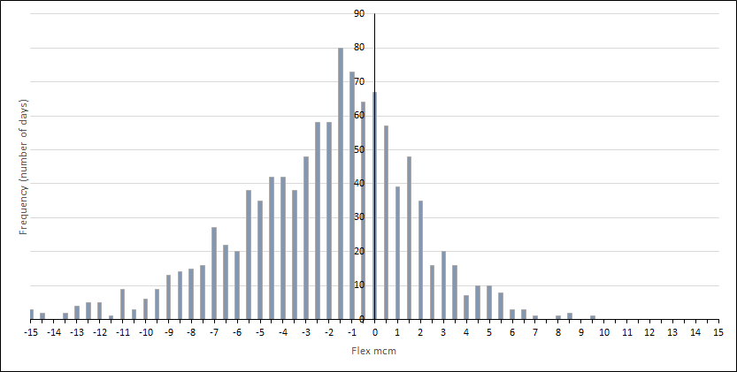
Figure 8 shows an approximately normal distribution of total supply driven linepack depletion, with an overall preference for backloading. In line with Section 2.2.1 the equivalent to a 1 day in 20 years value will be periodically re-assessed. This will provide a maximum quantity of supply driven linepack depletion to be considered, alongside flat supply levels, in our network capability assessments.
This is a total supply driven linepack depletion at a national level. To break this down amongst supply points we:
- choose the 25 highest supply driven linepack depletion days from the data set and the contribution of each supply point is calculated
- analyse the cumulative linepack depletion by supply point across those 25 days
- identify those supply points that make up the top 90% of the cumulative total supply driven linepack depletion across the 25 days
- identify the 95th percentile of the supply driven linepack depletion by supply point across the 25 days
- convert these values into percentages of the total supply driven linepack depletion.

Normalised supply profiles
Whilst the results of the previous section dictate the overall profiling behaviour (i.e. how much backloading and from which supply points), the individual profiles for each supply point need to be calculated for use within network analysis.
To do this, we:
- identify the 25 highest supply driven linepack depletion days
- normalised supply profiles by supply point for each day (a normalised supply profile gives a total of one million cubic metres (mcm) delivered to the NTS over one gas day)
- produce a backloading profile by identify the 5th percentile for each hour before 22:00 across the 25 gas days and the 95th percentile for each hour after 22:00 for each supply point.
- re-normalising the resultant profiles.
The result is a set of normalised supply profiles, one for each profiled supply point. An example of a final, normalised profile is illustrated in Figure 9.
Figure 9 Example of a normalised supply profile for a site between 2017 and 2020, with maximum, minimum and average profiles.

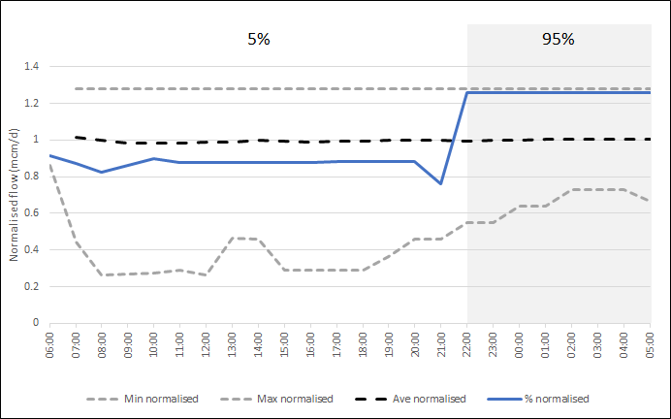

Unforeseen supply losses
Unforeseen supply losses are a sudden, significant and unplanned reductions from a supply terminal or sub-terminal that can contribute to a within day linepack depletion. To compensate for such an event, a combination of additional supplies from elsewhere on the network, as well as from the affected sub-terminal itself (after supplies are restored) are required. Causes of such a loss can include, but are not limited to:
- offshore production problems (e.g. bad weather)
- a fault at a terminal (e.g. an unforeseen plant failure)
- supply gas out of specification (e.g. a flow reduction caused by a Terminal Flow Advice).
For the purposes of this analysis no assumptions are made regarding the cause of the loss. Therefore, results are applicable to all supply loss scenarios. The linepack depletion, caused by such a loss, could result in an inability to meet minimum required pressures. To mitigate this risk, we model severe supply losses for use in network analysis.
The methodology comprises:
- building a supply loss model capable of replicating the pertinent features of real supply losses on the network.
- choosing appropriate values for the model parameters such that the features of the losses (e.g. magnitude, duration etc.) and subsequent network resilience are sufficient for the agreed requirements.

The model
Figure 10 schematically illustrates a model for a single supply loss from one supply point and the associated model parameters. The model is chosen to encompass all the behaviours of a real supply loss pertinent to the Gas Planning and Operating Standards (GPOS). Figure 11 illustrates an actual supply loss that occurred in 2017.
Figure 10 Model of a supply loss

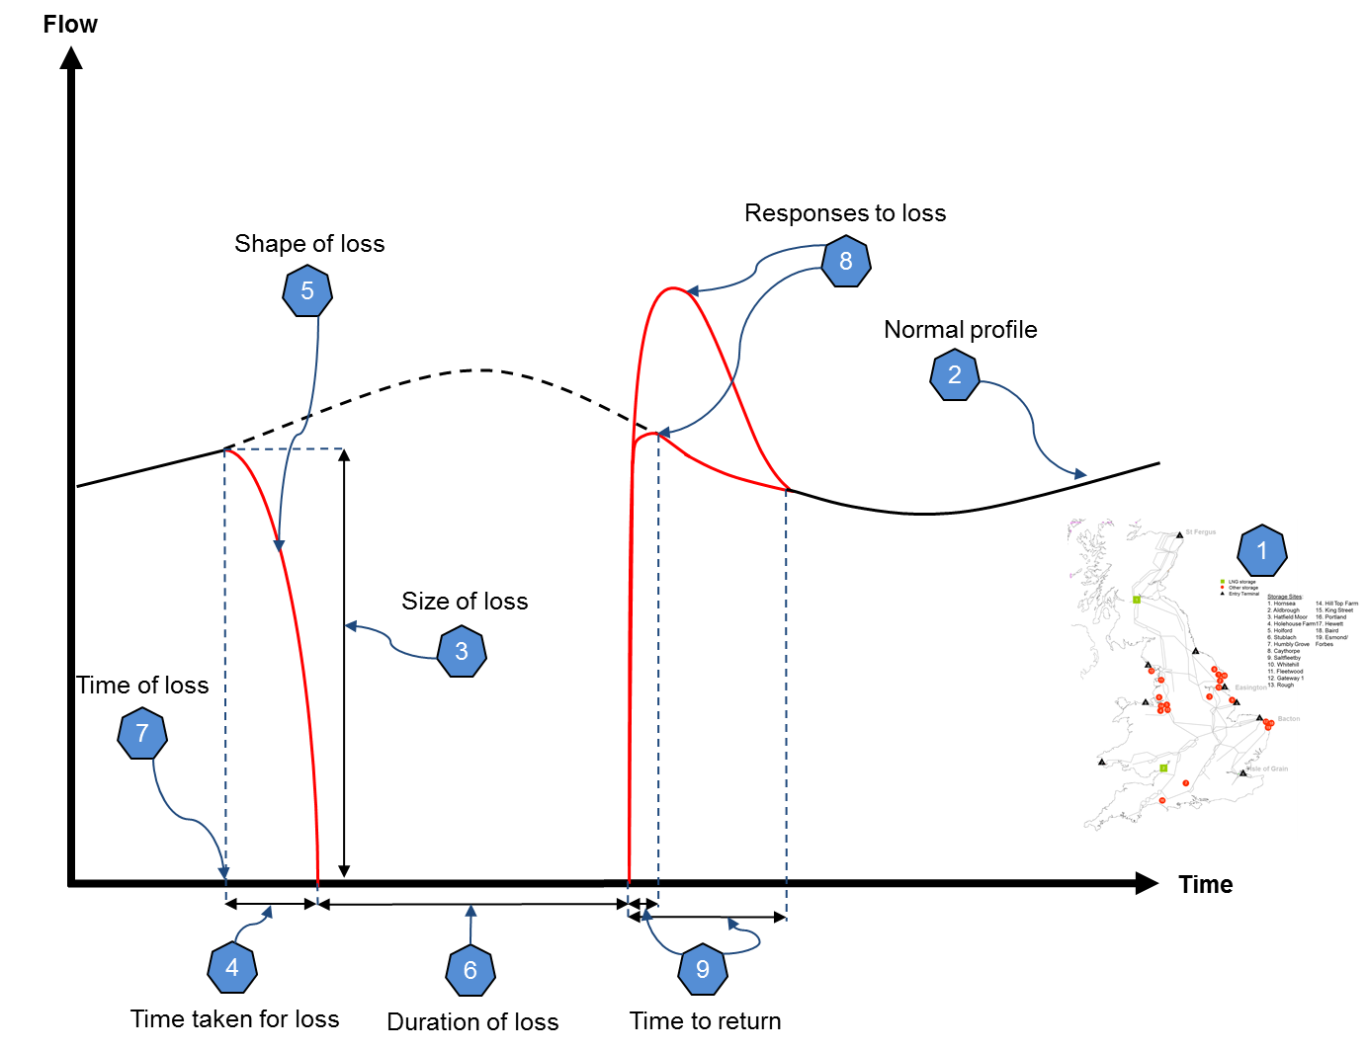
The model parameters illustrated in Figure 10 are as follows:
- Sub-terminal; the sub-terminal at which a supply loss is being considered.
- Normal profile; the supply profile that would otherwise be assumed in the absence of a supply loss.
- Size of loss; the amount by which the flow drops during the supply loss.
- Time taken for loss; the time over which the flow drop occurs.
- Shape of loss; the profile of the flow drop itself.
- Duration of loss; the period between the end of the flow drop and the start of the flow increase.
- Time of loss; the time at which the loss occurs.
- Response to loss; the mode by which supplies compensate (i.e. a combination of compensation at the affected sub-terminal and alternative sub-terminals on the network).
- Time to return; the time over which flows recommence to the ‘normal profile’.
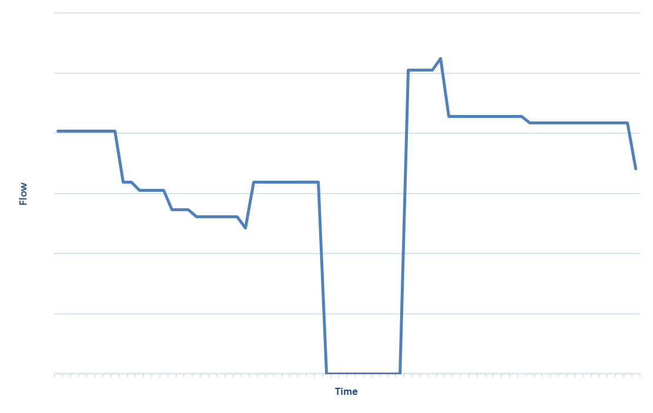
Figure 11 Actual flow profile for a ten-hour supply loss in 2017

Choosing model parameters
Having defined a suitable supply loss model, we choose values for the model parameters to ensure that the supply losses modelled and corresponding network resilience are in keeping with the agreed requirements. We use, historical analysis, business insight, modelling constraints and computer programs to determine the model’s parameter.
To arrive at the data set used for historical analysis we consider, hourly average supply volumes through all relevant supply points for each gas day for a three-year period. Thereafter we identify the hour bar over which the supply rate for each supply point experienced the greatest drop within each gas day. We can then identify the top ten supply drops for each supply point that reflect true supply losses (i.e. excluding noisy data or data anomalies).
The model parameters are as follows (see also Figure 12):
- Sub-terminal; the sub-terminals considered to be the highest risk in terms of the potential impact of a supply loss.
- Normal profile; the supply profiles that would otherwise be assumed in the absence of a supply loss are chosen to be those derived in the previous section.
- Size of loss; losses are modelled as 100% (i.e. a drop to 0mcm/hour) for the duration of the loss. This is in keeping with a number of 100% losses observed in the historical data.
- Time taken for loss; modelling is undertaken in hourly time steps. Given the immediate nature of supply losses and that a ramp down in supply lasting for 2 hours or greater could be considered within day profiling, the period over which the flow drop occurs is set at 1 hour.
- Shape of loss; given that the ramp down is to occur over 1 hour and that hourly time steps are assumed; the ramp down must necessarily be modelled as a constant rate change between the time of the loss at 14:00 and reaching a flow of zero at 15:00.
- Duration of loss; the average loss duration for the sub-terminals considered in the historic data set is approximately 8 hours, with the loss duration defined as the time taken for the system’s supply rate to return to its value at the time of the loss. This value is used for modelling purposes. A significantly shorter timescale would be unlikely to have a material impact on system pressures, whilst a significantly longer timescale would be considered a potential network emergency.
- Time of loss; given that the typical duration of a loss is set at 8 hours; losses are set to begin at 14:00. Thus, their end coincides with the typical time of minimal system linepack (approximately 22:00). This provides the most challenging network conditions, since the supply loss driven linepack depletion will coincide with the daily period of minimal system linepack, resulting in the lowest resultant network pressures.
- Response to loss; typically, the gas deficit caused by a supply loss is compensated by the affected supply point increasing its flow rate after supplies have been restored; as will other supply points on the network. For each supply point considered, the responses are pro-rated amongst a selection of supply points according to their historical contributions. To derive these contributions, the difference in flow rate between the loss time and recovery time is calculated, for each supply point, for each of the top ten supply losses.
- Time to return; whilst a range of flow behaviours are exhibited amongst the losses in the data, from gradual to rapid responses, for the purposes of this analysis we choose the minimum time (i.e. 1 hour) over the last hour of the loss (i.e. from 21:00 to 22:00).
- Shape of return; we model this as a constant rate increase all ramp ups for the final hour of the supply loss (i.e. from 21:00 to 22:00). For each sub-terminal, the extra supply required to compensate for the loss deficit is distributed equally over the remainder of the gas day (i.e. from 22:00 to 05:00). The exception is the final hour bar (from 04:00 to 05:00) as all flow rates must return to their start of day values to conduct network analysis.
Figure 12 Schematic illustration of parameter choices.

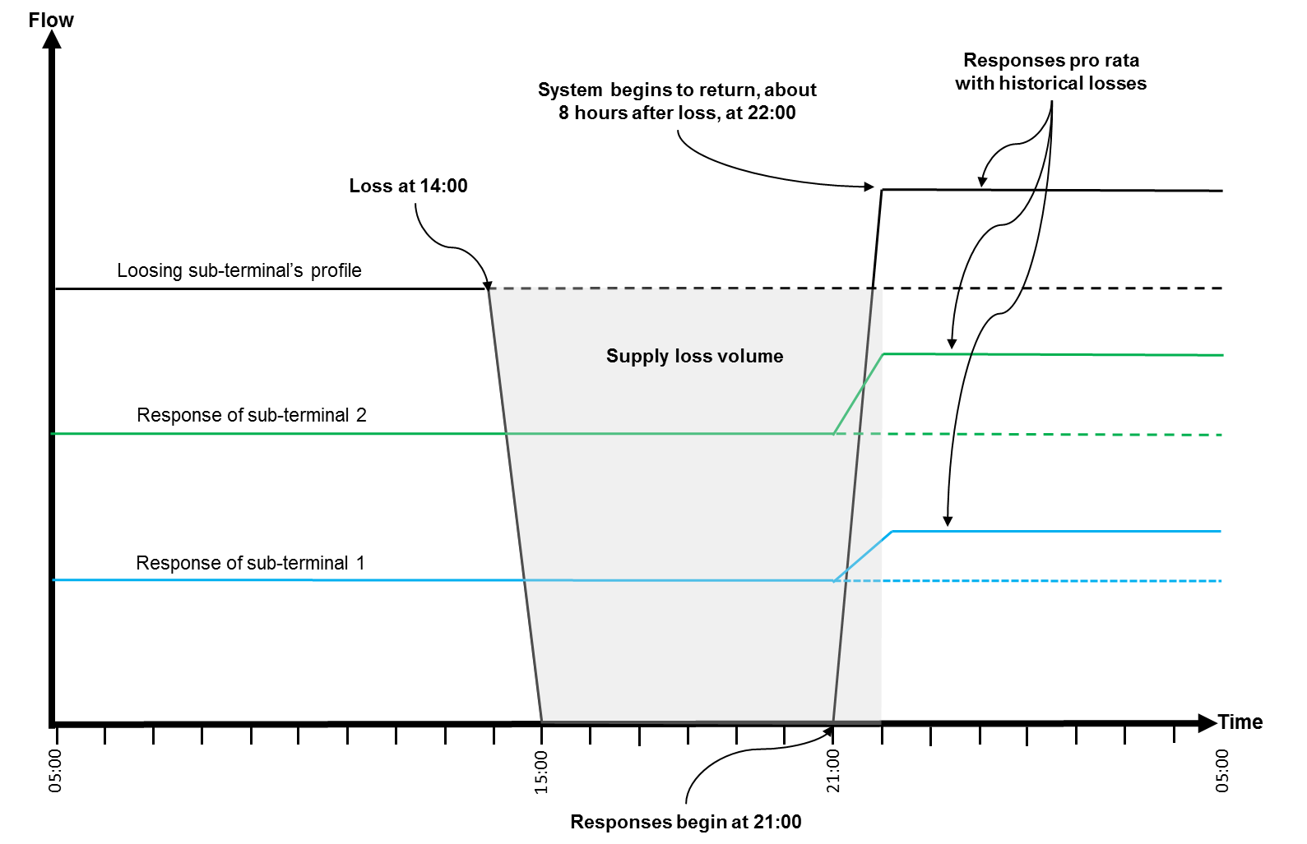

Demands
Alternative supplies connecting to the network, along with changing demand profiles, have resulted in fundamental changes to the way the NTS is operated. Over the years, a number of combined cycle gas turbines (CCGTs), which are gas driven electricity generators, have connected to the network. This results in increased demand profiles in some regions. To ensure suitable levels of resilience are in place it is imperative to understand CCGT behaviours and their potential impacts on the network and, in particular, its extremities.
A CCGT’s ability to not follow its forecast demand profile or nominated rates in short periods can have a substantial impact on instantaneous flow rates on the network. This can contribute significantly to linepack depletion in its region. For this reason, an appropriate amount of resilience is required.
To this end, we focus on two geographical regions, these are the South East and South West extremities. Focus is placed on these regions as there are several CCGTs connected in both regions. Typically, these are NTS capacity constrained areas of the network when local supplies are low. Within the South West region five CCGTs and their respective profiles over a three-year period were observed, in the South East region six CCGTS and their respective profiles over a three-year period were observed.

CCGT demand profiles
In this section, we describe our methodology to ensure appropriate demand driven linepack depletion resulting from CCGT demand profiles is taken into consideration.
Several factors can contribute to the profiling of CCGTs, some of which may have a bigger impact on profiling and hence linepack depletion. Some of the factors can include forecasting errors, weather and the availability of other forms of electricity generation.

Calculating an appropriate level of linepack depletion resulting from CCGT demand profiles
Like supply profiling, we identify the 25 days where the NTS saw the biggest regional linepack depletion in the South East, and the South West, due to CCGTs. It is these days which we use as a base to create normalised profiles.
Data sets are created for all 25 days with greatest linepack depletion. These are used to create hourly flow profiles on each day. Figure 13 shows example profiles of five CCGTs on a high profiled day.
Figure 13 South West power station flow profile over a real gas day in 2020

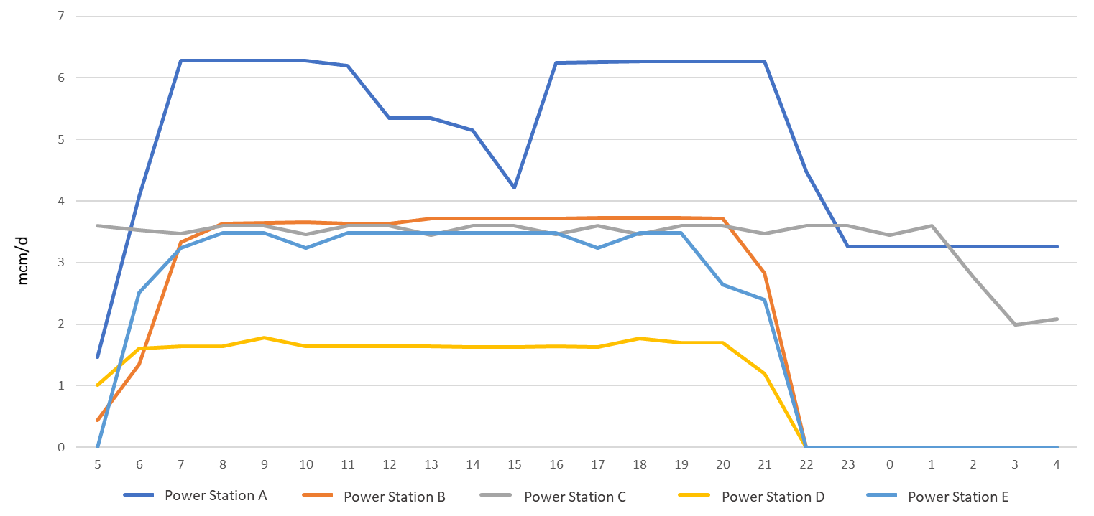

Normalised linepack depletion profile
We create normalised linepack depletion profiles based on the historic data set. To create a linepack depletion profile, the 95th percentile figure (high flow) is used between 06:00 and 22:00 and 5th percentile figure (low flow) used from 22:00 to 06:00 (see Figure 14).
Figure 14 Normalised linepack depletion profile in the South West, based on 25 highest days between 2017 and 2020

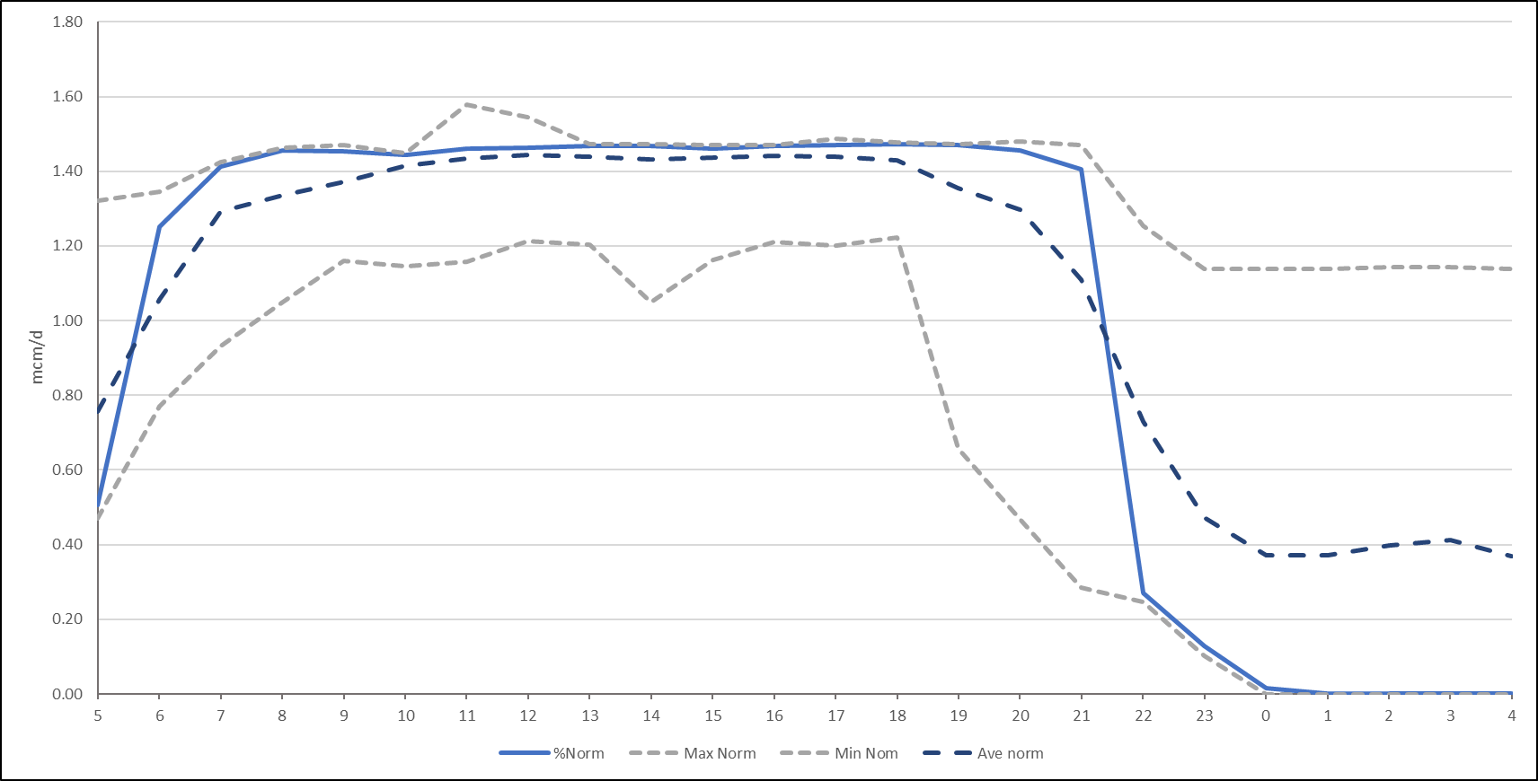
If the normalised profile, when applied to the forecast end of day volume of a CCGT, breaches the maximum NTS exit point offtake rate (MNEPOR) at any point during the day, the profile is scaled so that there is adherence to MNEPOR.
Comparison of this approach were made with historic levels, the 25 days with the highest CCGT driven linepack depletion in the South West range between 2.8 mcm and 3.35 mcm of linepack depletion. National Grid’s methodology typically generates 2.5 mcm of linepack depletion.

Unforeseen increases in CCGT demand
A sudden increase in a CCGT’s demand can have a substantial impact on instantaneous flow rates on the network and hence can contribute significantly to linepack depletion. Like CCGT profiling, forecast errors, weather and faults on other forms of electricity generation can all contribute to sudden increases in CCGT demand.
CCGT demand increases can occur at any time. However, it is the time that this demand ramp up begins which is of vital importance to real-time operations, due to the impact on local pressure and linepack. This sudden ramp up in demand can also have implications on nearby compression, as increased demand will in turn cause nearby compression to work harder to meet downstream pressure requirements and can potentially lead to compressor trips. This behaviour is especially pertinent to both the South East and South West extremities due to their location and the distance they are from NTS supplies. Smaller diameter pipework feeding these extremities also greatly affects pressures when flows increase.

Calculating appropriate increases in CCGT demand
Using historical data collected over three years, we identify sudden increases in demand for South East’s and South West’s CCGTs. Increases are considered over one hour, two hour and three hour periods.
Based on changes of hourly flow data, CCGT rate changes over the gas day are assessed, see Figure 15. Maximum rates of change along with a 99th percentile rate of change have been included in the figure. We use the 99th percentile for network analysis, as nearly all days are included in this data set as this is equivalent to excluding the top four days. Figure 15 shows two significant peaks which represent morning and early evening demand respectively, analogous to electricity demand.
Figure 15 Changes in CCGT demand over time in the South West region between 2017 and 2020.

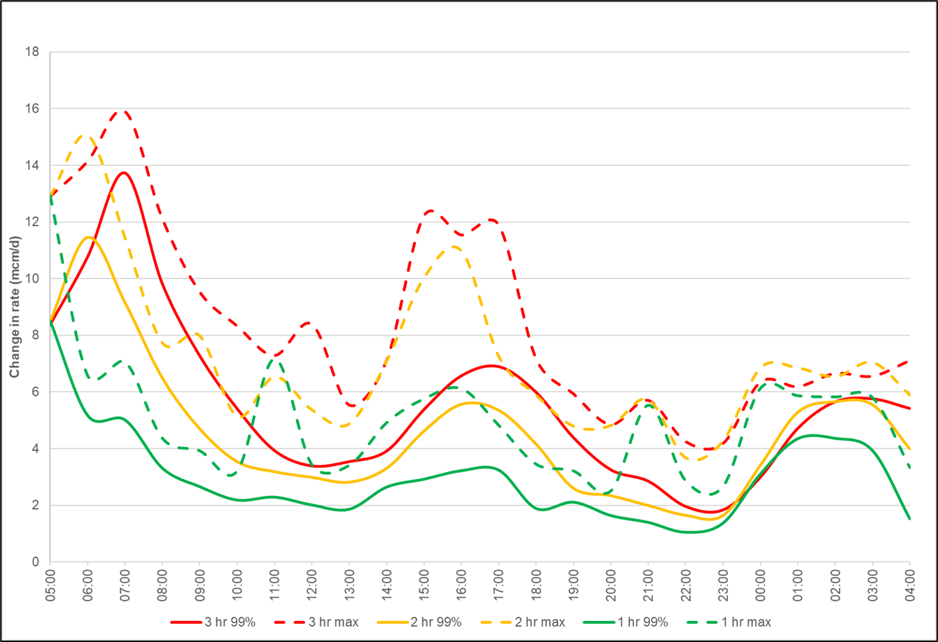

Increased demand profiles
We create a flow profile, which incorporates historic ramping behaviour that is used in network analysis. We apply the relevant three-hour increase, as described in the previous section, and combined it with the CCGT demand forecast for each CCGT in the South West and South East. This is done for each supply and demand pattern considered. Figure 16 is an illustrative example of how the three-hour ramp rate has been applied to forecast CCGT demand to meet the historic maximum flow.
Figure 16 Sudden increase in demand over 3 hours, applied to forecast CCGT demand

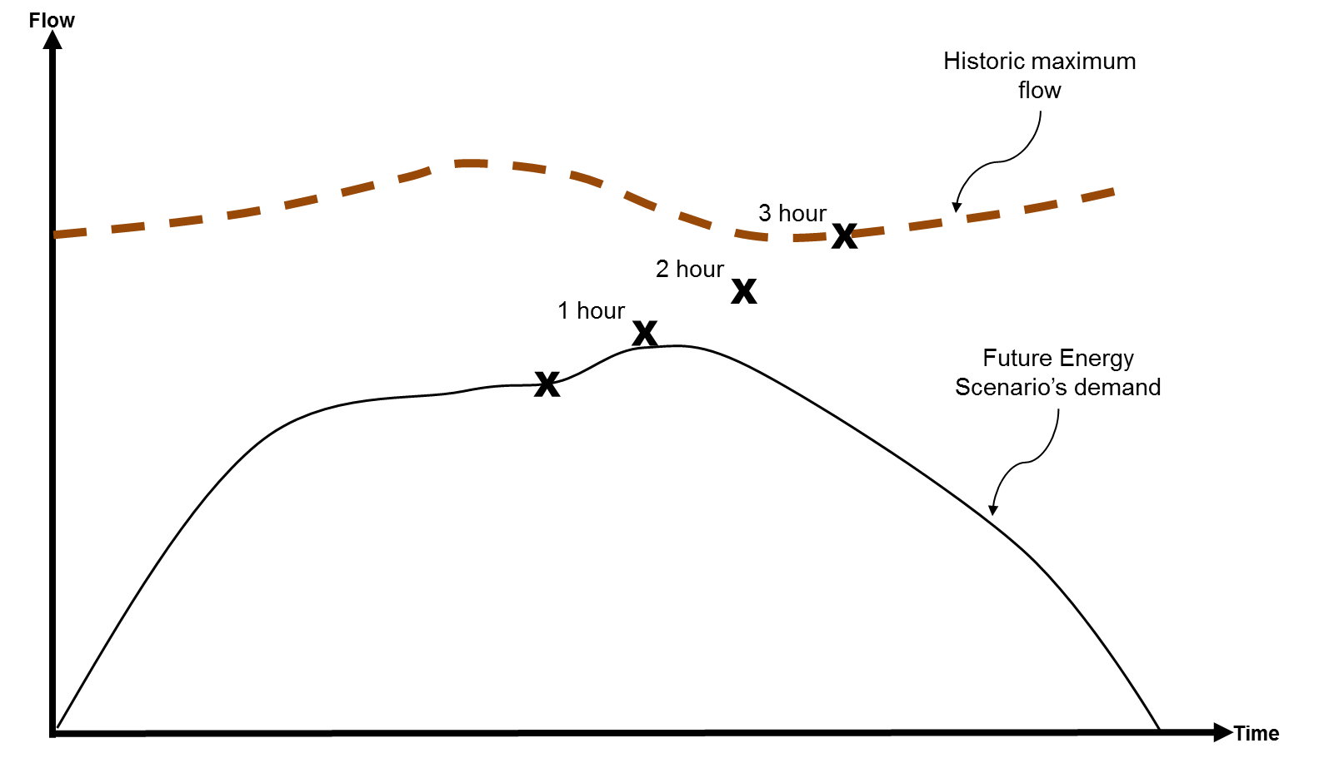
Figure 17 shows an example CCGT demand profile for a given supply and demand scenario. The calculated rate of increase has been applied to the flow profile from 14:00. By doing this, additional linepack depletion is experienced due to additional demand increases without an immediate supply response (as experienced by our Control Room in real-time operations).
The flow profile is then continued until 22:00 (approximate point of minimum linepack), at which point flow begins to decrease as demand normally turns down or until the end of the gas day to assess the potential impact of flows remaining at their historic maximum.
Figure 17 Ramp rate applied to South West profile from 14:00

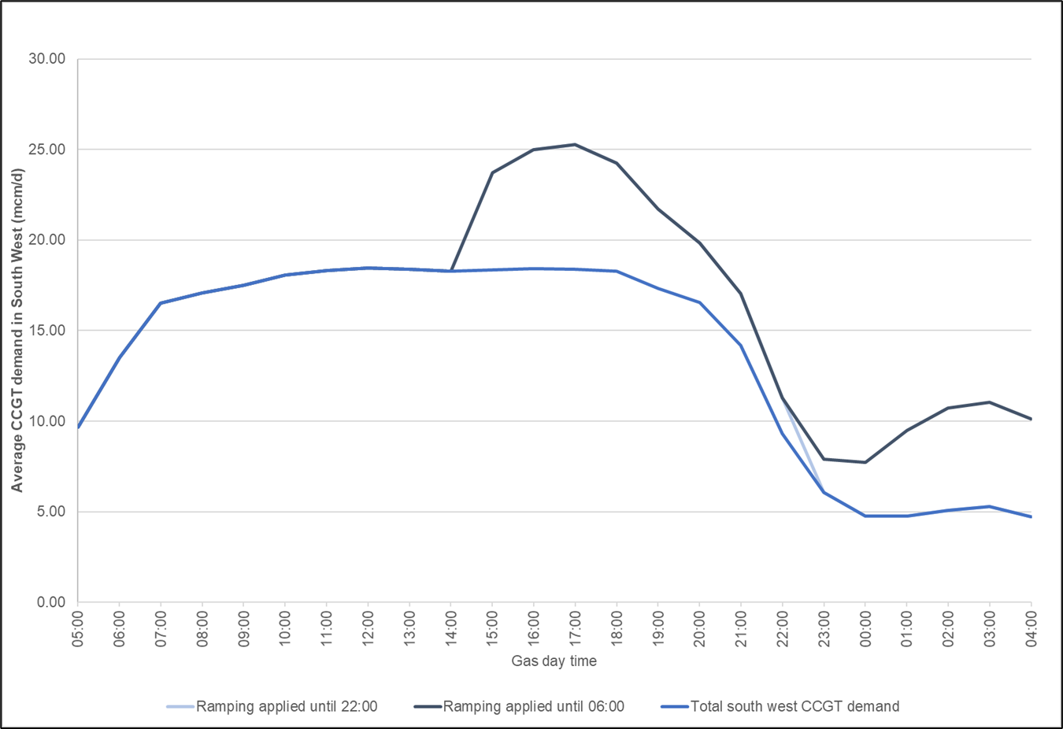

Assets
The NTS is controlled and configured using a variety of assets including compressors, valves and regulators. All ‘controllable’ assets present a risk that they may not respond to control actions from our Control Room. Although processes are in place to mitigate this risk, and occurrences are rare, it remains a possibility. Due to their significant complexity, and associated safety, monitoring and ancillary systems, response failures or trips (either failure to start or unforeseen shutdown whilst running) are more common in compressors. In addition to this, instances of failures to start, or trips, can be exacerbated by operating assets in a mode which is different to that for which they were designed. For example, most of the compressors on the NTS were designed to operate to allow bulk transportation of gas across the country, from north to south. This required, steady, continuous running. Given changes in NTS supply and demand behaviour, compressors are now required to operate much more flexibly, with quick increases, and decreases, in output.

Effects of a compressor trip
Compressor units are usually started either to increase falling downstream pressures and move gas towards the demand points, or to reduce upstream pressures and enable higher input rates by moving gas away from supply points. When a failure to start or a start-up trip occurs, the compressor has no effect on the NTS and it fails to increase downstream pressures. This means that the pressure decay or event triggering the use of the compressor continues unaffected.
A running trip, when the compressor suddenly stops whilst in operation, results in a sudden loss of immediate downstream pressure, with the effect continuing downstream as you move further from the compressor. Unless re-started, the downstream pressure reduction will continue until the pressure downstream has equalised with that on the upstream side, effectively the local state that would be seen without the compressor running. It is also possible for compressor trips to adversely affect nearby equipment and other compressors, the changing flow and pressure conditions resulting from a trip can cause additional trips of adjacent units. These events can ultimately compromise our ability to ensure that system pressures stay within the operating limits.

Recovery
Compressor trips occur for various reasons, including mechanical failure and sensor faults, and the response time to either re-start a unit or bring an additional unit online can vary. These limits can either be because of the time required to get staff to site, if out of normal hours, or because of hard coded limits put in place by the manufacturer.
If a response is time critical, and alternate units are available, then our Control Room may choose to use an alternate unit on site sooner, or re-configure the NTS and use an alternative site to provide partial mitigation.

Trips failure frequency
We assess the frequency of compressor trips to ensure suitable resilience is maintained. As more compression is typically used during the winter months and at high demand levels, the number of compressor trips observed is higher in these periods. Therefore, resilience is included for the possibility of a compressor trip on any given day where its use is required.

Calculating locational pressure cover
The results of the analysis into magnitude, duration and frequency of supply, demand and asset events are fed into specific network analysis activities to assess the impact of these events on system pressures. We do this to determine appropriate levels of locational pressure cover. These events are considered individually and not in combination.
We undertake analysis across a range of supply and demand patterns and national linepack levels to determine how the required pressure cover varies.
Figure 18 shows how pressure cover is calculated for an exit point for a given event with a given supply and demand pattern. The first diagram shows the simulated pressure profile with no event. The second diagram shows the impact of the event on the local linepack and hence the simulated pressure at that point. In this example, the distributions network’s assured offtake pressure (AOP) cannot be maintained at all times throughout the gas day. Pressure cover is therefore required to ensure that should the event occur, our Control Room has sufficient time to determine and enact the appropriate response to ensure that the AOP is maintained.
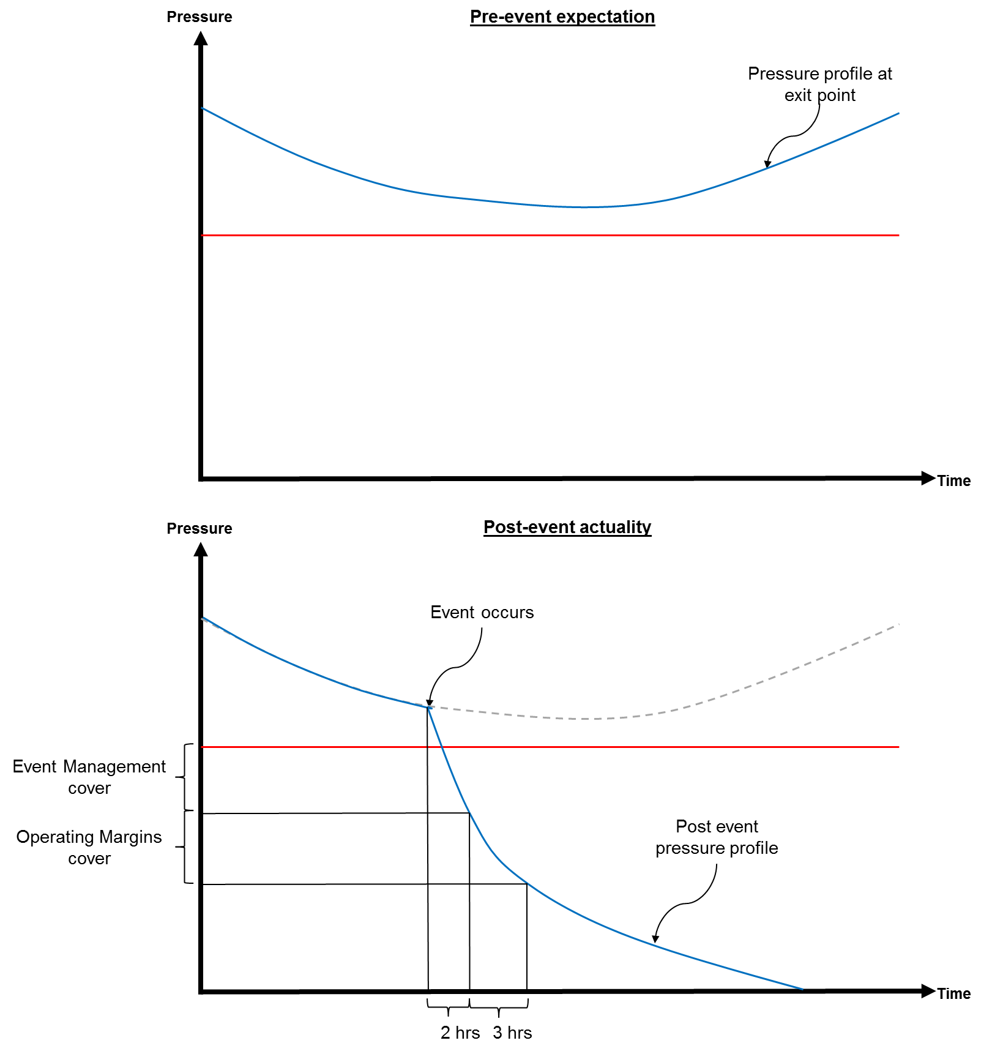
Figure 18 Calculating pressure cover
As described in Section 6.7.2 we calculate each pressure cover based on two categories:
- Event Management; a period of up to 2 hours allowing our Control Room to formulate a response to an uncertainty event and attempt resolution.
- Operating Margins (OM); if the Event Management is unsuccessful, then the period between our Control Room ‘calling’ OM and the physical response. This period is defined within OM contracts.
This is repeated for all defined events across supply and demand patterns and national linepack levels in line with the process described in Figure 19.

Figure 19 Pressure cover calculation process

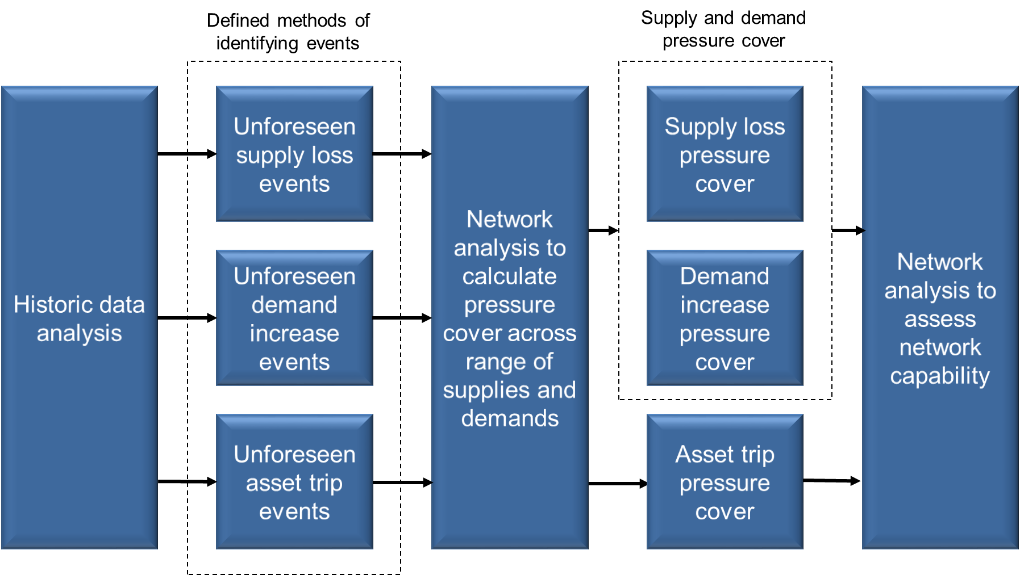

Appendix F: Glossary
Aftercooler
A device fitted on a compressor station that cools the gas after the compression process, in order that the gas temperature may be maintained within safe limits for the downstream pipeline.
Assured Offtake Pressure (AOP)
A minimum pressure at an offtake from the NTS to a DN that is required to support the downstream network. AOPs are agreed and revised through the annual OCS process.
Aggregate System Entry Point (ASEP)
A system entry point where there is more than one, or adjacent connected delivery facilities; the term is often used to refer to gas supply terminals.
Anticipated Normal Operating Pressure (ANOP)
A pressure that we may make available at an offtake to a large consumer connected to the NTS under normal operating conditions. ANOPs are specified within the NExA agreement for the site.
Bar(g)
The unit of pressure that is approximately equal to atmospheric pressure (0.987 standard atmospheres). Where the unit of bar is suffixed with the letter g, such as in bar(g), the pressure being referred to is gauge pressure, i.e. pressure relative to atmospheric pressure.
Best Available Technique (BAT)
A term used in relation to Industrial Emissions Directive (IED) 2010. In this context, BAT is defined as Best Available Technique and means applying the most effective methods of operation for providing the basis for emission limit values and other permit conditions designed to prevent and, where that is not practicable, to reduce emissions and the impact on the environment.
BEIS
Department for Business, Energy & Industrial Strategy.
Calorific Value (CV)
The ratio of energy to volume measured in mega joules per cubic metre (MJ/m), which for a gas is measured and expressed under standard conditions of temperature and pressure.
Carbon Monoxide (CO)
A colorless, odourless, tasteless gas that is slightly lighter than air. It is a product of incomplete combustion when carbon is burnt with insufficient oxygen.
Compression Energy
Gas and electricity used by us to operate the transportation system that includes energy used for compressor fuel, heating and venting.
Compressor Station
An installation that uses gas turbine or electrically driven compressors to boost pressures in the pipeline system. Compressors are used to increase transmission capacity and move gas through the network.
CV Shrinkage
A quantity of energy that may not be billed to end consumers under the Gas (Calculation of Thermal Energy) Regulations 1996. CV Shrinkage arises from variations in CV across an LDZ above a certain threshold. End consumers within the LDZ may only be billed on a maximum CV assumption of 1 MJ/m3 above the flow weighted average CV entering the LDZ.
Delivery Facility Operator (DFO)
The operator of a reception terminal or storage facility, who processes and meters gas deliveries from offshore pipelines or storage facilities before transferring the gas to the NTS.
Distribution Network (DN)
A gas transportation system that delivers gas to industrial, commercial and domestic consumers within a defined geographical boundary. There are currently eight DNs, each consisting of one or more local distribution zones (LDZs). DNs typically operate at lower pressures than the NTS.
Distribution Network Operator (DNO)
Distribution network operators own and operate the distribution networks that are supplied by the NTS.
Domestic Customer Supply Security Standard
The availability of a supply of gas which would equal the peak aggregate daily demand for the relevant gas supplier’s current domestic customers which, having regard to historical weather data derived from at least the previous 50 years and other relevant factors, is likely to be exceeded (whether on one or more days) on in 1 year out of 20 years. The definition also includes the availability of supplies of gas over a year which could equal the aggregate annual demand, and over the first six months of a year which would equal the aggregate demand during such a six-month period which, in each case, is likely to be exceeded only in 1 year out of 50 years.
Emission Limit Value (ELV)
The permissible quantity of a substance contained in the waste gases from a combustion plant which may be discharged into the air during a given period.
Entry Capacity
The right to deliver a quantity of gas into the NTS at an entry point, as defined in the Licence and UNC TPD Section B.
Entry Capacity Release Methodology Statement (ECR)
A document produced in accordance with Special Condition 9.18 of the Licence. The ECR describes the methodology that we employ to determine the quantity of entry capacity that it will release to comply with its obligations in the Licence and Uniform Network Code. It applies to all entry capacity, i.e. existing system entry capacity and additional "incremental" entry capacity, including capacity release at Interconnection Points. It defines under what circumstances we will accept applications for incremental entry capacity from shippers received through processes described in the Uniform Network Code, and thereby the level of financial commitment required from those shippers.
Entry Capacity Substitution Methodology Statement (ECS)
A document produced in accordance with Special Condition 9.17 of the Licence. This document describes the methodology that we will utilise when considering the substitution of NTS entry capacity from one ASEP to another ASEP where demand for entry capacity exceeds existing obligated quantities. It defines:
- under what circumstances we will consider such substitutions
- the process to be undertaken by us to determine its proposals to substitute capacity and revise baseline quantities.
Entry Capacity Transfer and Entry Trade Methodology Statement (ECTET)
A document produced by us in accordance with Special Condition 9.17 of our Gas Transporter Licence (the Licence).
Entry Point
A point at which gas is delivered into the NTS. The entry point may comprise several facilities where gas is delivered. Also, referred to as an aggregate system entry point in the UNC.
Environment Agency
A non-departmental public body sponsored by the United Kingdom Government’s Department for Environment, Food and Rural Affairs, with responsibilities relating to the protection and enhancement of the environment in England.

European Network of Transmission System Operators for Gas (ENTSOG)
An organisation to facilitate cooperation between national gas transmission system operators across Europe to ensure the development of a pan-European transmission system in line with European Union energy goals.
EU Emissions Trading Scheme (EU ETS)
The European Union, EU ETS, market based policy commenced on 1 January 2005 to tackle emissions of carbon dioxide and other greenhouse gases, to help combat climate change.
Exit Capacity
The right to offtake a quantity of gas into the NTS at an exit point, as defined in the Licence and UNC TPD Section B.
Exit Capacity Release (ExCR) Methodology Statement
A document produced in accordance with Special Conditions 9.18 of the Licence. This document describes the methodology that we employ for the release of all exit capacity, i.e. incremental and existing system exit capacity, including capacity release at interconnection points.
Exit Capacity Substitution and Revision (ExCS) Methodology Statement
A document produced in accordance with Special Condition 9.17 of the Licence. This document describes the methodology that we will utilise to determine proposals for:
- the substitution of NTS exit baseline capacity from one NTS Exit Point to another where demand for exit capacity exceeds existing obligated quantities
- the revision to NTS baseline exit capacities at NTS Exit Points where new pipeline infrastructure installed to facilitate the release of incremental entry capacity has a beneficial effect on the availability of exit capacity.
Exit Point
A point at which gas is taken from the NTS. The exit point may comprise several facilities where gas may be taken.
Flow Swaps
We or a DNO user may request a revision to offtake profile notices (OPNs) for two or more offtakes within a particular local distribution zone (LDZ) where the revised rates of offtake requested are the same as the aggregate rates of offtake under the prevailing OPNs at the time the request is made. The rules around flow swaps are currently contained in UNC Offtake Arrangements Document (OAD) Section I2.4 and I2.5.
Future Energy Scenarios (FES)
The Future Energy Scenario consultation includes questionnaires, as well as one to one discussions with stakeholders, industry workshops and presentations to stakeholders. The Future Energy Scenarios document describes in detail the assumptions behind the main scenarios used in planning analysis and future energy scenarios.
Gas and Electricity Markets Authority (GEMA)
The Gas and Electricity Markets Authority (the Authority) governs the natural gas industry in the UK, and is the body that grants and administers licences to gas transporters, shippers and suppliers.
Gas Future Operability Planning (GFOP)
The GFOP is published annually alongside the GTYS, and contains information on the operability challenges that we foresee for the NTS.
Gas Ten Year Statement (GTYS)
The Gas Ten Year Statement is published annually and contains information on our long-term gas supply and demand scenarios, and investment proposals over the ten-year planning horizon.

Gas Transporter (GT)
Gas transporters, such as us, are licensed by the Gas and Electricity Markets Authority to transport gas to consumers.

GSMR
Gas Safety (Management) Regulations.
Health and Safety Executive (HSE)
The HSE is the UK regulatory body responsible for regulating health and safety at work.
Industrial Emissions Directive (IED)
The Industrial Emissions Directive came into force on 6th January 2011. IED recasts seven existing Directives related to industrial emissions into a single clear, coherent legislative instrument. The recast includes IPPC, LCPD, the Waste Incineration Directive, the Solvents Emissions Directive and three Directives on Titanium Dioxide.
IGEM
Institute of Gas Engineers and Managers.
Incremental Obligated Entry Capacity
Incremental obligated entry capacity is capacity that we must offer for sale to shippers above a pre-determined baseline level (also defined in the Licence) and is triggered through long term auction signals placed by shippers.
Interconnector
A pipeline transporting gas to another country. The Irish Interconnector transports gas across the Irish Sea to both the Republic of Ireland and Northern Ireland. The Belgian Interconnector (IUK) transports gas between Bacton and Zeebrugge and is capable of flowing gas in either direction. The Dutch Interconnector (BBL) transports gas between Balgzand in the Netherlands and Bacton.
IP
Interconnection point a physical or virtual point connecting adjacent entry-exit systems or connecting an entry-exit system with an interconnector, in so far as these points are subject to booking procedures by network users.
IPPC
Integrated Pollution Prevention and Control.
Kilowatt hour (kWh)
A unit of energy used by the gas industry. Approximately equal to 0.0341 therms. One megawatt hour (MWh) equals 10³ kWh.
Large Combustion Plant Directive (LCPD)
A European Union directive which introduced measures to control the emissions of sulphur dioxide, oxides of nitrogen and dust from large combustion plant, including power stations.
Licence
Used in this document to refer to our Gas Transporter Licence in respect of the NTS.
Linepack
The volume of gas within the National Transmission System at any time.
Liquefied Natural Gas (LNG)
Gas stored or transported in liquid form.
Load Duration Curve (1-in-50 Severe)
The 1-in-50 severe load duration curve is that curve which, in a long series of years, with connected load held at the levels appropriate to the year in question, would be such that the volume of demand above any given demand threshold (represented by the area under the curve and above the threshold) would be exceeded in one out of 50 years.
Load Duration Curve (Average)
The average load duration curve is that curve which, in a long series of winters, with connected load held at the levels appropriate to the year in question, the average volume of demand above any given threshold, is represented by the area under the curve and above the threshold.
Local Distribution Zone (LDZ)
A geographic area supplied by one or more NTS offtakes that comprises a part of a distribution network.
Locational buys and sells on the OCM
When a shipper has a clear idea of its supply and demand on a day, it may decide to use the OCM to buy gas from or sell gas to the NTS for system balancing purposes. The shipper might also make location specific bids, which can be selected by the NTS when it needs to increase or reduce flows at a location.
Maximum Operating Pressure (MOP)
The maximum pressure that each section of the NTS can operate at and is relevant to connected NTS exit and NTS entry point or terminals.
Medium Combustion Plant Directive (MCP)
The Medium Combustion Plant Directive (MCPD) will apply limits on emissions to air from sites below 50 MW thermal input. The MCPD is likely to come into force by 2020.
Millions of Standard Cubic Meters per Day (mscm/d)
A standard cubic meter is the unit of volume, expressed under metric standard conditions (15ºC, 1.01325 bar, dry gas), approximately equal to 35.37 standard cubic feet. 1 million standard cubic meters is equal to 10⁶ standard cubic meters. The units mscm/d refer to a standard volumetric flow rate.
National Transmission System (NTS)
A high-pressure gas transportation system consisting of compressor stations, pipelines, multi-junction sites and offtakes. NTS pipelines transport gas from terminals to NTS offtakes and are designed to operate up to pressures of 94 bar(g).
Network Analysis
The modelling of the physical behaviour of a network of pipes, compressors and other equipment using mathematical software.
Network Entry Agreement (NEA)
An agreement that sets out the technical and operational conditions for the connection and is required by the Uniform Network Code (UNC). The NEA is agreed between the delivery facility operator (DFO) and us and is normally discussed with the future operator of the entry facility in parallel with the connection process.
Network Exit Agreement (NExA)
An agreement that sets out the technical and operational conditions for the connection point. The NExA is agreed between us and the facility operator or the shipper and is normally discussed in parallel with the connection process.
Nitrous Oxides (NOx)
A group of chemical compounds, some of which are contributors to pollution, acid rain or are classified as greenhouse gases.
NTS Exit (Flat) Capacity
The right to offtake a quantity of gas from the NTS at a steady rate over a gas day as defined in the UNC TPD Section B.

NTS Exit (Flexibility) Capacity
The right to vary the offtake a quantity of gas from the NTS at from a steady rate over a gas day as defined in the UNC TPD Section B. Only DNOs may hold NTS Exit (Flexibility) Capacity.
Offtake
An installation defining the boundary between the NTS and a DN or a very large consumer. The offtake installation includes equipment for metering, pressure regulation, etc.
Operational Balancing Actions
We utilise a range of tools designed to deliver gas flow rate changes for management of the NTS. Some tools are direct e.g. locational actions. Other tools are less direct e.g. capacity buy-backs, gas trades and are used where commercial actions are anticipated to give rise to flow rate changes.
Offtake Capacity Statement (OCS)
The agreement made between us and DNOs in respect of the DNOs’ bookings for NTS exit (flat) capacity, NTS exit (flexibility) capacity and assured offtake pressures as described in the UNC TPD Section B.
Offtake Flow Reductions
In relation to a relevant system exit point, a period of notice may be given to the relevant gas transporter of any change to the rate of offtake, an offtake rate change, by means of a modified Offtake Profile Notice. The rates of change can be either an increase or a decrease.
Office of Gas and Electricity Markets (Ofgem)
The regulatory body responsible for regulating Great Britain’s gas and electricity markets.
Operating Margins Gas (OM)
A quantity of gas held in store to be used to maintain system pressures if other system management services are considered not to have the desired effect. A quantity of operating margins will be kept in reserve to manage the orderly run-down of the system following the exhaustion of all other storage gas and during periods of high demand. Operating margins may also be used to support system pressures on the gas day in the event of a compressor trip, pipe break or other failure or damage to transmission plant.
Offtake Profile Notice
In relation to a relevant system exit point or NTS/LDZ offtake a notification known as an Offtake Profile Notice (OPN) is submitted to the relevant gas transporter setting out the rates of offtake throughout the gas flow day. The rules around OPNs are contained in UNC TPD J4.5.
Planning & Advanced Reservation of Capacity Agreement (PARCA)
A PARCA is a multi-phased bilateral contract, between us and a customer, which, would allow firm quarterly system entry capacity or firm enduring annual NTS exit (flat) capacity to be reserved for that customer, whilst they develop the initial phases of their own project.
Peak Day Demand (1-in-20 Peak Demand)
The 1-in-20 peak day demand is the level of demand that, in a long series of winters, with connected load held at the levels appropriate to the winter in question, would be exceeded in one out of 20 winters, with each winter counted only once.
Pollution Prevention and Control (Scotland) Regulation (PPC)
The Scottish enactment put in place to comply with European Integrated Pollution Prevention and Control Directive (IPPC).
Quarterly System Entry Capacity (QSEC)
NTS entry capacity available on a long-term basis (up to 17 years into the future) via an auction process. Also known as long term system entry capacity (LTSEC).
Regulator
A device that may be used to control gas pressure or flow rate.
Revenue Drivers
Revenue drivers are the means of increasing our allowed revenue as a consequence of the release of funded incremental obligated entry or exit capacity to fund the construction of additional assets or contractual arrangements to facilitate the release of that capacity.
Scale back of interruptible NTS entry capacity
If the amount or rate at which gas is delivered or will be delivered to the NTS is greater than the system entry capability (as determined by us) or if there is or will be a transportation constrained or localised transportation deficit, interruptible NTS entry capacity holdings can be subject to curtailment at one more NTS entry points on a pro-rated basis per shipper based on shippers’ capacity holdings.
Scottish Environment Protection Agency (SEPA)
A non-departmental public body of the Scottish Government, whose role is to make sure that the environment and human health are protected, to ensure that Scotland’s natural resources and services are used as sustainably as possible and contribute to sustainable economic growth.
Shipper
A company with a Shipper’s Licence that can buy gas from a producer, then sell it to a supplier and employ gas transporter(s) to transport gas to consumers.
Shrinkage
Gas that is input to the system but is not delivered to consumers or injected into storage. It comprises compression energy, CV shrinkage and unaccounted for gas.
Storage Connection Agreement (SCA)
A storage connection agreement contains elements of the network entry agreement (NEA) and the network exit agreement (NExA).
Storage Operator
The operator of a storage facility connected to the NTS.
Sulphur dioxide (SO2)
A colourless gas, which is emitted when fossil fuels are combusted. It reacts on the surface of a variety of airborne solid particles, is soluble in water and can be oxidised within airborne water droplets.
Supplier
A company with a Supplier Licence that contracts with a shipper to buy gas, which is then sold to consumers. A supplier may also be licensed as a shipper.
System Management Principles Statement (SMPS)
A document that sets out processes and obligations which are aligned to and shall be interpreted and applied in accordance with applicable national and European law, notably Article 6 and Article 9 of Regulation EC 312/2014.
Transitional National Plan (TNP)
Allows large combustion plants first licensed before 27 November 2002 to trade their annual allowances for sulphur dioxide, nitrogen oxide and particulate matter (dust) with other large combustion plants within the TNP scheme.
Transmission System Operator (TSO)
An entity entrusted with transporting energy in the form of natural gas or electrical power on a national or regional level, using fixed infrastructure.
Transportation Principal Document (TPD)
Part of the Uniform Network Code (UNC) that sets out transportation arrangements between Transporters and Users and certain similar arrangements between upstream transporters and DNO users.
Transporter
See Gas Transporter.
Unaccounted for Gas
Energy transported through the NTS that cannot be accounted for, for example, as a result of metering uncertainty in the measurement of gas delivered to and taken from the system.
Uniform Network Code (UNC)
The Uniform Network Code is the legal and commercial framework that governs the arrangements between the gas transporters and shippers operating in the UK gas market. The UNC comprises different documents including the Transportation Principal Document (TPD) and Offtake Arrangements Document (OAD).
UKCS
United Kingdom continental shelf.
UK Emissions Trading Scheme (UK ETS)
The UK ETS has the same scope as the European Union, EU ETS,market based policy (which commenced on 1 January 2005 to tackle emissions of carbon dioxide and other greenhouse gases, to help combat climate change).
Wobbe Index
The Wobbe Index is a parameter used to measure the interchangeability of fuel gases. Combustion appliances are designed to work safely over a particular range of Wobbe Indices.

National Grid plc
National Grid House,
Warwick Technology Park,
Gallows Hill, Warwick.
CV34 6DA United Kingdom
Registered in England and Wales
No. 4031152

nationalgrid.com

https://eur-lex.europa.eu/eli/reg/2017/1938/oj
https://assets.publishing.service.gov.uk/media/5c17dfb0e5274a46824303c5/Gas_SI.pdf
http://fes.nationalgrid.com/
https://www.nationalgridgas.com/insight-and-innovation/gas-ten-year-statement-gtys
https://www.gasgovernance.co.uk/TPD Section B – System Use & Capacity, section 3.3
https://www.nationalgrideso.com/future-energy/future-energy-scenarios/fes-2021/documents
https://www.nationalgrideso.com/document/199916/download
https://www.nationalgrid.com/uk/gas-transmission/document/132516/download
Measure of the weather, incorporating the effects of both the temperature and wind speed.
https://www.nationalgrid.com/uk/gas-transmission/document/135991/download
https://www.nationalgrid.com/uk/gas-transmission/insight-and-innovation/network-capability
For a high level overview of the Gas Network Development Process see: https://www.nationalgrid.com/uk/gas-transmission/document/132891/download
https://www.nationalgrid.com/gtys
https://www.nationalgrid.com/sites/default/files/documents/39678-PARCA%20Customer%20Guidance.pdf
This includes bids received from the QSEC and long-term interconnection point (IP) entry capacity secured through the IP annual yearly auctions, detailed in the ENTSOG auction calendar.
Within this proposal we will, where required, also provide the Authority with the volume of incremental obligated entry capacity proposed to be treated as non-incremental obligated entry capacity provided by entry capacity substitution.
https://www.nationalgridgas.com/capacity/capacity-methodology-statements
https://www.nationalgridgas.com/capacity/capacity-methodology-statements
https://www.legislation.gov.uk/eur/2017/459/signature
https://eur-lex.europa.eu/legal-content/EN/ALL/?uri=CELEX%3A32017R0459
https://www.nationalgridgas.com/capacity/capacity-methodology-statements
https://www.gasgovernance.co.uk/UNC, Transportation Principal Document, Section B, 3.3 Demonstration Dates
https://www.nationalgridgas.com/capacity/capacity-methodology-statements
Planning of gas transmission and storage systems operating at pressures exceeding 16 bar, Institute of Gas Engineers and Managers
National Grid, Gas Transporter Safety Case
https://www.nationalgrid.com/uk/gas-transmission/about-us/how-were-regulated/gas-industry-compliance
Network Entry Agreements, Network Exit Agreements or Storage Connection Agreements
Gas that does not contain significant levels of water vapour, condensate or liquid hydrocarbons.
This is a pressure that we may make available at an offtake to a large consumer connected to the NTS under normal operating conditions. ANOPs are specified within the NExA agreement for the site.
https://www.igem.org.uk/technical-services/technical-gas-standards/transmission-and-distribution/igem-td-1-edition-5-a-2016-steel-pipelines-and-associated-installations-for-high-pressure-gas-transmission/
This timeframe is used to allow for the 36 month notice period for changing ANOPs.
More detailed information on the Gas Demand Forecasting can be found here: https://www.nationalgrid.com/uk/gas-transmission/about-us/system-operator-incentives/demand-forecasting
https://www.nationalgrid.com/uk/gas-transmission/about-us/how-were-regulated/gas-industry-compliance
Transportation arrangements are defined in the Uniform Network Code and the requirement is defined in Licence Standard Special Condition A11: Network Code and Uniform Network Code.
Reform of exit capacity arrangements applies to capacity held from 1st October 2012.
The Gas Safety (Management) Regulations 1996 define a gas supply emergency as being an ‘emergency endangering persons and arising from the loss of pressure in a network...’. The definition of danger is limited to risks from the gas itself.
https://www.nationalgrid.com/uk/gas-transmission/land-and-assets/planning-and-development
Regulatory changes through RIIO and commercial changes through UNC are being progressed to address this issue
Planning Portal: appeal handling times: http://www.planningportal.gov.uk/planning/appeals/guidance/handlingtimes
https://www.legislation.gov.uk/eudr/2011/92
National Grid’s Stakeholder, Community and Amenity Policy
http://www.legislation.gov.uk/ukdsi/2018/9780111163023/contents
https://www.legislation.gov.uk/sdsi/2017/9780111036884
http://ec.europa.eu/environment/archives/air/stationary/ippc/legis.htm
https://eur-lex.europa.eu/legal-content/EN/TXT/?uri=CELEX:32015L2193
https://eur-lex.europa.eu/legal-content/EN/TXT/?uri=celex%3A32010L0075
Subsequently, the Industrial Emissions Directive (see later) led to more stringent emission limit values for the emissions of oxides of nitrogen (NOx) for all our operated large combustion plant (gas turbines >50 MW thermal input).
https://eur-lex.europa.eu/legal-content/EN/TXT/?uri=CELEX:02001L0080-20070101
https://www.legislation.gov.uk/eudr/2010/75/article/7/adopted
https://www.gov.uk/government/publications/transitional-national-plan-tnp-quarterly-register
https://eur-lex.europa.eu/legal-content/EN/ALL/?uri=CELEX%3A32009L0073
https://www.legislation.gov.uk/eudr/2009/73/article/30
https://eur-lex.europa.eu/legal-content/EN/ALL/?uri=CELEX%3A32009R0715
https://www.legislation.gov.uk/eur/2009/715/introduction
https://eur-lex.europa.eu/legal-content/EN/ALL/?uri=CELEX%3A32009R0713
https://www.legislation.gov.uk/eur/2009/713/contents
https://www.entsog.eu/tyndp#
https://eur-lex.europa.eu/eli/reg/2017/1938/oj
https://www.legislation.gov.uk/eur/2017/1938/contents
https://www.igem.org.uk/
https://eur-lex.europa.eu/legal-content/EN/TXT/?uri=CELEX%3A32009R0715
https://www.legislation.gov.uk/eur/2009/715/introduction
Commission Decision of 10 November 2010 amending Chapter 3 of Annex I to Regulation (EC) 715/2009, paragraph 3.1.2.(m).
Article 2.
Article 18 paragraph 3
https://www.nationalgrid.com/uk/gas-transmission/document/135991/download
Since 2010 all network analysis has been completed using the SIMONE (SIMulation and Optimization of NEtworks) analysis software. http://www.simone.eu/simone-simonesoftware.asp
https://www.nationalgridgas.com/insight-and-innovation/gas-ten-year-statement-gtys
http://fes.nationalgrid.com/
https://www.nationalgridgas.com/document/69756/download

